DATA SOURCES
This thesis draws from three specific and interdependent datasets to provide a comprehensive, multi-perspective analysis of hospital quality and patient experience across all states of the USA. Eash dataset provides a distinctive dimension: one captures government-collected clinical and administrative information about hospitals; the second consolidates patient responses of a standardized national survey instrument administered at ambulatory surgical centers; and the final dataset provides unstructured but de-identified consumer-generated online reviews from a widely used public-facing platform. Altogether, these datasets form the foundations needed to perform text-mining analysis and clustering applied across ten states that were common to all three datasets. The following subsections talk more about the parameters and dimensions considered for the purposes of this thesis.

3.1 Hospital General Information Dataset (CMS Provider Data Catalog)

The first dataset used in this thesis is the Hospital General Information Dataset. It is made available to the public by the Centers for Medicare & Medicaid Services (CMS) through its official website, data.cms.gov. CMS is a U.S. government agency that operates under the Department of Health and Human Services and is responsible for administering programs such as Medicare and Medicaid. The dataset provides publicly accessible hospital-level information, which allows consumers, researchers, and policymakers to review and compare healthcare institutions in a standardized and transparent manner. In this study, the dataset serves as a reliable source of structured hospital performance data for further analysis.
The dataset used for this study was downloaded from the CMS Provider Data Catalog on August 3, 2025. CMS releases updates to the Hospital Quality Initiative data on a quarterly basis, generally during January, April, July, and October, so that hospital performance information reflects the most recent reporting periods. Since the dataset is published under the federal open government data policy, it is freely available in the public domain without licensing restrictions. Although the data can be accessed and used without limitation, proper acknowledgment of CMS as the source agency is recommended.
The version of the dataset used in this thesis contains 5,385 rows, with each row representing a unique hospital across the United States. The dataset includes 38 columns that capture various hospital-level performance parameters. It is provided in CSV format and is approximately 1 megabyte in size, making it relatively easy to handle for computational analysis. The file structure is simple and does not require extensive preprocessing before conducting further analysis.
The dataset covers a wide range of healthcare facilities, including acute care hospitals, critical access hospitals, children’s hospitals, Veterans Health Administration (VHA) medical centers, Department of Defense hospitals, and hospital outpatient departments. These facilities are distributed across all fifty states, ensuring national-level representation in the analysis.
The dataset is fully de-identified at the individual level and does not contain any patient-specific information, medical records, or personal health data. No attributes are included that could be used to identify individual patients or healthcare personnel. All information is reported at the facility level, using publicly-available identifiers such as hospital names and addresses. Throughout this study, the hospital facility serves as the primary unit of analysis rather than individual patients.
For the broader research community, this dataset provides a structured overview of hospital infrastructure across the United States. It includes essential facility-level attributes such as Facility ID, Facility Name, Address, City, State, ZIP Code, County Name, Phone Number, Hospital Type, Ownership Type, Emergency Services availability, and the Overall Star Rating assigned by CMS. The Overall Star Rating represents a composite quality measure based on hospital performance across five domains: mortality, safety of care, readmission rates, patient experience, and timely and effective care. Hospitals are evaluated on a scale ranging from one to five stars, where five stars indicate stronger performance relative to peer hospitals at the national level.
For this research, the primary variables taken from the dataset include the State field, Hospital Type, and most importantly, the Overall Star Rating. The Overall Star Rating functions as the main quantitative indicator of hospital quality, enabling structured comparisons across states and among the clusters identified later on in this study. For the primary multi-source clustering analysis, state-level filtering was applied to include only the ten states that were present in all three datasets used in the integrated analysis, ensuring a uniform geographic scope within the core analytical framework. However, for supplementary descriptive exploration, the dataset was also examined across its broader state coverage. The resulting filtered dataset within the integrated framework serves as the hospital-level quality benchmark, which is later compared with patient sentiment patterns derived from the remaining datasets.
3.2 OAS CAHPS Survey Dataset — Ambulatory Surgical Centers (CMS Provider Data Catalog)
The second dataset used in this study is the Outpatient and Ambulatory Surgery Consumer Assessment of Healthcare Providers and Systems (OAS CAHPS) survey dataset for ambulatory surgical centers. It is published by the Centers for Medicare & Medicaid Services (CMS) and is available at data.cms.gov under. The version utilized in this research was downloaded on Aug 31, 2025. Like the Hospital General Information dataset, it is distributed as a public domain resource and is freely accessible without licensing restrictions.
Ambulatory Surgical Centers (ASCs) are standalone healthcare facilities that function separately from traditional hospital setup. All surgeries and diagnosis performed at these centers are conducted on an outpatient basis, meaning patients are discharged on the same day without requiring overnight admission. ASCs represent an important and expanding component of the United States healthcare system, performing millions of procedures each year. These procedures range from routine services such as colonoscopies and cataract surgeries to more advanced orthopedic and cardiovascular interventions.
The OAS CAHPS survey is a nationally standardized tool designed to measure patients’ perceptions and experiences of care at hospital outpatient departments (HOPDs) and ambulatory surgical centers (ASCs). The survey is administered to a random sample of adult patients aged eighteen and above after they are discharged from the facility, and it includes responses from both medically necessary and elective procedures. To ensure consistency and reliability, CMS establishes standardized administration protocols, and the survey is conducted through multiple modes such as mail, telephone, and web-based methods.
The dataset contains 572 rows, with each row representing a single ambulatory surgical center (ASC). The columns include facility identifiers, geographic information, and aggregated patient survey results. Survey outcomes are reported as percentage distributions of patient responses across several experience-related dimensions, including communication with facility staff, staff responsiveness, pain management, communication about medications, clarity of discharge instructions, cleanliness, quietness, and preparation for recovery at home. Each measure reflects the percentage of respondents who provided favorable responses, which allows for consistent and standardized comparisons across facilities.
This dataset is completely de-identified to uphold individual patient privacy. All information is aggregated at the facility level, and no personal identifiers related to survey respondents are included. Patient responses are combined over a twelve-month reporting period and presented as facility-level summary statistics. The data follows a rolling update structure, in which each quarterly release replaces the oldest quarter with the most recently completed one. This approach ensures that the reported results reflect a current and representative view of patient experience at each facility.

For this study, the OAS CAHPS dataset provides a structured, quantitative summary of patient-reported experiences at the facility level. The percentage-based survey response measures serve as the primary analytical variables from this dataset within the clustering framework. For the primary multi-source clustering analysis, state-level filtering was applied to retain only the ten states common across all three datasets, ensuring alignment within the integrated analytical scope. However, for supplementary descriptive exploration, the dataset was also examined across its broader state coverage. Collectively, these survey measures reflect how patients perceive their care experiences, and their aggregated patterns contribute as a key input in the integrated analysis of hospital quality and patient sentiment.

3.3 Yelp Open Dataset
The third dataset used in this research is the Yelp Open Dataset, a publicly available subset of Yelp’s proprietary business and consumer data released by Yelp, Inc. for academic and educational use. The dataset can be accessed through Yelp’s official data portal at business.yelp.com/data/resources/open-dataset/ and has been widely used in research across areas such as natural language processing, sentiment analysis, recommender systems, and geographic consumer behavior studies. Its use in this study complies with Yelp’s terms for non-commercial academic research.
Unlike the two CMS datasets described in the preceding subsections, the Yelp Open Dataset is not distributed in a single, ready-to-use tabular format. In its raw form, the dataset is provided as a compressed archive containing multiple JSON files, each representing a different entity type within Yelp’s data ecosystem, including business, review, user, check-in, and tip information. Each file follows a newline-delimited JSON (NDJSON) structure, where each line represents a distinct JSON object. The complete archive is substantially larger than the CMS datasets in its raw form. However, for the purposes of this research, only businesses categorized within healthcare-related sectors and their associated review data were extracted for analysis. As a result, the working subset used in this study is considerably smaller and more targeted than the full Yelp Open Dataset.
The Yelp Open Dataset contains review data spanning from Yelp’s founding in 2004 through approximately 2022, covering nearly two decades of consumer feedback. It includes approximately 6.9 million reviews across more than 150,000 businesses located in eleven metropolitan areas in the United States and Canada. Business categories encompass a wide range of sectors, including restaurants, retail, nightlife, health and medical services, and others. For the purposes of this study, the dataset was filtered to retain only businesses categorized within the health and medical sector, specifically hospitals or closely related healthcare facilities, and further restricted to the ten states common across all three datasets.
The Yelp Open Dataset is de-identified and publicly released for academic use. Reviews are linked to user IDs rather than real names, and no personally identifiable information is included. Business entries represent publicly listed entities, and the review text consists of voluntarily submitted public opinions.
This dataset is widely used for sentiment analysis and consumer behavior research. In this study, the primary focus is the unstructured review text, which serves as the source of patient sentiment for hospital-type businesses and forms the input for the text mining component of the analysis. These reviews complement the structured survey data from OAS CAHPS, enabling a more comprehensive assessment of patient experience.

3.4 Data Preparation and Feature Selection
3.4.1 Hospital General Information Dataset
From the Hospital General Information dataset, we used the following columns for our analysis: State, Hospital Overall Rating, Count of MORT Measures Better, Count of MORT Measures No Different, Count of MORT Measures Worse, Count of Safety Measures Better, Count of Safety Measures No Different, Count of Safety Measures Worse, Count of READM Measures Better, Count of READM Measures No Different, and Count of READM Measures Worse.
For each of these columns, we calculated the median value across all hospitals within each state. After doing this, the dataset no longer contained individual hospital records and instead had one row representing each state. The median was used because it gives a better representation of the central value and is not heavily affected by extreme values. In some states, a few hospitals may perform very high or very low, which can influence the mean and make it less reliable. Using the median helps capture the typical hospital performance within a state and provides a more stable value for clustering and correlation analysis. Since these quality measures are limited to specific ranges, such as counts and ratings, the median is also more appropriate for this type of ordinal and bounded data without assuming equal distance between values.
3.4.2 Outpatient and Ambulatory Surgical Centre CAHPS Dataset
From the OAS CAHPS Ambulatory Surgical Centre dataset, we used the following columns for our analysis: State, Patients who reported that staff definitely gave care in a professional way and the facility was clean, Patients who reported that staff somewhat gave care in a professional way or the facility was somewhat clean, Patients who reported that staff did not give care in a professional way or the facility was not clean, Facilities and staff linear mean score, Patients who reported that staff definitely communicated about what to expect during and after the procedure, Patients who reported that staff somewhat communicated about what to expect during and after the procedure, Patients who reported that staff did not communicate about what to expect during and after the procedure, Communication about your procedure linear mean score, Patients who gave the facility a rating of 9 or 10 on a scale from 0 to 10, Patients who gave the facility a rating of 7 or 8 on a scale from 0 to 10, Patients who gave the facility a rating of 0 to 6 on a scale from 0 to 10, Patients' rating of the facility linear mean score, Patients who reported YES they would DEFINITELY recommend the facility to family or friends, Patients who reported PROBABLY YES they would recommend the facility to family or friends, Patients who reported NO they would not recommend the facility to family or friends, and Patients recommending the facility linear mean score.
For each of these survey response columns, we calculated the median value across all ambulatory surgical centres within each state. This approach maintains consistency with the aggregation used for the Hospital General Information dataset and provides a state-level representation of patient experience. The median was chosen for the same reason as before, since it represents the typical patient experience in that state and is not heavily influenced by facilities with very high or very low satisfaction levels. Survey response percentages, similar to the quality measures, are better summarized using the median when the goal is to identify stable patterns across states for clustering analysis.
3.4.3 Yelp Open Dataset
From the Yelp Open Dataset, we used two columns for our analysis: State and the review text. Before selecting these features, the dataset was filtered to keep only businesses whose categories field contained the keyword “Hospitals” or other healthcare-related terms. In the Yelp data structure, each business can have multiple category labels stored as a comma-separated list instead of a single fixed category. Because of this, filtering for the keyword “Hospitals” within this list allows us to capture a wider range of hospital-related facilities. These include general hospitals, medical centers, emergency rooms, pediatric hospitals, rehabilitation centers, urgent care facilities connected to hospital networks, and specialty practices associated with hospital systems. This approach reflects how hospitals and related facilities are actually categorized on the Yelp platform and helps ensure that relevant hospital-type businesses are not excluded simply because additional specialty categories are listed.
Unlike the CMS datasets, where numerical quality measures and survey response percentages were aggregated to the state level using the median, the Yelp dataset contains unstructured textual data. Because of this, the review text column was not aggregated numerically. Instead, the reviews were grouped by state, creating a collection of hospital-related reviews for each of the ten states that appear in all three datasets. These state-level text groups are then used as the input for the text mining and natural language processing analysis. From this text data, sentiment patterns, common themes, and language indicators related to patient satisfaction or dissatisfaction are identified and later interpreted together with the clustering results.

5. Methodology
5.1 Pearson Correlation Analysis
The analysis of both datasets began with Pearson correlation analysis, which helped understand the linear relationships among the selected state-level median variables in each dataset. A custom Python script was used to perform this analysis, supported by Pandas, SciPy, and Seaborn. The same overall method was applied to both datasets, with variation only in the dataset-specific input values and selected variables.
Pandas is a Python library used for working with data, and its main structure, the DataFrame, organises data into rows and columns similar to an Excel sheet or a database table. In this study, Pandas was used to read each state-level median dataset from Excel and to generate the correlation matrices that were later exported.
SciPy is a scientific computing library in Python that offers a wide range of mathematical, statistical, and signal processing functions. In this analysis, the scipy.stats.pearsonr function was used to calculate the Pearson correlation coefficient and the two-tailed p-value between two variables. The Pearson coefficient indicates how strongly two continuous variables are linearly related and whether the relationship is positive or negative, using a scale from -1 to +1. The p-value helps determine whether the observed correlation may have occurred by chance, and if it is below 0.05, the result is considered statistically significant at the 95% confidence level.
Seaborn is a Python library for statistical data visualization that is built on top of Matplotlib. It was used in this analysis to create a correlogram of the full correlation matrix. Each cell was colored according to its r value, with blue indicating negative correlation and red indicating positive correlation. The r values were also shown inside the cells, which helped make the relationships across all variable pairs easier to interpret both visually and numerically.
The Pearson correlation analysis was performed pairwise across all eleven selected variables for the ten states included in the dataset: Arizona, Indiana, Florida, Idaho, Tennessee, Pennsylvania, New Jersey, Missouri, Louisiana, and Illinois. The state-level median values used as input for this analysis are presented in Table 1 below.

Table 1: State-Level Median Values — Hospital General Information Dataset
State | Overall Rating | MORT Better | MORT No Diff | MORT Worse | Safety Better | Safety No Diff | Safety Worse | READM Better | READM No Diff | READM Worse | Facility TE
AZ | 3 | 0 | 6 | 0 | 1 | 5 | 0 | 0 | 7 | 1 | 9
IN | 3 | 0 | 5 | 0 | 1 | 5 | 0 | 0 | 8 | 0 | 10
FL | 3 | 0 | 6 | 0 | 1 | 5 | 0 | 0 | 7 | 1 | 8
ID | 4 | 0 | 5 | 0 | 1 | 4 | 0 | 1 | 6 | 0 | 10
TN | 3 | 0 | 4 | 0 | 1 | 4 | 0 | 0 | 7 | 0 | 10
PA | 4 | 0 | 5 | 0 | 1 | 5 | 0 | 0 | 8 | 0 | 10
NJ | 3 | 0 | 6 | 0 | 1 | 5 | 0 | 0 | 7 | 1 | 9
MO | 3 | 0 | 5 | 0 | 1 | 4.5 | 0 | 0 | 8 | 0 | 10
LA | 3 | 0 | 5 | 0 | 1 | 5 | 0 | 0 | 7.5 | 0 | 9
IL | 3 | 0 | 5 | 0 | 1 | 5 | 0 | 0 | 7 | 1 | 10

Several variables did not show any variation across the ten states, namely Count of MORT Measures Better, Count of MORT Measures Worse, Count of Safety Measures Better, and Count of Safety Measures Worse. In each of these cases, all states had the same median value, either zero or one. Since Pearson correlation requires variation in both variables, the coefficient was undefined for these pairs. They were therefore shown as blank cells in the correlation matrix and were not included in the interpretation. This was not a weakness in the method, but rather a reflection of the data itself, showing that these quality domains did not meaningfully distinguish the states included in this study.

For all remaining variable pairs, Pearson r values and corresponding p-values were calculated and visualized in the correlogram presented in Figure 1 below. The statistically significant correlations (p < 0.05) are summarized in Table 2.

Figure 1: Correlogram — Pearson R Values, Hospital General Information Dataset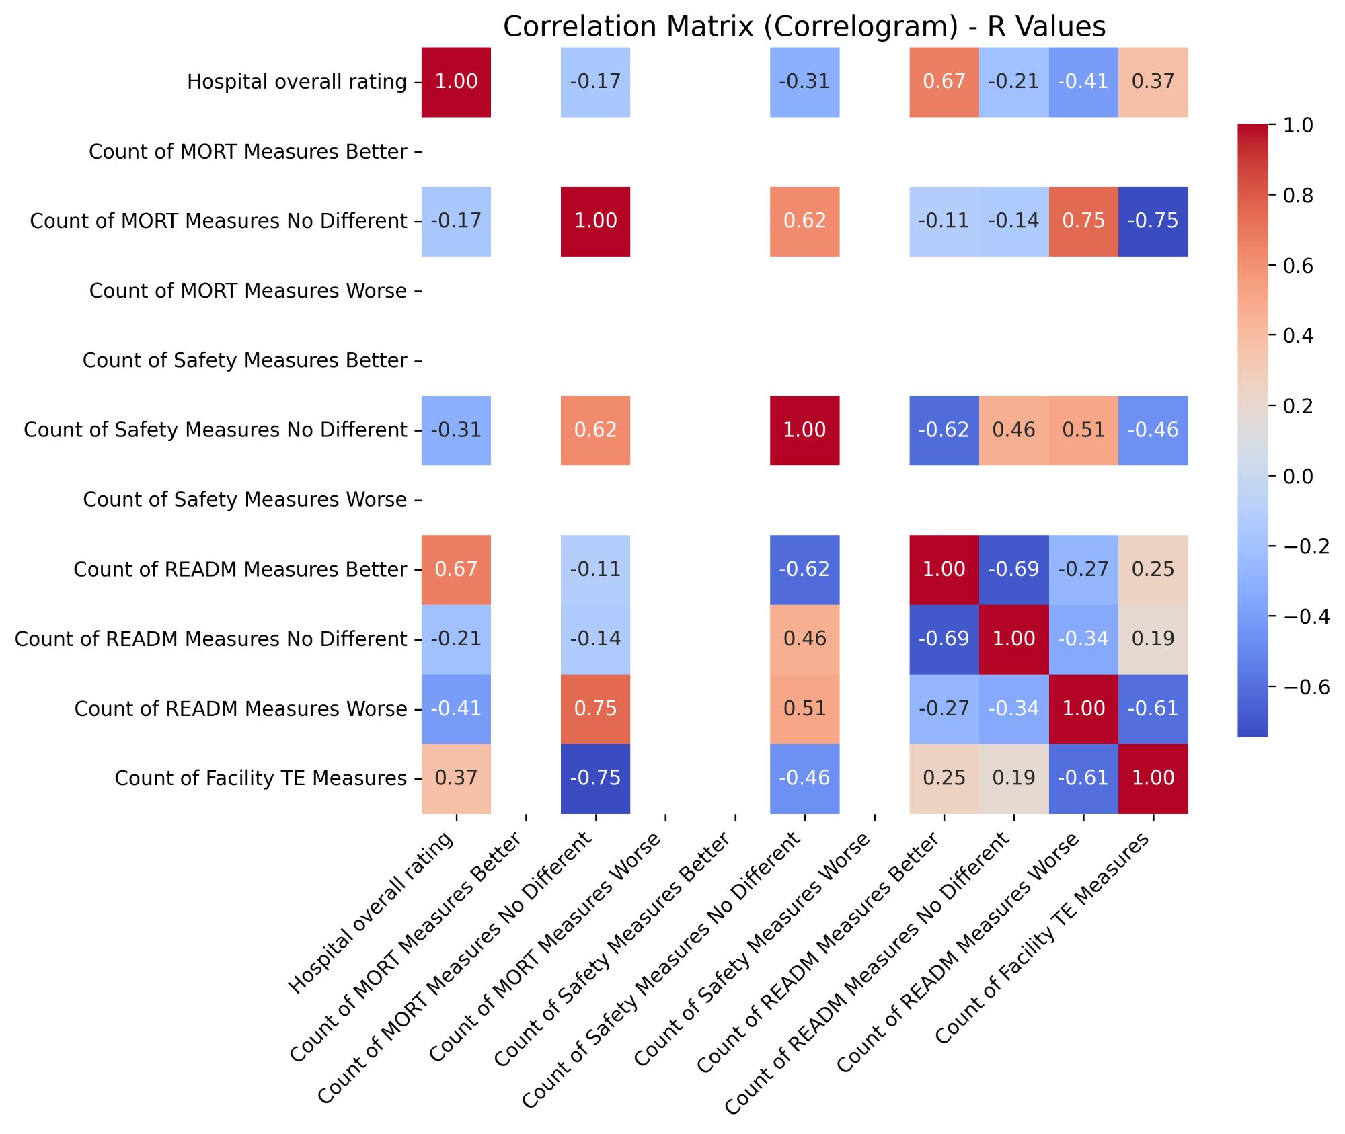

Table 2: Statistically Significant Pearson Correlations (p < 0.05) — Hospital General Information Dataset
Variable 1 | Variable 2 | R Value | P Value | Interpretation
Hospital Overall Rating | Count of READM Measures Better | 0.667 | 0.035 | Moderate positive — states with more hospitals performing better on readmissions tend to have higher overall ratings
Count of MORT Measures No Different | Count of READM Measures Worse | 0.748 | 0.013 | Strong positive — states where mortality is broadly average also tend to have more poor readmission performers
Count of MORT Measures No Different | Count of Facility TE Measures | -0.745 | 0.013 | Strong negative — as average mortality performance increases, timely & effective care measure count decreases
Count of READM Measures Better | Count of READM Measures No Different | -0.692 | 0.027 | Moderate negative — states with more readmission high-performers have fewer average performers

One of the key findings from the correlation analysis was the statistically significant positive relationship between Hospital Overall Rating and Count of READM Measures Better (r = 0.667, p = 0.035). This suggests that states with a larger number of hospitals performing above the national average on readmission measures also tend to have higher median hospital quality ratings overall. This finding is important because readmission rates are often used as an indicator of how well hospitals manage discharge planning, follow-up care, and continuity of care.
Another strong positive relationship was found between Count of MORT Measures No Different and Count of READM Measures Worse (r = 0.748, p = 0.013). This suggests that states where hospitals perform around the national average on mortality may still have more hospitals performing poorly on readmission measures. This could indicate a pattern in which states achieve adequate outcomes across quality areas, but not particularly strong ones. The strong negative correlation between Count of MORT Measures No Different and Count of Facility TE Measures (r = -0.745, p = 0.013) supports this interpretation and points to a possible trade-off between mortality performance and the reporting of timely and effective care measures. Lastly, the moderate negative correlation between Count of READM Measures Better and Count of READM Measures No Different (r = -0.692, p = 0.027) is not surprising, because as more hospitals perform above average on readmissions, fewer remain in the average category.

5.1.2 OAS CAHPS Survey Dataset
The same Pearson correlation method was subsequently applied to the state-level median values derived from the OAS CAHPS Ambulatory Surgical Centre survey dataset, using the twelve selected survey response columns across the same ten states. The corresponding state-level median values are presented in Table 3 below. One column, representing patients who reported that staff did not provide care professionally and that the facility was not clean, showed a uniform median value of zero across all ten states. As a result, it was excluded from the correlation analysis, consistent with the treatment of zero-variance columns in the Hospital General Information dataset.

Table 3: State-Level Median Values — OAS CAHPS Survey Dataset
State | Staff & Facility Definitely Clean/Prof. (%) | Staff & Facility Somewhat Clean/Prof. (%) | Staff & Facility Not Clean/Prof. (%) | Staff Definitely Communicated About Procedure (%) | Staff Somewhat Communicated About Procedure (%) | Staff Did Not Communicate About Procedure (%) | Facility Rated 9–10 out of 10 (%) | Facility Rated 7–8 out of 10 (%) | Facility Rated 0–6 out of 10 (%) | Would Definitely Recommend (%) | Would Probably Recommend (%) | Would Not Recommend (%)
AZ | 98 | 2 | 0 | 92 | 7 | 2 | 91 | 8 | 1 | 86 | 12 | 2
FL | 97 | 3 | 0 | 91 | 7 | 2 | 90 | 9 | 2 | 88.5 | 10 | 2
ID | 98.5 | 1.5 | 0 | 94 | 5 | 1 | 90 | 8.5 | 1.5 | 88 | 9.5 | 2.5
IL | 98 | 2 | 0 | 93 | 6 | 1 | 90 | 9 | 1 | 90 | 9 | 2
IN | 98 | 2 | 0 | 91 | 7.5 | 1.5 | 90 | 9 | 1 | 88 | 11 | 1
LA | 98 | 2 | 0 | 92 | 6 | 2 | 89.5 | 8.5 | 1.5 | 90 | 9 | 1.5
MO | 98 | 2 | 0 | 92 | 6 | 1 | 89 | 9 | 2 | 87 | 12 | 2
NJ | 98 | 2 | 0 | 91 | 6 | 2 | 90 | 9 | 1 | 88 | 10 | 1
PA | 98 | 2 | 0 | 94 | 5 | 1 | 93 | 5 | 1 | 91 | 8 | 1
TN | 98 | 2 | 0 | 93 | 6 | 1 | 91 | 8 | 1 | 90 | 9 | 1

For all variable pairs with sufficient variance, Pearson r values and their corresponding p-values were calculated and visualized in the correlogram presented in Figure 2 below. The statistically significant correlations (p < 0.05) are summarized in Table 4.

Figure 2: Correlogram — Pearson R Values, OAS CAHPS Survey Dataset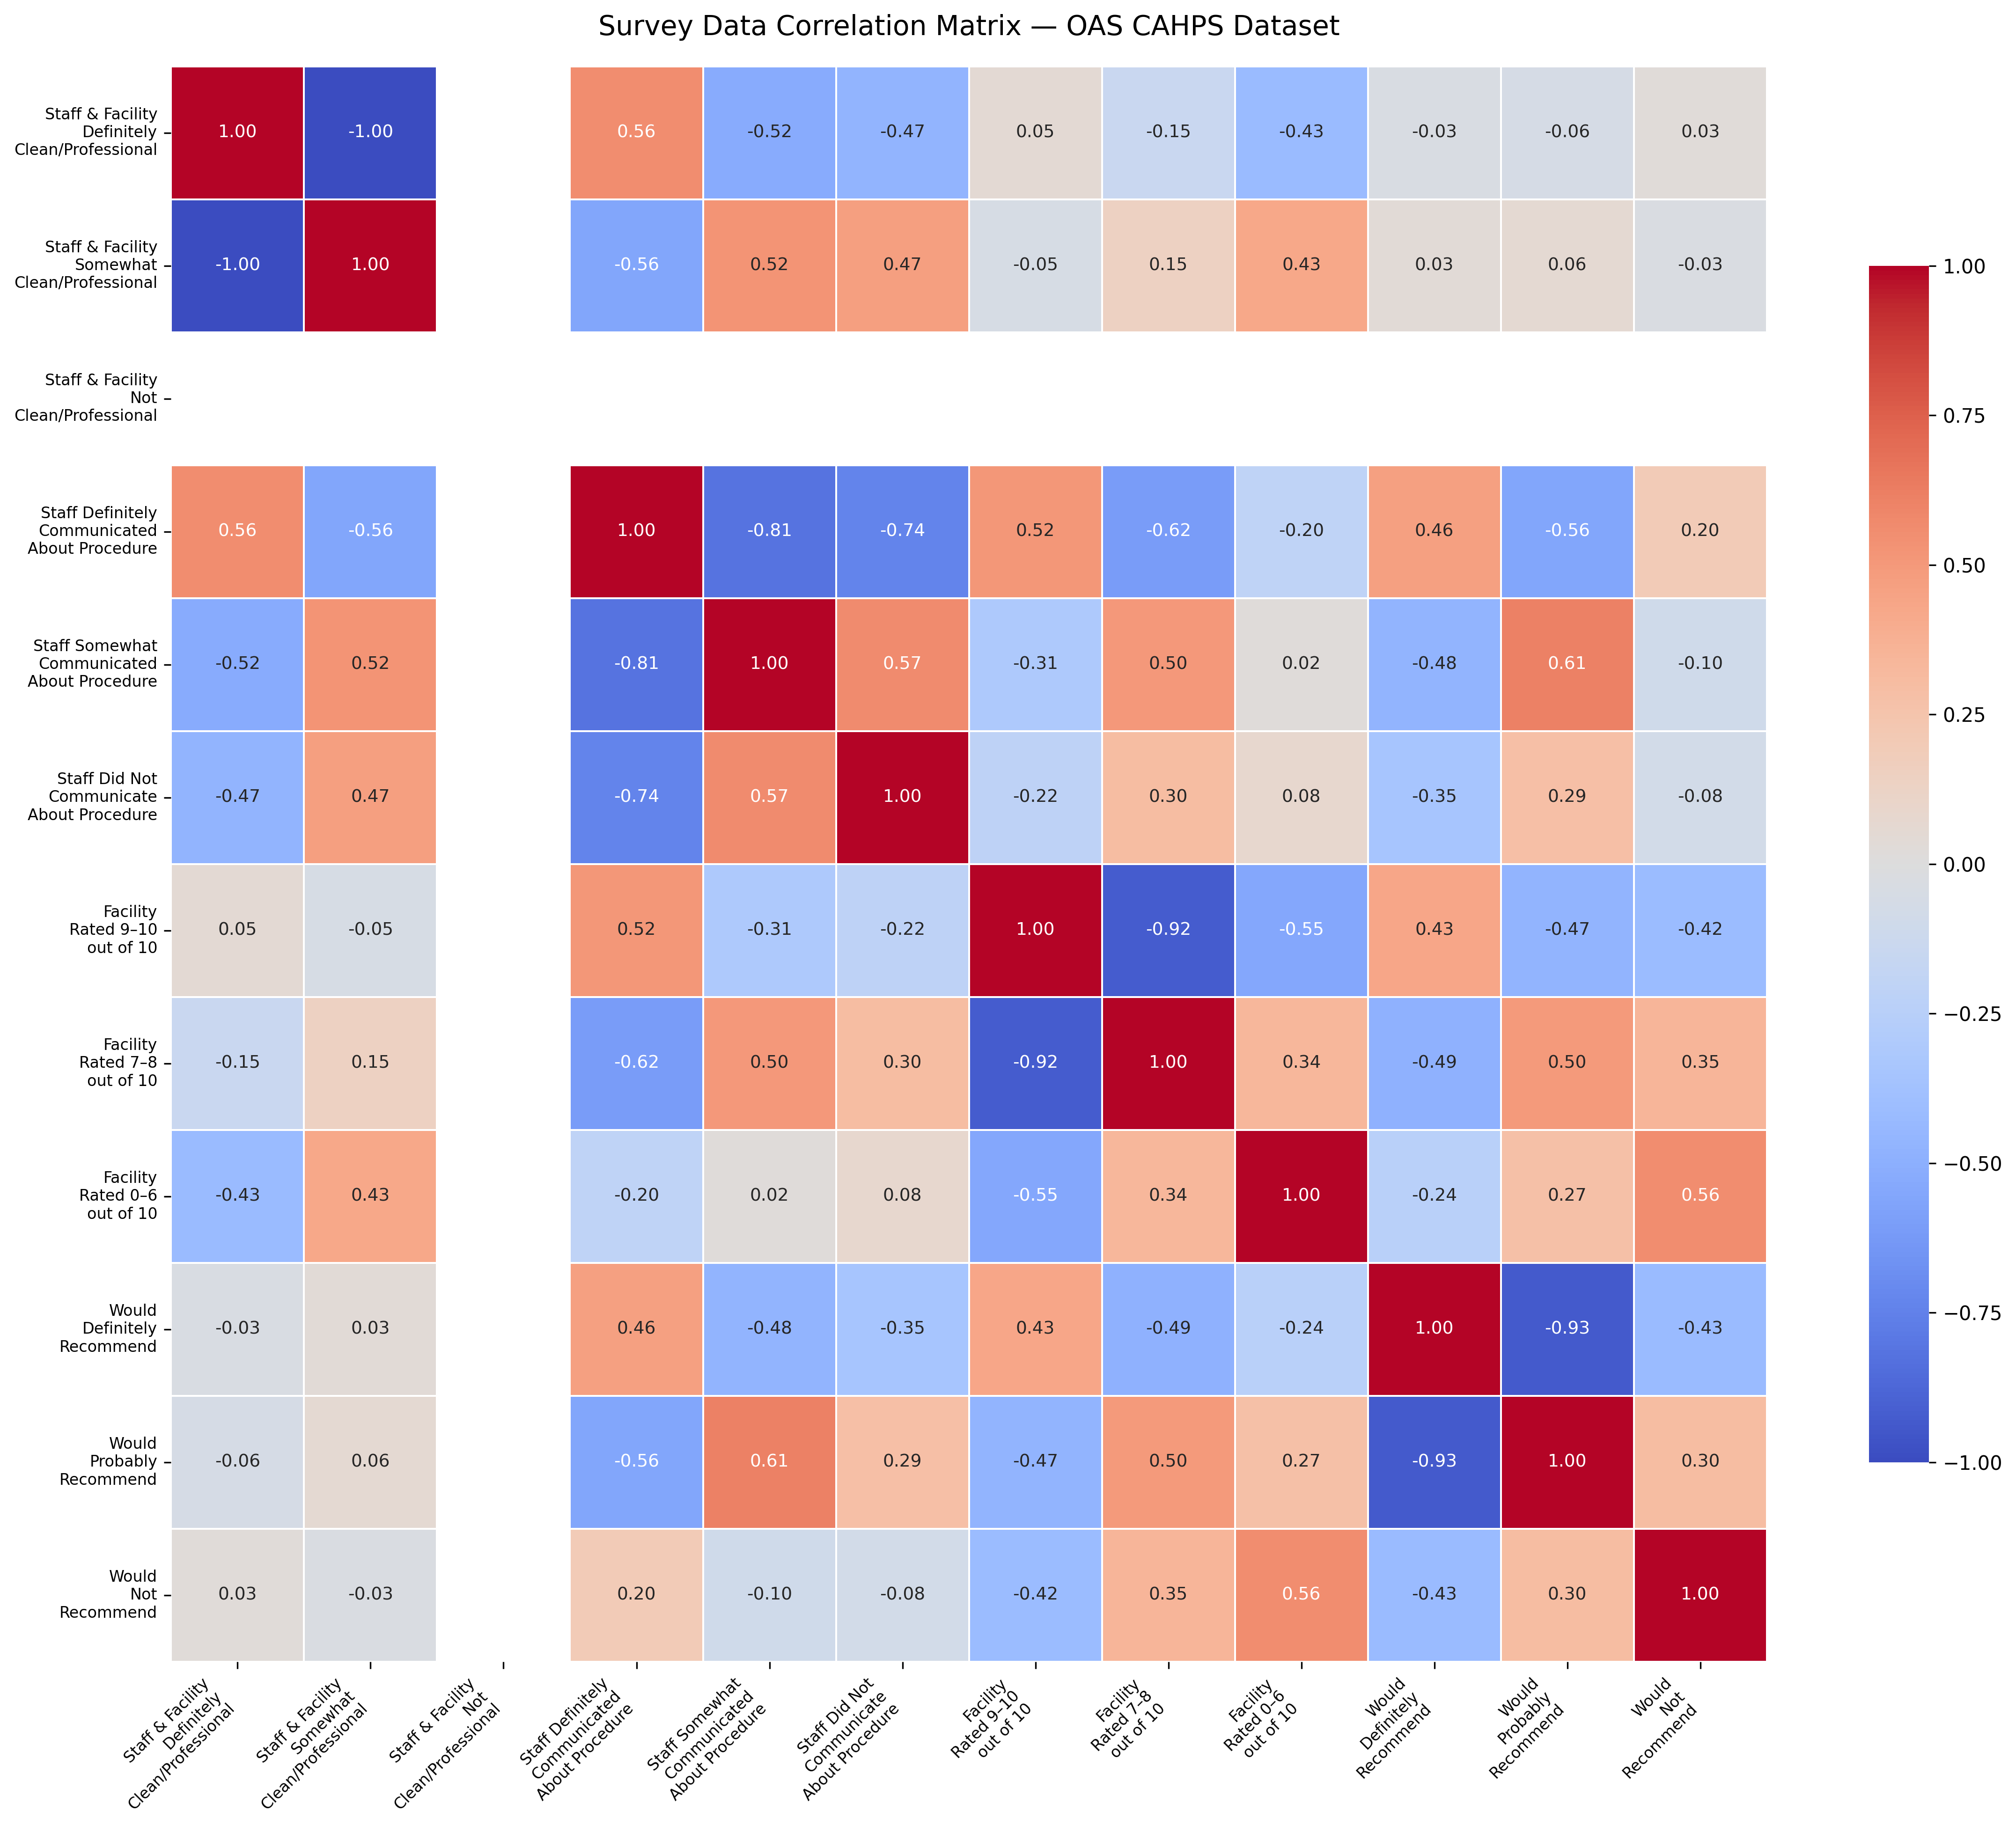

Table 4: Statistically Significant Pearson Correlations (p < 0.05) — OAS CAHPS Survey Dataset
Staff Definitely Communicated About Procedure | Staff Somewhat Communicated About Procedure | -0.814 | 0.004 | Strong negative — states where more patients report definite communication have fewer reporting only partial communication, indicating clear polarisation in communication quality
Staff Definitely Communicated About Procedure | Staff Did Not Communicate About Procedure | -0.742 | 0.014 | Strong negative — states with high definite communication rates have very few patients reporting no communication at all
Facility Rated 9–10 out of 10 | Facility Rated 7–8 out of 10 | -0.923 | <0.001 | Very strong negative — states with more top-rated facilities have markedly fewer moderately rated facilities, indicating a high-performance cluster pattern
Would Definitely Recommend | Would Probably Recommend | -0.935 | <0.001 | Very strong negative — as the proportion of patients who would definitely recommend rises, those who would only probably recommend falls, reflecting a consistent shift toward strong endorsement

A major finding from the OAS CAHPS correlation analysis was the very strong negative relationship between patients who rated the facility 9 or 10 out of 10 and those who rated it 7 or 8 (r = -0.923, p < 0.001). This shows that across the ten states, a higher share of top ratings is consistently associated with a lower share of moderate ratings. Rather than reflecting a smooth distribution of patient opinions, this pattern suggests a clear split in satisfaction at the state level. In other words, states tend to fall more clearly into either higher-performing or more average-performing groups, with little middle ground.
A similarly strong negative correlation was also found between patients who would definitely recommend the facility and those who would probably recommend it (r = -0.935, p < 0.001). This reinforces the same overall pattern seen in the facility ratings: states with more patients giving strong recommendations tend to have fewer patients giving only moderate recommendations. Together, these findings suggest that the states differ not only in whether patients are satisfied, but also in how strongly that satisfaction is expressed.
In the communication-related responses, significant negative correlations were found between patients who reported clear communication and those who reported only partial communication (r = -0.814, p = 0.004) or no communication at all (r = -0.742, p = 0.014). These results suggest that communication quality is a fairly stable state-level pattern. States with stronger communication performance tend to show that strength more broadly, while states with weaker communication tend to have more reports of partial or missing communication.

5.2 Scatter Matrix with Polynomial Trendlines
After completing the Pearson correlation analysis, a scatter matrix with fitted polynomial trendlines was generated for both the Hospital General Information dataset and the OAS CAHPS Survey dataset. This visualization was used to support the correlation results by showing the pairwise relationships between variables more directly. It was especially useful for identifying non-linear patterns that may not be fully reflected by a single correlation coefficient. In the scatter matrix, every variable is plotted against every other variable in a grid, and each cell contains a scatter plot with a fitted trendline.
The Python script used for this visualization relied on three main libraries. NumPy was used to fit polynomial trendlines to each scatter plot through its polyfit function, which finds the best-fitting polynomial curve for the data using the least squares method. Matplotlib was used to create and render the visualizations, with control over the figure layout, axes, and styling. Its PdfPages utility was used to save the complete scatter matrix as a single PDF file. Because the matrix included twelve variables, the output contained a 12 × 12 grid with 144 individual scatter plots. Pandas was again used to load and manage the data, just as in the previous stages of the analysis.
The trendlines were based on a degree-2 polynomial, or quadratic fit. Unlike a linear fit, which shows only a straight-line relationship, a quadratic fit can curve and is therefore better suited to relationships where the rate of change is not constant. To make the trendline smooth, the fitted curve was calculated using two hundred evenly spaced points between the minimum and maximum values of the x-axis variable.

5.2.1 Hospital General Information Dataset — Linear Trendlines
When the scatter matrix was created for the Hospital General Information dataset, the fitted trendlines appeared mostly as straight lines rather than curves, even though a degree-2 polynomial fit was used. This was due to the nature of the data, not a weakness in the method. As noted earlier in the data preparation stage, the Hospital General Information variables show very little variation across the ten states. For example, the Overall Star Rating takes only two values, 3 and 4, and several measure count columns also contain only one or two unique values across the states. Because the data have such a limited range and very few distinct values, the quadratic fit does not have enough variation to produce a meaningful curve. Instead, it behaves more like a linear fit and results in straight trendlines. This reflects the fact that the ten states are highly similar in their clinical quality measure distributions, with only small differences between them. The straight trendlines therefore indicate that the relationships among these variables, where they exist, are simple and roughly linear in form.

5.2.2 OAS CAHPS Survey Dataset — Curved Trendlines
In contrast, the scatter matrix for the OAS CAHPS Survey dataset showed noticeable curved trendlines across many variable pairs. This was mainly due to the greater variation and wider spread of values in the survey data. For example, across the states, the percentage of patients who would definitely recommend the facility ranged from 86% to 91%, the percentage rating the facility 7 or 8 out of 10 ranged from 5% to 9%, and the percentage rating it 9 or 10 ranged from 89% to 93%. Since the survey data contain more unique values and a broader spread, and the points do not fall into a simple straight-line pattern, the degree-2 polynomial fit is able to detect genuine curvature in the relationships between variables.
The curved trendlines suggest that the relationships between the survey variables do not follow a constant proportional pattern across the full range of state-level values. For example, the relationship between the proportion of patients giving a top rating and those giving a moderate rating does not decline at a constant rate. Instead, the pattern changes depending on the level of the x-axis variable. This non-linear behavior is important because it suggests that improvements in patient satisfaction at the state level do not happen in a simple straight-line way, and may instead involve threshold effects or diminishing returns at certain performance levels. The scatter matrix therefore provides a more detailed view of how the variables relate to one another than the correlation coefficients alone, and it acts as a useful visual complement to the Pearson analysis.
Figure 3 below presents the full scatter matrix for the OAS CAHPS Survey dataset. Each cell in the grid contains a scatter plot of the row variable against the column variable, along with an orange quadratic trendline fitted to the data. As expected, the diagonal cells, where each variable is plotted against itself, show a degenerate point cluster and a flat trendline.

Figure 3: Scatter Matrix with Polynomial Trendlines — OAS CAHPS Survey Dataset


5.3 Hierarchical Clustering and K-Means Analysis
The third step of the analysis involved applying hierarchical clustering and K-means clustering to the state-level median datasets from both the Hospital General Information and OAS CAHPS Survey sources. Two distance metrics were used, Euclidean distance and Cosine distance, and several hierarchical linkage methods were tested for each one. The analysis was carried out in Python using SciPy, Scikit-learn, and Matplotlib.

The main hierarchical clustering functions came from SciPy’s scipy.cluster.hierarchy module. The linkage function was used to build the hierarchical cluster tree by repeatedly merging the closest pairs of states based on the selected distance metric and linkage method. The dendrogram function displayed this structure as a tree diagram, with merge distances shown on the vertical axis and the states listed along the horizontal axis. The fcluster function was then used to cut the dendrogram at a chosen threshold and assign states to flat clusters. Before these steps, pairwise distances between all states were calculated using the pdist function from scipy.spatial.distance.

Before any Euclidean-based clustering was performed, the data were standardized using Scikit-learn’s StandardScaler. This ensured that variables measured on different scales did not have too much influence on the distance calculations. For Cosine-based clustering, the standardized data were further normalized using Scikit-learn’s normalize function so that each state’s feature vector had unit length. This made Cosine distance reflect similarity in the overall pattern of values rather than differences in magnitude.

For Euclidean distance, four linkage methods were used: Single, Complete, Average, and Ward. These methods differ in how they define the distance between clusters, with Ward specifically aiming to minimize within-cluster variance at each merging step. For Cosine distance, only Single, Complete, and Average linkage were used. Ward linkage was excluded because it relies on centroid calculations in Euclidean space and is therefore not compatible with Cosine distance.

The number of clusters for each hierarchical run was chosen automatically using a threshold equal to 70% of the maximum merge distance in the linkage matrix. The same threshold was applied across all linkage methods and distance metrics so that cluster assignment remained consistent and objective. The resulting K values and cluster memberships for each combination are reported in the summary tables below.

Euclidean distance was used as the primary similarity measure because it directly captures absolute differences in state-level values across the quality and survey variables. Cosine distance was included as a complementary measure because it focuses on the overall pattern of high and low values across variables, even when the absolute values differ. Since both datasets contain bounded measures such as counts and percentages, Cosine distance provides a useful second view of similarity by identifying states with similar structural profiles. Using both metrics therefore gives a more complete picture of inter-state similarity than relying on Euclidean distance alone.

After completing the hierarchical clustering analysis, K-means clustering was run for each unique K value identified from the hierarchical results for a given dataset. If the same K value appeared more than once, it was consolidated and K-means was run only once for that value. K-means assigns each state to the cluster with the nearest centroid, where the centroid represents the average feature profile of the states in that cluster. The algorithm keeps updating cluster assignments and centroids until the solution stops changing. Scikit-learn’s KMeans implementation was used with ten random initializations and a fixed random seed to ensure reproducibility. Each K-means result was then visualized using centroid profile plots, in which cluster centroids were plotted as connected lines across all variables to make comparison between clusters easier.

For each dataset, centroid profile plots were also created for selected hierarchical clustering results, specifically for Complete linkage under both Euclidean and Cosine distance. These hierarchical centroid plots use the standardized or normalized feature space rather than the original variable scale, because that is the space in which the hierarchical distances were computed. In contrast, the K-means centroid plots were converted back to the original variable scale so that they would be easier to interpret.

5.3.1 Hospital General Information Dataset
Hierarchical clustering was applied to the state-level median values of the Hospital General Information dataset across seven combinations of linkage method and distance metric. The automatic threshold-based cluster assignment produced K values ranging from 2 to 4 across the seven combinations. The full results are summarised in Table 5 below.
Table 5: Hierarchical Clustering Results — Hospital General Information Dataset
Linkage Method | Distance Metric | Auto K | Cluster Composition
Single | Euclidean | 2 | C1: AZ, IN, FL, TN, PA, NJ, MO, LA, IL | C2: ID
Complete | Euclidean | 3 | C1: AZ, FL, NJ | C2: IN, TN, PA, MO, LA, IL | C3: ID
Average | Euclidean | 2 | C1: AZ, IN, FL, TN, PA, NJ, MO, LA, IL | C2: ID
Ward | Euclidean | 3 | C1: AZ, FL, NJ | C2: IN, TN, PA, MO, LA, IL | C3: ID
Single | Cosine | 4 | C1: AZ, FL, NJ | C2: IN, TN, PA, MO, LA | C3: ID | C4: IL
Complete | Cosine | 3 | C1: AZ, FL, NJ, IL | C2: IN, PA, MO, LA | C3: ID, TN
Average | Cosine | 3 | C1: AZ, FL, NJ, IL | C2: IN, PA, MO, LA | C3: ID, TN

The dendrograms for each of the seven combinations are presented in Figures 3 through 9 below. Each dendrogram displays the hierarchical merge structure of the ten states, with the legend identifying which states belong to each automatically determined cluster.
Figure 3: Dendrogram — Single Linkage, Euclidean Distance (Hospital General Information Dataset)
[INSERT FIGURE: single_euclidean — Hospital General (K=2)]
Figure 4: Dendrogram — Complete Linkage, Euclidean Distance (Hospital General Information Dataset)
[INSERT FIGURE: complete_euclidean — Hospital General (K=3)]
Figure 5: Dendrogram — Average Linkage, Euclidean Distance (Hospital General Information Dataset)
[INSERT FIGURE: average_euclidean — Hospital General (K=2)]
Figure 6: Dendrogram — Ward Linkage, Euclidean Distance (Hospital General Information Dataset)
[INSERT FIGURE: ward_euclidean — Hospital General (K=3)]
Figure 7: Dendrogram — Single Linkage, Cosine Distance (Hospital General Information Dataset)
[INSERT FIGURE: single_cosine — Hospital General (K=4)]
Figure 8: Dendrogram — Complete Linkage, Cosine Distance (Hospital General Information Dataset)
[INSERT FIGURE: complete_cosine — Hospital General (K=3)]
Figure 9: Dendrogram — Average Linkage, Cosine Distance (Hospital General Information Dataset)
[INSERT FIGURE: average_cosine — Hospital General (K=3)]
Across all seven combinations, Idaho (ID) consistently appeared as a distinct outlier cluster in every Euclidean-based run, separating from the other nine states at a much higher distance threshold. This pattern is consistent with the earlier correlation analysis, which showed that Idaho was one of only two states with an Overall Star Rating of 4, while most of the remaining states had a rating of 3. The Cosine-based runs produced a more nuanced three-cluster structure by grouping states according to the overall pattern of their quality measure distributions rather than their absolute values. Across multiple combinations, Arizona, Florida, and New Jersey consistently formed one cluster, while Indiana, Pennsylvania, Missouri, and Louisiana formed a second, and Idaho and Tennessee formed a third under Complete and Average Cosine linkage.
The unique K values identified across the seven combinations were 2, 3, and 4. K-means clustering was therefore performed for K = 2, K = 3, and K = 4. The hierarchical centroid plots for Complete linkage under both Euclidean and Cosine distance are presented in Figures 10 and 11, followed by the K-means centroid profile plots in Figures 12, 13, and 14.

Figure 10: Hierarchical Centroid Plot — Complete Linkage, Euclidean Distance (Hospital General Information Dataset)
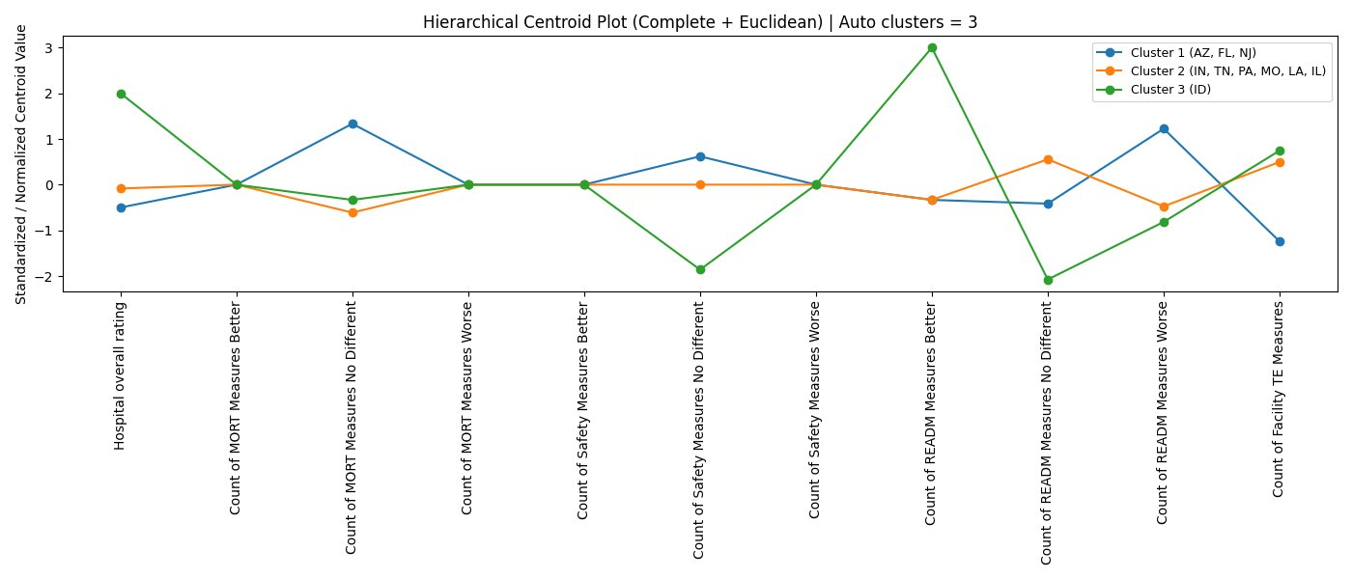

Figure 11: Hierarchical Centroid Plot — Complete Linkage, Cosine Distance (Hospital General Information Dataset)
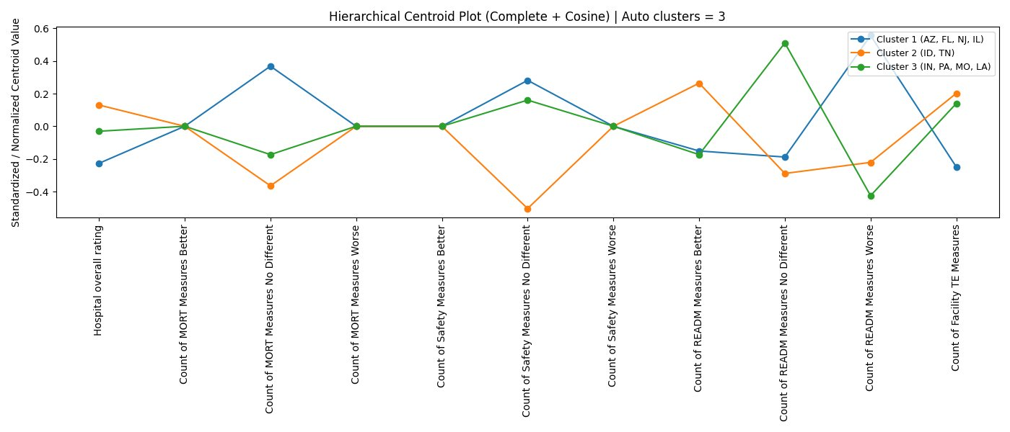
Figure 12: K-Means Centroid Profile Plot — K=2 (Hospital General Information Dataset)
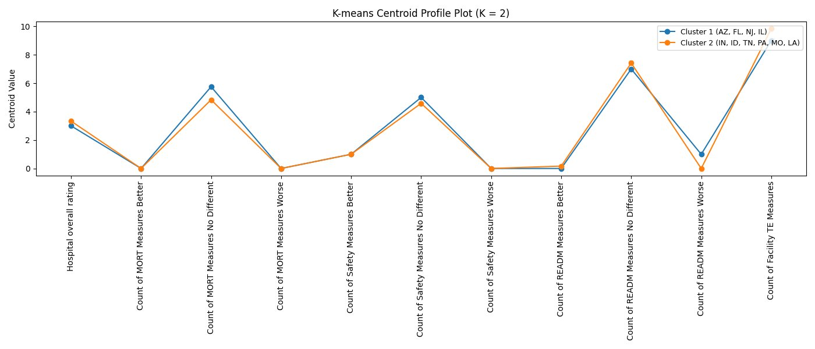

Figure 13: K-Means Centroid Profile Plot — K=3 (Hospital General Information Dataset)
[INSERT FIGURE: kmeans_centroids_k3 — Hospital General]
Figure 14: K-Means Centroid Profile Plot — K=4 (Hospital General Information Dataset)
[INSERT FIGURE: kmeans_centroids_k4 — Hospital General]
The K-means centroid profile plots reveal that for K=2, the two clusters are broadly separated by their Count of MORT Measures No Different and Count of READM Measures No Different values, with Idaho's single-state cluster exhibiting a distinctly higher READM Better count and lower READM No Different count relative to the nine-state cluster. As K increases to 3, the state groupings stabilise around the pattern identified by the Euclidean Complete and Ward dendrograms — Arizona, Florida, and New Jersey forming one cluster characterised by relatively higher MORT No Different and lower TE Measures counts; Indiana, Tennessee, Pennsylvania, Missouri, Louisiana, and Illinois forming a second cluster; and Idaho remaining isolated as a third. At K=4, Tennessee separates into its own cluster, reflecting its marginally distinct position on several quality measure dimensions.

5.3.2 OAS CAHPS Survey Dataset
The same hierarchical clustering and K-means methodology was applied to the state-level median values of the OAS CAHPS Survey dataset. The seven hierarchical combinations produced K values ranging from 3 to 5, reflecting greater variability in the survey data's cluster structure relative to the Hospital General dataset. The full results are summarised in Table 6 below.
Table 6: Hierarchical Clustering Results — OAS CAHPS Survey Dataset
Linkage Method | Distance Metric | Auto K | Cluster Composition
Single | Euclidean | 4 | C1: AZ, ID, IL, IN, LA, NJ, TN | C2: FL | C3: MO | C4: PA
Complete | Euclidean | 3 | C1: AZ, ID, IL, IN, LA, MO, NJ, TN | C2: FL | C3: PA
Average | Euclidean | 4 | C1: AZ, IL, IN, LA, NJ, TN | C2: FL | C3: ID, MO | C4: PA
Ward | Euclidean | 4 | C1: AZ, IN, NJ | C2: FL | C3: ID, IL, LA, MO, TN | C4: PA
Single | Cosine | 5 | C1: AZ, IN, NJ | C2: FL | C3: ID, IL, PA, TN | C4: LA | C5: MO
Complete | Cosine | 3 | C1: AZ, IN, NJ | C2: FL, MO | C3: ID, IL, LA, PA, TN
Average | Cosine | 4 | C1: AZ, IN, NJ | C2: FL, MO | C3: ID, IL, PA, TN | C4: LA
The dendrograms for all seven combinations are presented in Figures 15 through 21 below.
Figure 15: Dendrogram — Single Linkage, Euclidean Distance (OAS CAHPS Survey Dataset)

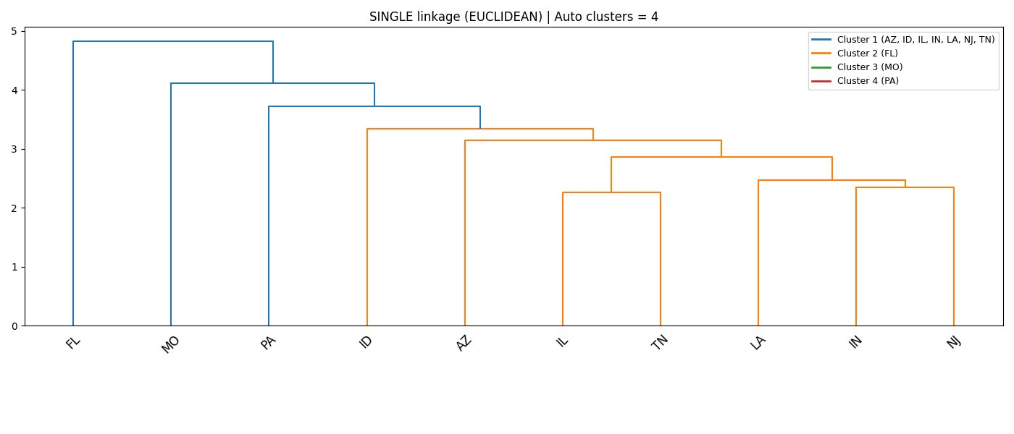
Figure 16: Dendrogram — Complete Linkage, Euclidean Distance (OAS CAHPS Survey Dataset)
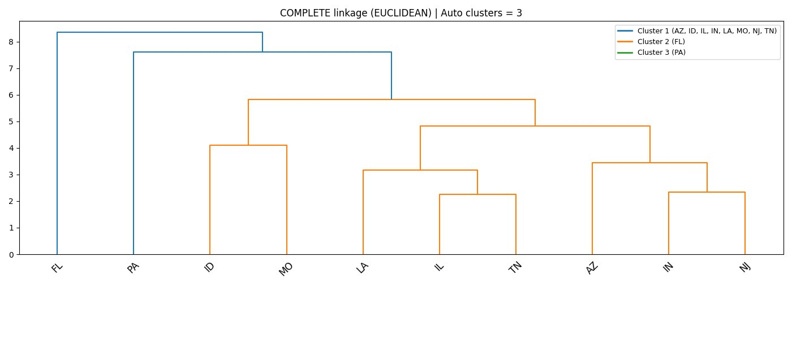
Figure 17: Dendrogram — Average Linkage, Euclidean Distance (OAS CAHPS Survey Dataset)
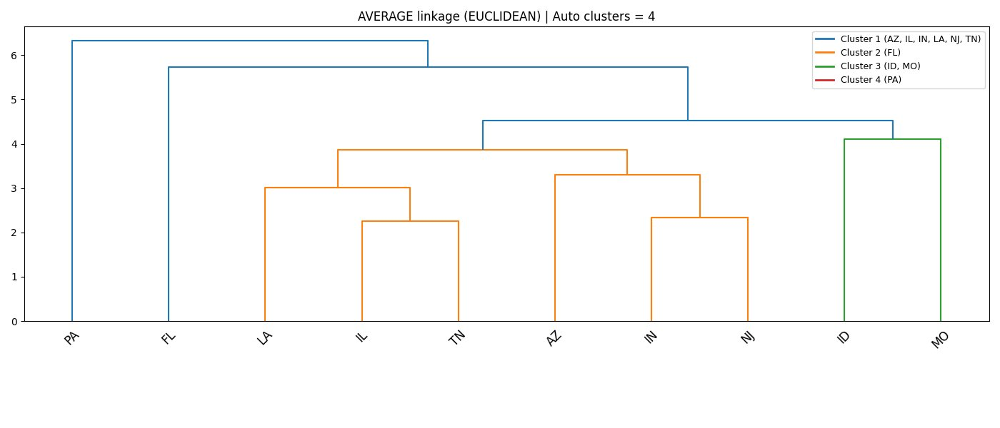
Figure 18: Dendrogram — Ward Linkage, Euclidean Distance (OAS CAHPS Survey Dataset)
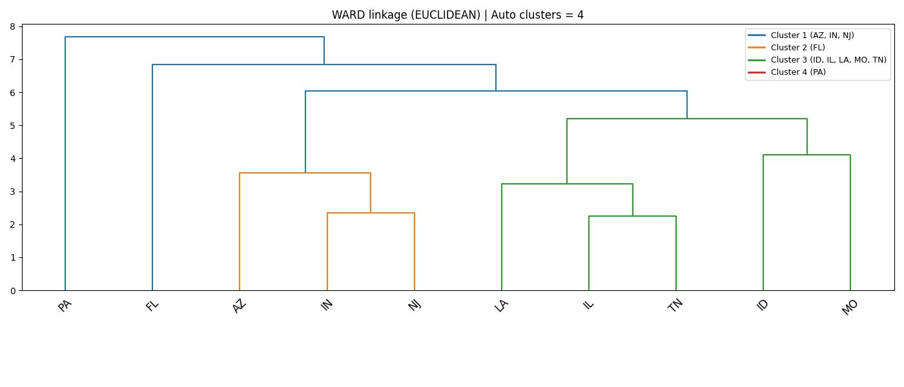
Figure 19: Dendrogram — Single Linkage, Cosine Distance (OAS CAHPS Survey Dataset)
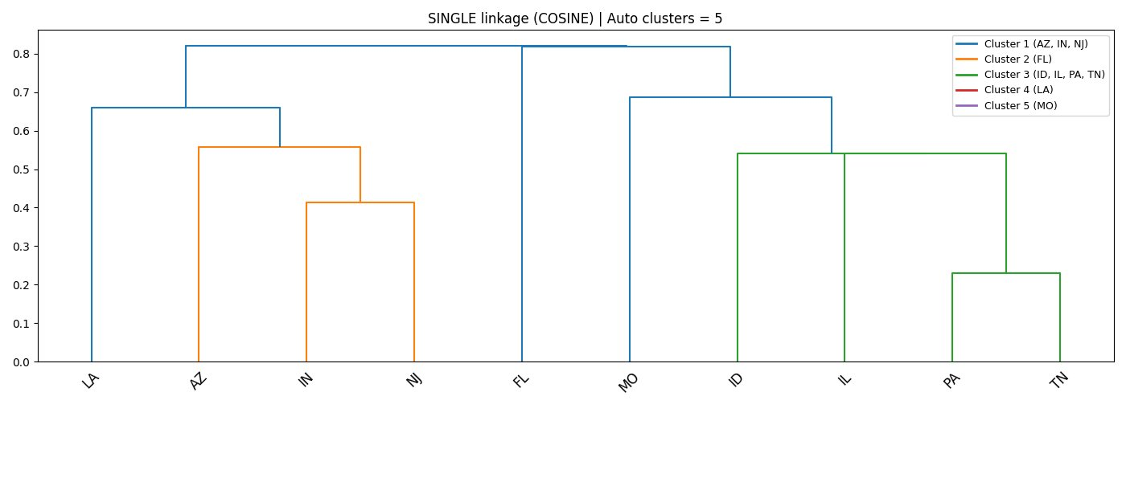
Figure 20: Dendrogram — Complete Linkage, Cosine Distance (OAS CAHPS Survey Dataset)
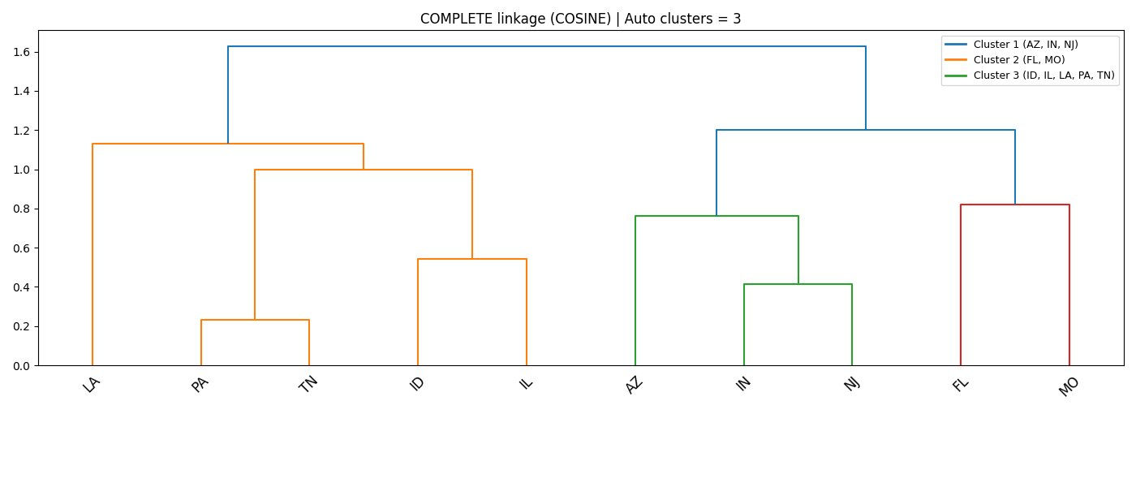
Figure 21: Dendrogram — Average Linkage, Cosine Distance (OAS CAHPS Survey Dataset)
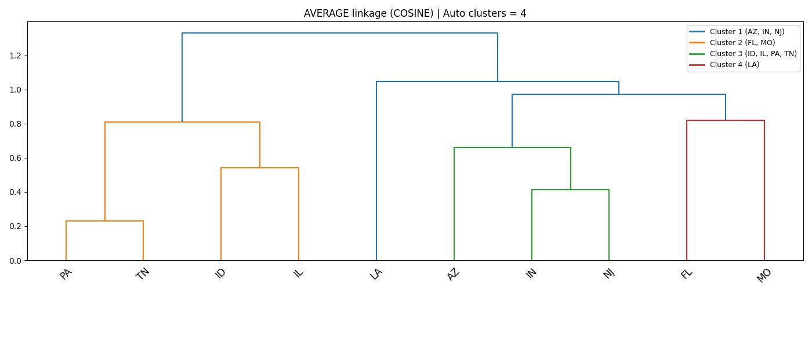
The survey dataset dendrograms reveal a more varied clustering structure than the Hospital General dataset, which is consistent with the greater variance and wider value ranges observed in the survey data during the correlation analysis. Florida and Pennsylvania emerged as frequent outlier states across multiple combinations. Florida consistently separated as a single-state cluster in the Euclidean-based runs, while Pennsylvania appeared as a singleton in several combinations including Complete Euclidean and Ward Euclidean. The state of Missouri also separated individually under Single Euclidean linkage.
The Cosine-based dendrograms produced more interpretable cluster structures. Under Complete Cosine linkage, three clusters emerged consistently: Arizona, Indiana, and New Jersey forming one cluster; Florida and Missouri forming a second; and Idaho, Illinois, Louisiana, Pennsylvania, and Tennessee forming a third. This grouping by directional survey profile suggests that the first cluster represents states with a characteristic pattern of strong patient endorsement and high communication scores, while the third cluster captures a broader group of states with a more moderate and varied survey response profile.
The unique K values across all seven combinations were 3, 4, and 5. K-means clustering was therefore run for K=3, K=4, and K=5. The hierarchical centroid plots for the Cosine distance under Complete and Average linkage are presented in Figures 22 and 23, followed by the K-means centroid profile plots for K=3, K=4, and K=5 in Figures 24, 25, and 26.
Figure 22: Hierarchical Centroid Plot — Complete Linkage, Cosine Distance (OAS CAHPS Survey Dataset)
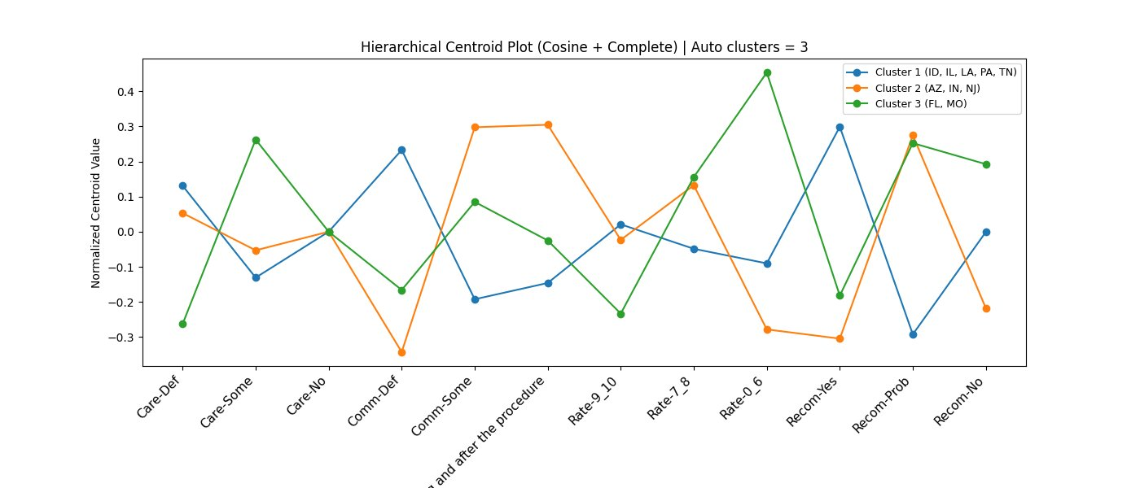
Figure 23: Hierarchical Centroid Plot — Average Linkage, Cosine Distance (OAS CAHPS Survey Dataset)
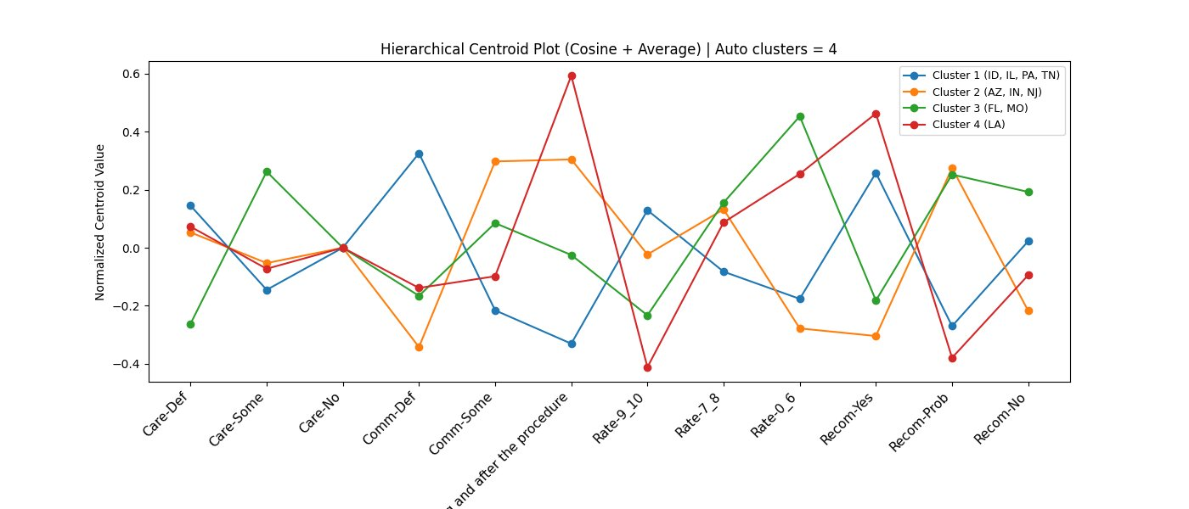
Figure 24: K-Means Centroid Profile Plot — K=3 (OAS CAHPS Survey Dataset)
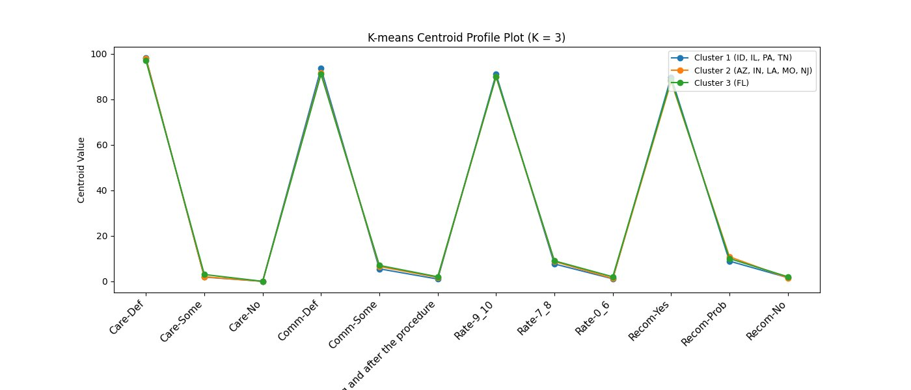
Figure 25: K-Means Centroid Profile Plot — K=4 (OAS CAHPS Survey Dataset)
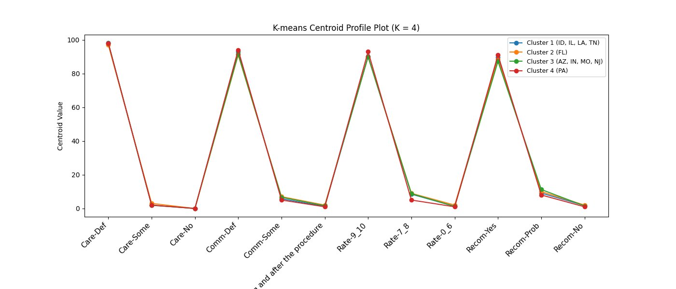
Figure 26: K-Means Centroid Profile Plot — K=5 (OAS CAHPS Survey Dataset)
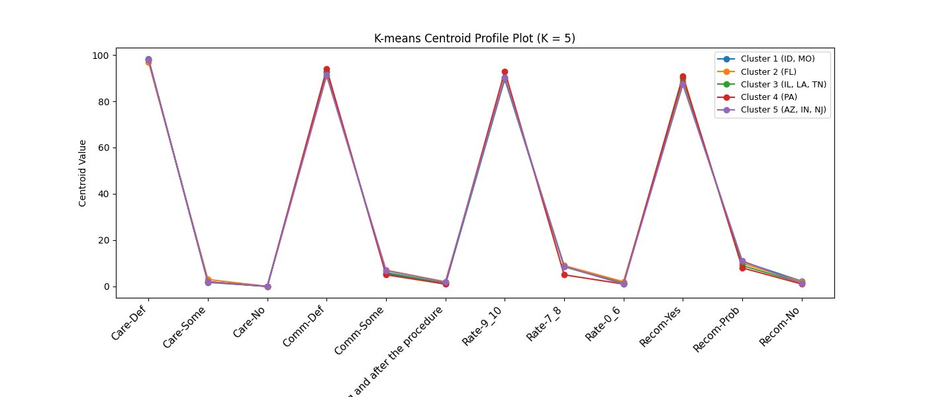
The K-means centroid profile plots for the survey dataset reveal that the centroid lines are visually very close across all clusters for all values of K. This is a direct consequence of the extremely narrow variance in the survey data — all ten states score very highly on the key satisfaction dimensions (Care-Def and Comm-Def both above 97%, Rate-9-10 above 89%, and Recom-Yes above 86% for all states), leaving only marginal absolute differences between clusters. The clusters are therefore differentiated by subtle but consistent directional differences rather than large absolute gaps, which is precisely why Cosine distance was a valuable complementary metric for this dataset — it was able to identify the directional pattern differences that Euclidean distance, sensitive to absolute values, would treat as negligible.
For K=3, the K-means solution groups Idaho, Illinois, Pennsylvania, and Tennessee as one cluster; Arizona, Indiana, Louisiana, Missouri, and New Jersey as a second; and Florida as a third. This structure is broadly consistent with the Complete Cosine hierarchical result, validating the cluster assignments across two independent clustering methods. As K increases to 4 and 5, the clusters fragment further, primarily separating Florida and Pennsylvania into individual clusters, reflecting their consistently distinct survey profiles relative to the other eight states. The stability of the three-cluster solution across both hierarchical and K-means approaches, and across both distance metrics, provides confidence that the three-cluster structure represents a meaningful and robust grouping of the ten states based on their ambulatory surgical centre patient experience profiles.

5.4 Finalised Cluster Selection
After comparing the results of the hierarchical and K-means clustering analyses across all linkage methods and distance metrics, Complete linkage with Cosine distance was chosen as the final clustering solution for both the Hospital General Information dataset and the OAS CAHPS Survey dataset. This decision was based on the overall quality and interpretability of the clusters, with particular attention to whether singleton clusters were present and how evenly the states were distributed across the identified groups.

The combination summaries below show that most Euclidean-based hierarchical runs across both datasets produced one or more singleton clusters. In the Hospital General dataset, Idaho was isolated as its own cluster in nearly all Euclidean runs, while in the Survey dataset, Florida and Pennsylvania appeared as singleton clusters in several Euclidean runs. Although these clusters are mathematically valid, they are less useful for interpretation because they represent isolated outliers rather than meaningful groups of states with shared characteristics. This limits the practical value of the clustering for comparison. The Cosine Single linkage runs made this issue even more pronounced by producing four and five clusters, with multiple singletons in each case.

Among all the combinations, Complete linkage with Cosine distance produced the most balanced and analytically meaningful cluster structures for both datasets. It resulted in exactly three clusters in each dataset, with no singleton groups, and the states were grouped in a way that reflected genuine similarity in their variable profiles rather than simply isolating outliers. Although Average Cosine produced the same three-cluster solution for the Hospital General dataset, it introduced a singleton cluster in the Survey dataset. For this reason, Complete linkage was preferred over Average linkage because it consistently produced clean cluster solutions without singletons across both datasets.
Table 7: Clustering Combination Evaluation — Hospital General Information Dataset
Linkage | Distance | K | Cluster Membership | Assessment
Single | Euclidean | 2 | C1: AZ, IN, FL, TN, PA, NJ, MO, LA, IL | C2: ID | One singleton (ID). No meaningful differentiation.
Complete | Euclidean | 3 | C1: AZ, FL, NJ | C2: IN, TN, PA, MO, LA, IL | C3: ID | ID remains isolated. Large imbalance (1 vs 6 vs 3).
Average | Euclidean | 2 | C1: AZ, IN, FL, TN, PA, NJ, MO, LA, IL | C2: ID | One singleton (ID). Same as Single Euclidean.
Ward | Euclidean | 3 | C1: AZ, FL, NJ | C2: IN, TN, PA, MO, LA, IL | C3: ID | ID remains isolated singleton.
Single | Cosine | 4 | C1: AZ, FL, NJ | C2: IN, TN, PA, MO, LA | C3: ID | C4: IL | Two singletons (ID, IL). Over-fragmented.
Complete | Cosine | 3 | C1: AZ, FL, NJ, IL | C2: IN, PA, MO, LA | C3: ID, TN | ✓ Selected. Balanced groups (4/4/2). No singletons.
Average | Cosine | 3 | C1: AZ, FL, NJ, IL | C2: IN, PA, MO, LA | C3: ID, TN | Same membership as Complete Cosine but Complete preferred for robustness.

Table 8: Clustering Combination Evaluation — OAS CAHPS Survey Dataset
Linkage | Distance | K | Cluster Membership | Assessment
Single | Euclidean | 4 | C1: AZ,ID,IL,IN,LA,NJ,TN | C2: FL | C3: MO | C4: PA | Two singletons (FL, MO, PA). Highly fragmented.
Complete | Euclidean | 3 | C1: AZ,ID,IL,IN,LA,MO,NJ,TN | C2: FL | C3: PA | Two singletons (FL, PA). Minimal differentiation.
Average | Euclidean | 4 | C1: AZ,IL,IN,LA,NJ,TN | C2: FL | C3: ID,MO | C4: PA | Two singletons (FL, PA). Fragmented.
Ward | Euclidean | 4 | C1: AZ,IN,NJ | C2: FL | C3: ID,IL,LA,MO,TN | C4: PA | Two singletons (FL, PA). Fragmented.
Single | Cosine | 5 | C1: AZ,IN,NJ | C2: FL | C3: ID,IL,PA,TN | C4: LA | C5: MO | Three singletons (FL, LA, MO). Over-fragmented.
Complete | Cosine | 3 | C1: AZ, IN, NJ | C2: FL, MO | C3: ID, IL, LA, PA, TN | ✓ Selected. Balanced (3/2/5). No singletons. Clean structure.
Average | Cosine | 4 | C1: AZ,IN,NJ | C2: FL,MO | C3: ID,IL,PA,TN | C4: LA | One singleton (LA). One excess cluster vs Complete.

5.4.1 Finalised Clusters — Hospital General Information Dataset
The finalised three-cluster solution for the Hospital General Information dataset, derived from Complete Cosine hierarchical clustering, is presented in Table 9 below.
Table 9: Finalised Clusters — Hospital General Information Dataset (Complete Cosine, K=3)
Cluster | Member States | Characteristic Profile
Cluster 1 | AZ, FL, NJ, IL | States with relatively higher mortality measure counts at national average and a distinct readmission profile — broadly reflecting moderate-to-high performing hospital systems.
Cluster 2 | ID, TN | States with a distinctly different quality measure profile, notably Idaho's consistently higher overall star rating and readmission performance separating this pair from the wider group.
Cluster 3 | IN, PA, MO, LA | States characterised by lower readmission better counts and a higher count of facilities reporting timely and effective care measures, reflecting a different operational quality profile.

5.4.2 Finalised Clusters — OAS CAHPS Survey Dataset
The finalised three-cluster solution for the OAS CAHPS Survey dataset, likewise derived from Complete Cosine hierarchical clustering, is presented in Table 10 below.
Cluster | Member States | Characteristic Profile
Cluster 1 | ID, IL, LA, PA, TN | States with a moderate patient experience profile — slightly lower definite communication and recommendation rates relative to the other clusters, but consistently high overall satisfaction.
Cluster 2 | AZ, IN, NJ | States with strong patient experience alignment — higher definite communication scores and stronger recommendation rates, reflecting a consistently positive care experience pattern.
Cluster 3 | FL, MO | States with a distinct survey profile characterised by the highest rate of patients who would probably (rather than definitely) recommend the facility, reflecting a pattern of solid but less emphatic patient endorsement.

These two cluster structures form the basis for all subsequent analysis in this thesis. The three clusters identified in each dataset represent distinct groupings of states by hospital quality measure profiles and patient experience survey profiles respectively, and serve as the analytical lens through which the text mining findings from the Yelp Open Dataset are interpreted and contextualised in the following sections.
5.5 Text Mining Analysis — Yelp Open Dataset
The text mining analysis was carried out on Yelp Open Dataset reviews associated with hospital-related businesses and grouped according to the six clusters defined in Section 5.4: three from the Hospital General Information dataset (HG-C1, HG-C2, HG-C3) and three from the OAS CAHPS Survey dataset (S-C1, S-C2, S-C3). For each cluster, all reviews were combined and treated as one body of consumer-generated text representing the shared patient voice of the states in that cluster. The analysis included six main components: overall sentiment, attribute-level net scores, emotion distribution, the Passion Index, word association networks, and word clouds. Each component was computed using a separate Python program, and the outputs are presented and interpreted in the following subsections.
5.5.1 Overall Sentiment Analysis
Overall sentiment analysis was performed using VADER (Valence Aware Dictionary and sEntiment Reasoner), which is available through NLTK. NLTK is a widely used Python library for natural language processing and provides tools for tasks such as text classification, tokenization, tagging, and sentiment analysis. VADER is a rule-based sentiment analysis tool developed specifically for social media and consumer review text. Unlike machine learning approaches that require training data, VADER uses a built-in sentiment lexicon together with language rules that account for context effects such as negation, intensifiers, and punctuation. For each review, it calculates a compound sentiment score ranging from -1 to +1, where -1 represents strongly negative sentiment and +1 represents strongly positive sentiment. Reviews with scores of 0.05 or above were classified as positive, those with scores of -0.05 or below were classified as negative, and those in between were classified as neutral. Neutral reviews were excluded from the percentage calculation. For each cluster, the final output reports the percentage of positive and negative sentiment-bearing reviews along with the total review count.
The results for all six clusters are summarized in Table 11 below, while the individual cluster charts are presented in Figures 27 through 32.
Table 11: Overall Sentiment Summary — All Clusters
Cluster | States | Positive | Negative
HG-C1 | AZ, FL, NJ, IL | 66.2% (247) | 33.8% (126)
HG-C2 | ID, TN | 60.6% (77) | 39.4% (50)
HG-C3 | IN, PA, MO, LA | 62.3% (425) | 37.7% (257)
S-C1 | ID, IL, LA, PA, TN | 60.1% (369) | 39.9% (245)
S-C2 | AZ, IN, NJ | 65.6% (250) | 34.4% (131)
S-C3 | FL, MO | 70.2% (165) | 29.8% (70)
Figure 27: Overall Sentiment — HG-C1 (AZ, FL, NJ, IL)
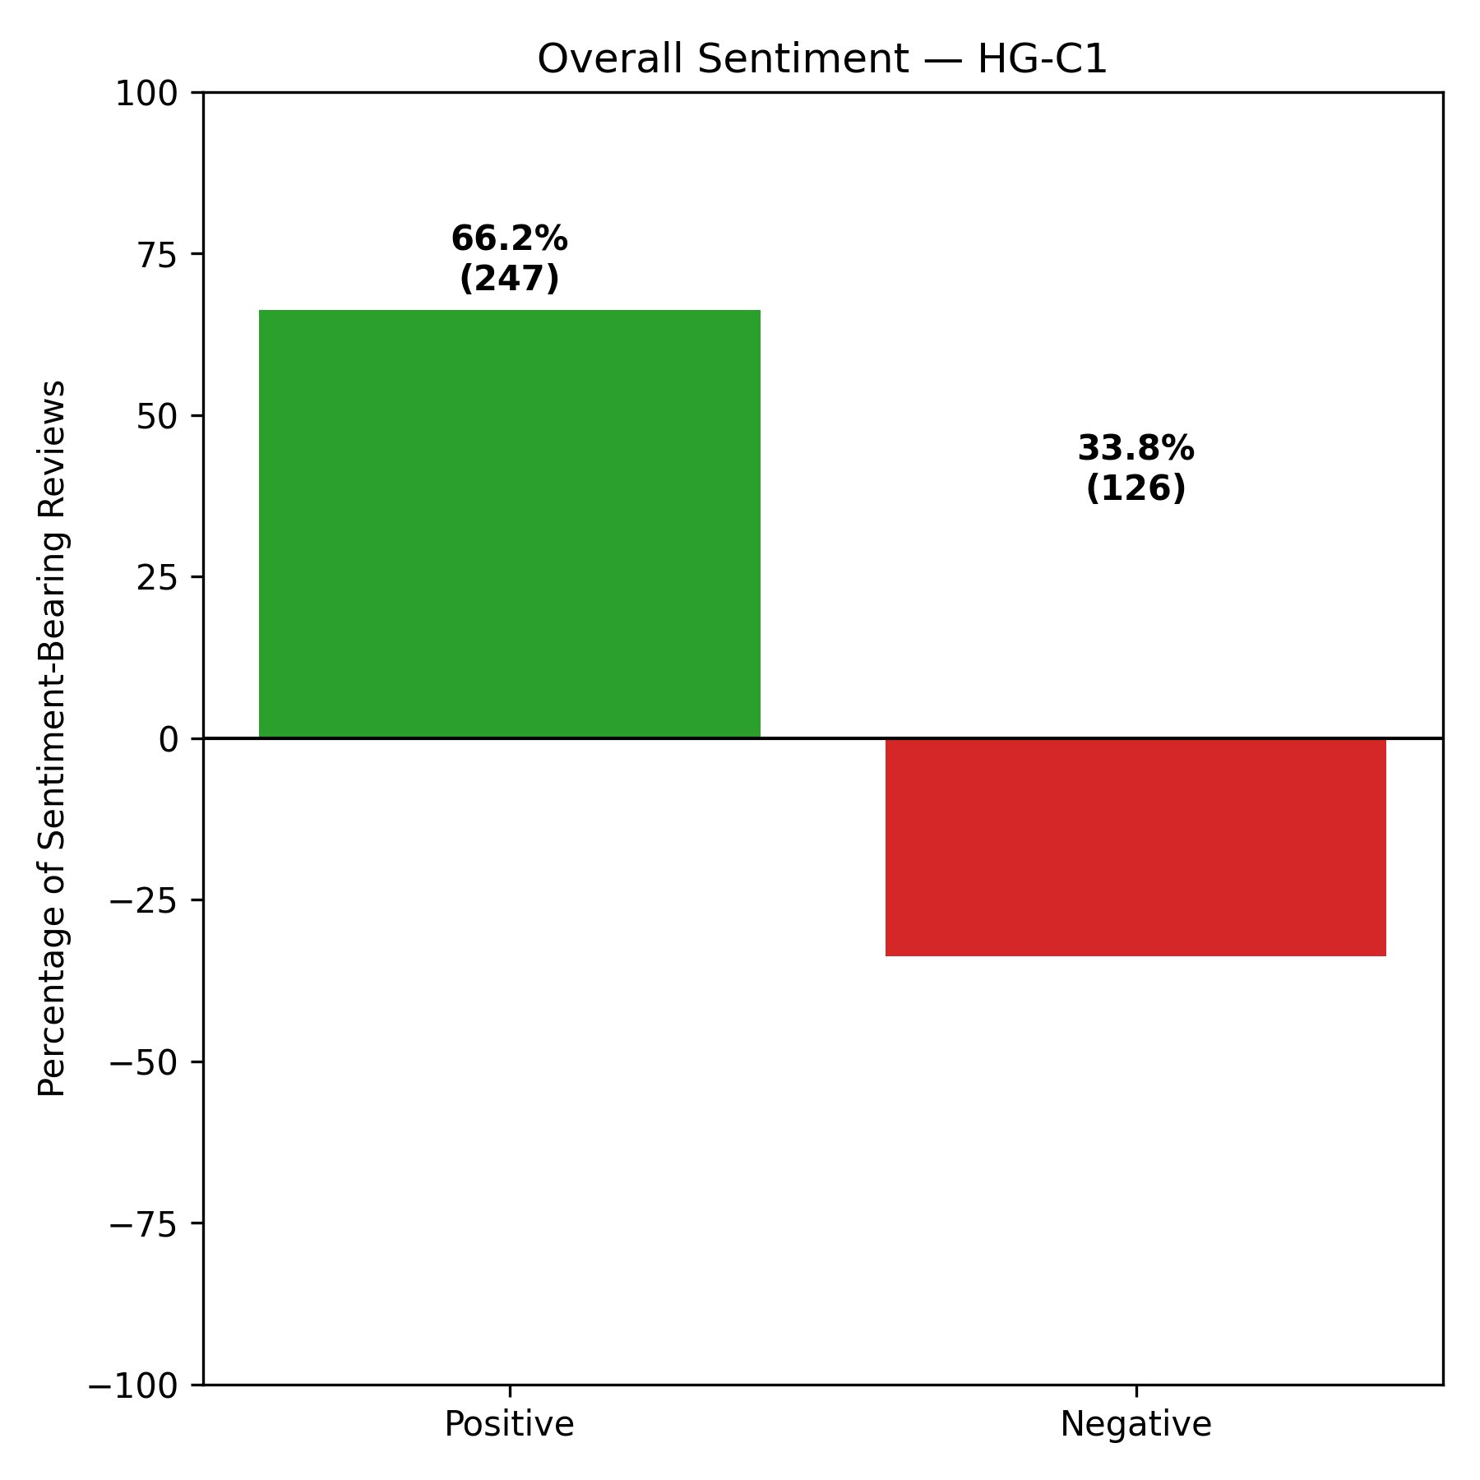
Figure 28: Overall Sentiment — HG-C2 (ID, TN)
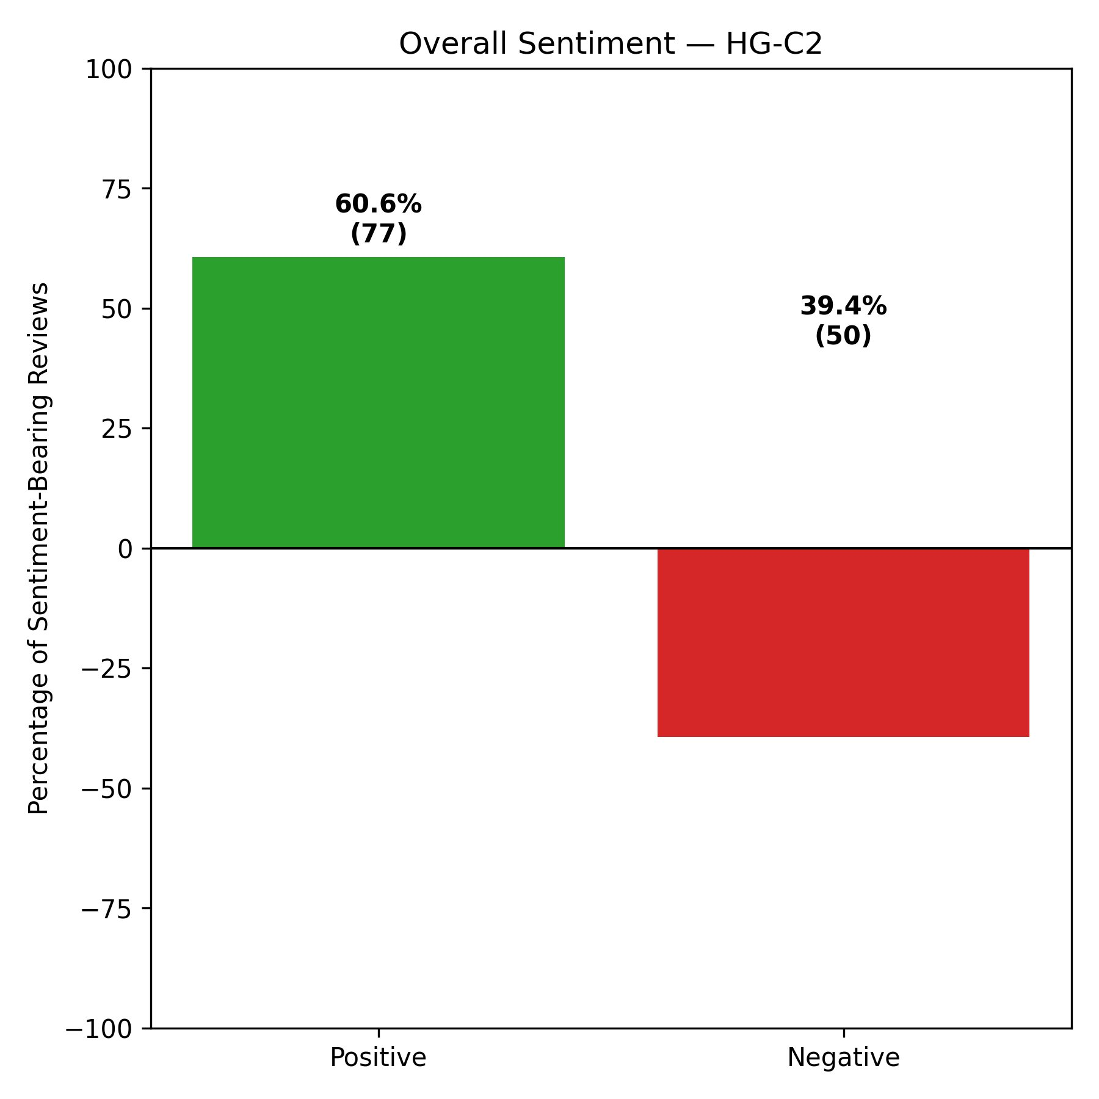
Figure 29: Overall Sentiment — HG-C3 (IN, PA, MO, LA)
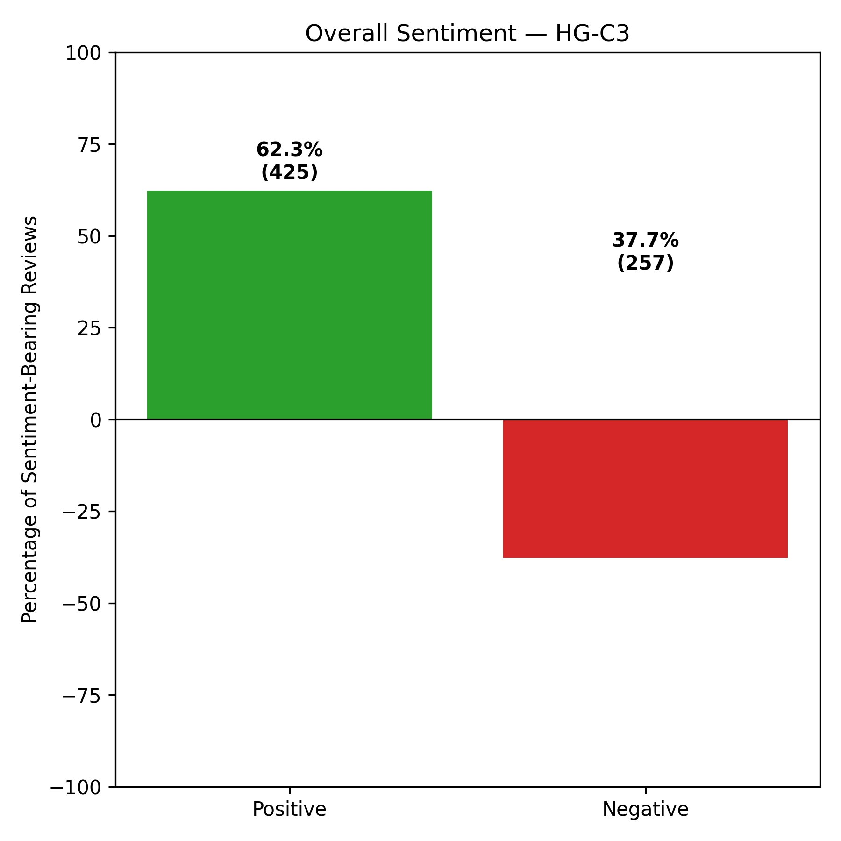
Figure 30: Overall Sentiment — S-C1 (ID, IL, LA, PA, TN)
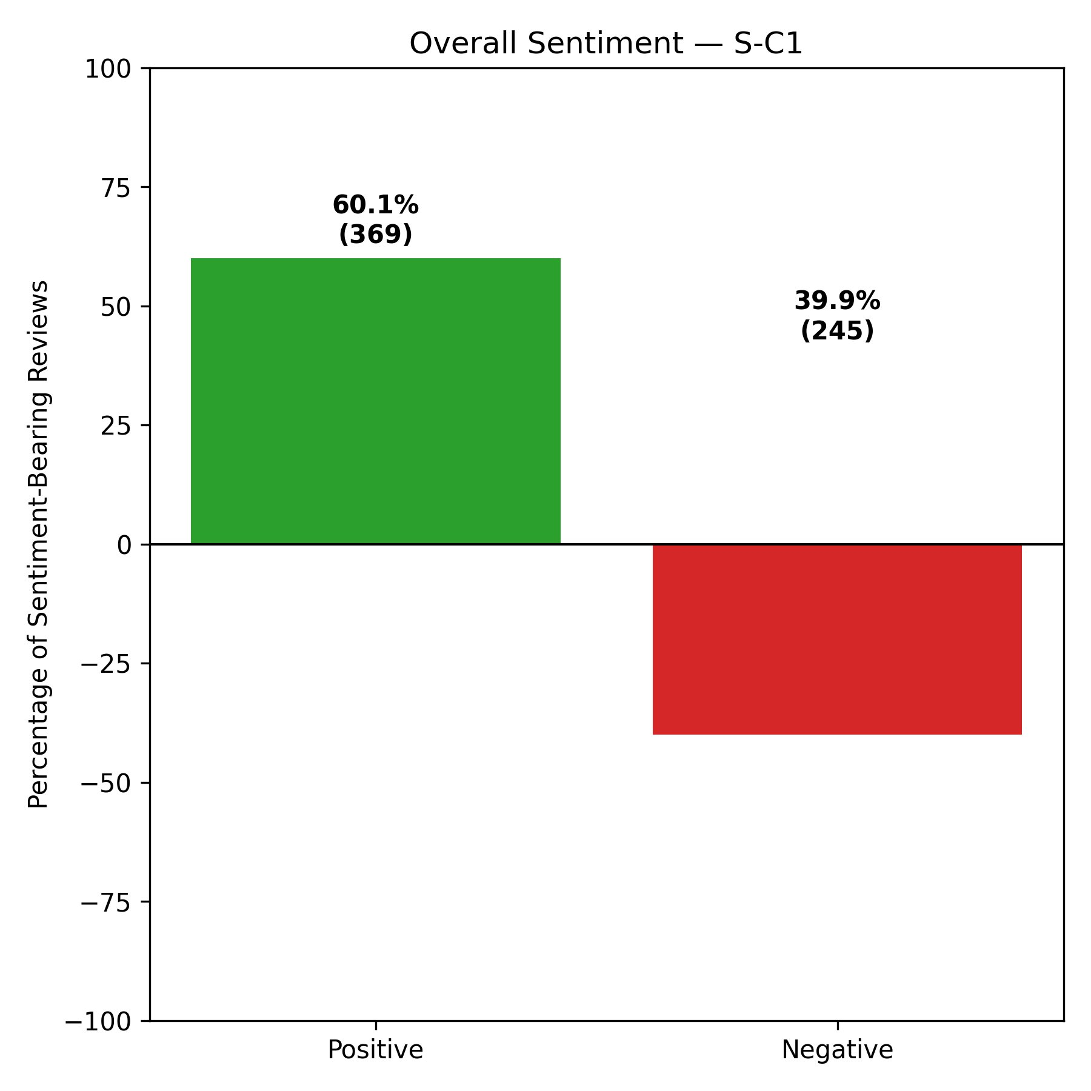
Figure 31: Overall Sentiment — S-C2 (AZ, IN, NJ)
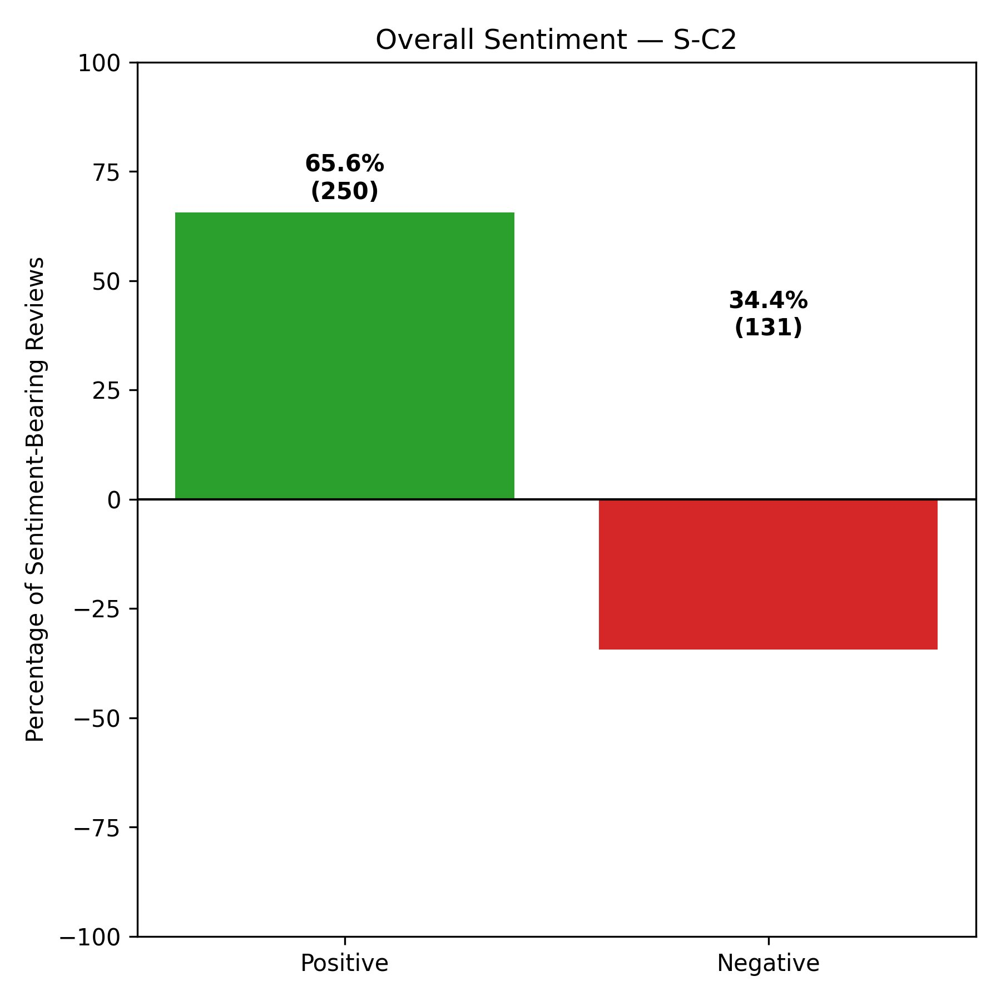
Figure 32: Overall Sentiment — S-C3 (FL, MO)
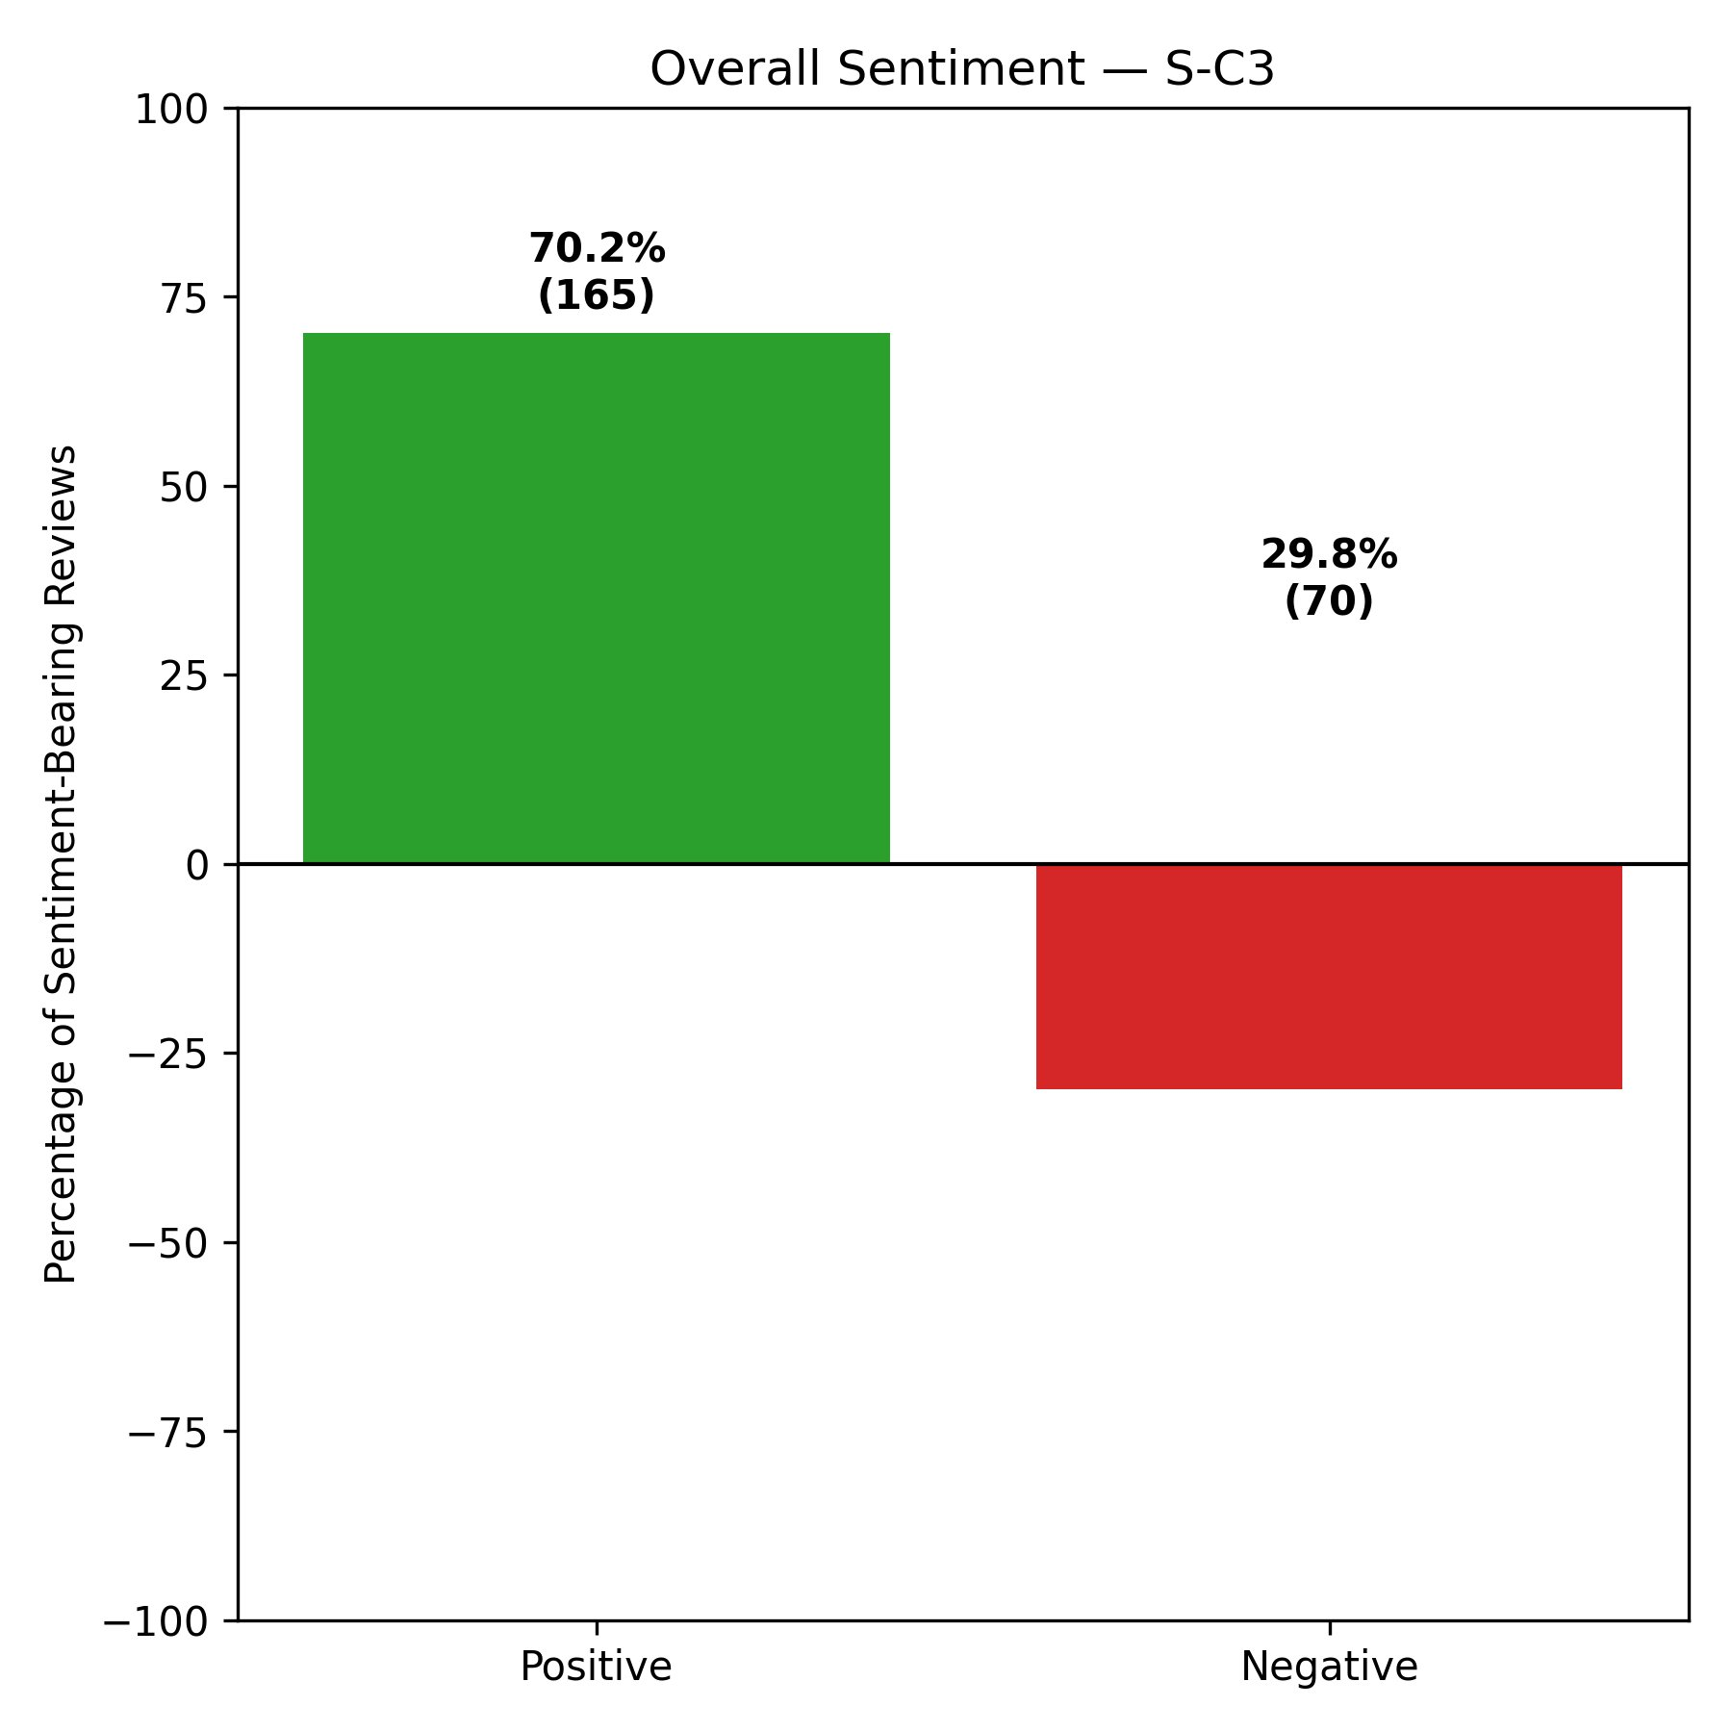
Across all six clusters, positive sentiment was higher than negative sentiment, indicating that most patients who left Yelp reviews with clear sentiment described a generally positive experience with hospital facilities. The highest positive sentiment was observed in S-C3 (Florida and Missouri) at 70.2%, followed by HG-C1 (Arizona, Florida, New Jersey, and Illinois) at 66.2%, and S-C2 (Arizona, Indiana, and New Jersey) at 65.6%. The lowest positive sentiment appeared in S-C1 (Idaho, Illinois, Louisiana, Pennsylvania, and Tennessee) at 60.1% and HG-C2 (Idaho and Tennessee) at 60.6%, and these two clusters also showed the highest negative sentiment levels at 39.9% and 39.4%, respectively. S-C3’s strong positive sentiment also aligns with its dominant position in the LOVE quadrant of the Passion Index, discussed in Section 5.5.4, suggesting that this cluster reflects both a high frequency and a high intensity of positive patient expression.

5.5.2 Attribute Net Score Analysis
The attribute net score analysis examined patient sentiment in more detail by focusing on six healthcare-related dimensions: Effectiveness, Wait Time, Staff, Cleanliness, Cost, and Communication. For each review, relevant keywords were identified using string matching. For example, Effectiveness included terms such as effective, worked, improved, care, and treatment; Wait Time included wait, waiting, delay, and long; Staff included staff, doctor, nurse, rude, and kind; Cleanliness included clean, dirty, and hygiene; Cost included cost, bill, expensive, and insurance; and Communication included explain, communication, and informed. VADER’s compound score was then applied to each matched review, and the result was classified as positive, negative, or neutral using the same thresholds as in the overall sentiment analysis. The Net Score for each attribute was calculated using the formula ((positive − negative) / (positive + negative)) × 100, which represents the percentage difference between positive and negative mentions among matched reviews with clear sentiment. A positive net score indicates that mentions of the attribute were mostly favorable, while a negative net score indicates the opposite.
The net scores for all six attributes across the six clusters are presented in Table 12 and visualized in Figures 33 through 38.
Table 12: Attribute Net Scores (%) — All Clusters
Cluster | Effectiveness | Wait Time | Staff | Cleanliness | Cost | Communication
HG-C1 | 42.50% | 19.10% | 33.80% | 56.80% | -6.70% | 25.00%
HG-C2 | 25.90% | 5.90% | 29.90% | 28.60% | -29.40% | 23.10%
HG-C3 | 30.20% | 7.50% | 23.20% | 50.00% | -3.40% | 16.30%
S-C1 | 27.50% | 3.60% | 24.80% | 38.50% | -16.20% | 7.50%
S-C2 | 39.80% | 23.10% | 30.40% | 55.60% | 13.70% | 21.40%
S-C3 | 43.10% | 19.30% | 34.60% | 72.40% | -6.70% | 37.90%

Two consistent trends appear across all six clusters. First, Cleanliness has the highest positive net score in every cluster, ranging from 28.6% in HG-C2 to 72.4% in S-C3. This shows that patients across all state groupings generally speak positively about cleanliness. S-C3 is especially notable, with a Cleanliness net score nearly 17 percentage points higher than any other cluster. S-C2 also performs strongly on both Cleanliness and Effectiveness, which fits with its overall higher positive sentiment profile. Second, Cost is the only attribute with a negative net score in five of the six clusters, suggesting that patients usually speak unfavorably about the financial side of their hospital experience. The most negative Cost score appears in HG-C2 (Idaho and Tennessee) at -29.4%, which is far lower than any other cluster. S-C2 is the only exception, with a positive Cost net score of 13.7%, suggesting that patients in Arizona, Indiana, and New Jersey view the cost of care more favorably than those in the other clusters.

5.5.3 Emotion Analysis
The emotion analysis was performed using NRCLex, a Python library built on the NRC Word-Emotion Association Lexicon, also known as EmoLex, developed by Saif Mohammad and Peter Turney. The NRC Lexicon contains more than 14,000 English words, and each word is associated with one or more of eight basic emotions — anger, anticipation, disgust, fear, joy, sadness, surprise, and trust — as well as positive or negative sentiment. NRCLex works by breaking each review into tokens, checking them against the NRC Lexicon, and counting how often each emotion appears across all reviews in a cluster. These raw emotion counts were obtained through the library’s raw_emotion_scores attribute, which returns the count for each emotion in the processed text.
For each cluster, two plots were created: one showing the total count of emotion-related words and another showing the proportion of each emotion as a percentage of the total emotion count. The second plot makes it easier to compare clusters of different sizes. Figures 39 through 44 show the emotion count charts, and Figures 45 through 50 show the emotion distribution percentage charts.
Figure 39: Emotion Counts — HG-C1 (AZ, FL, NJ, IL)
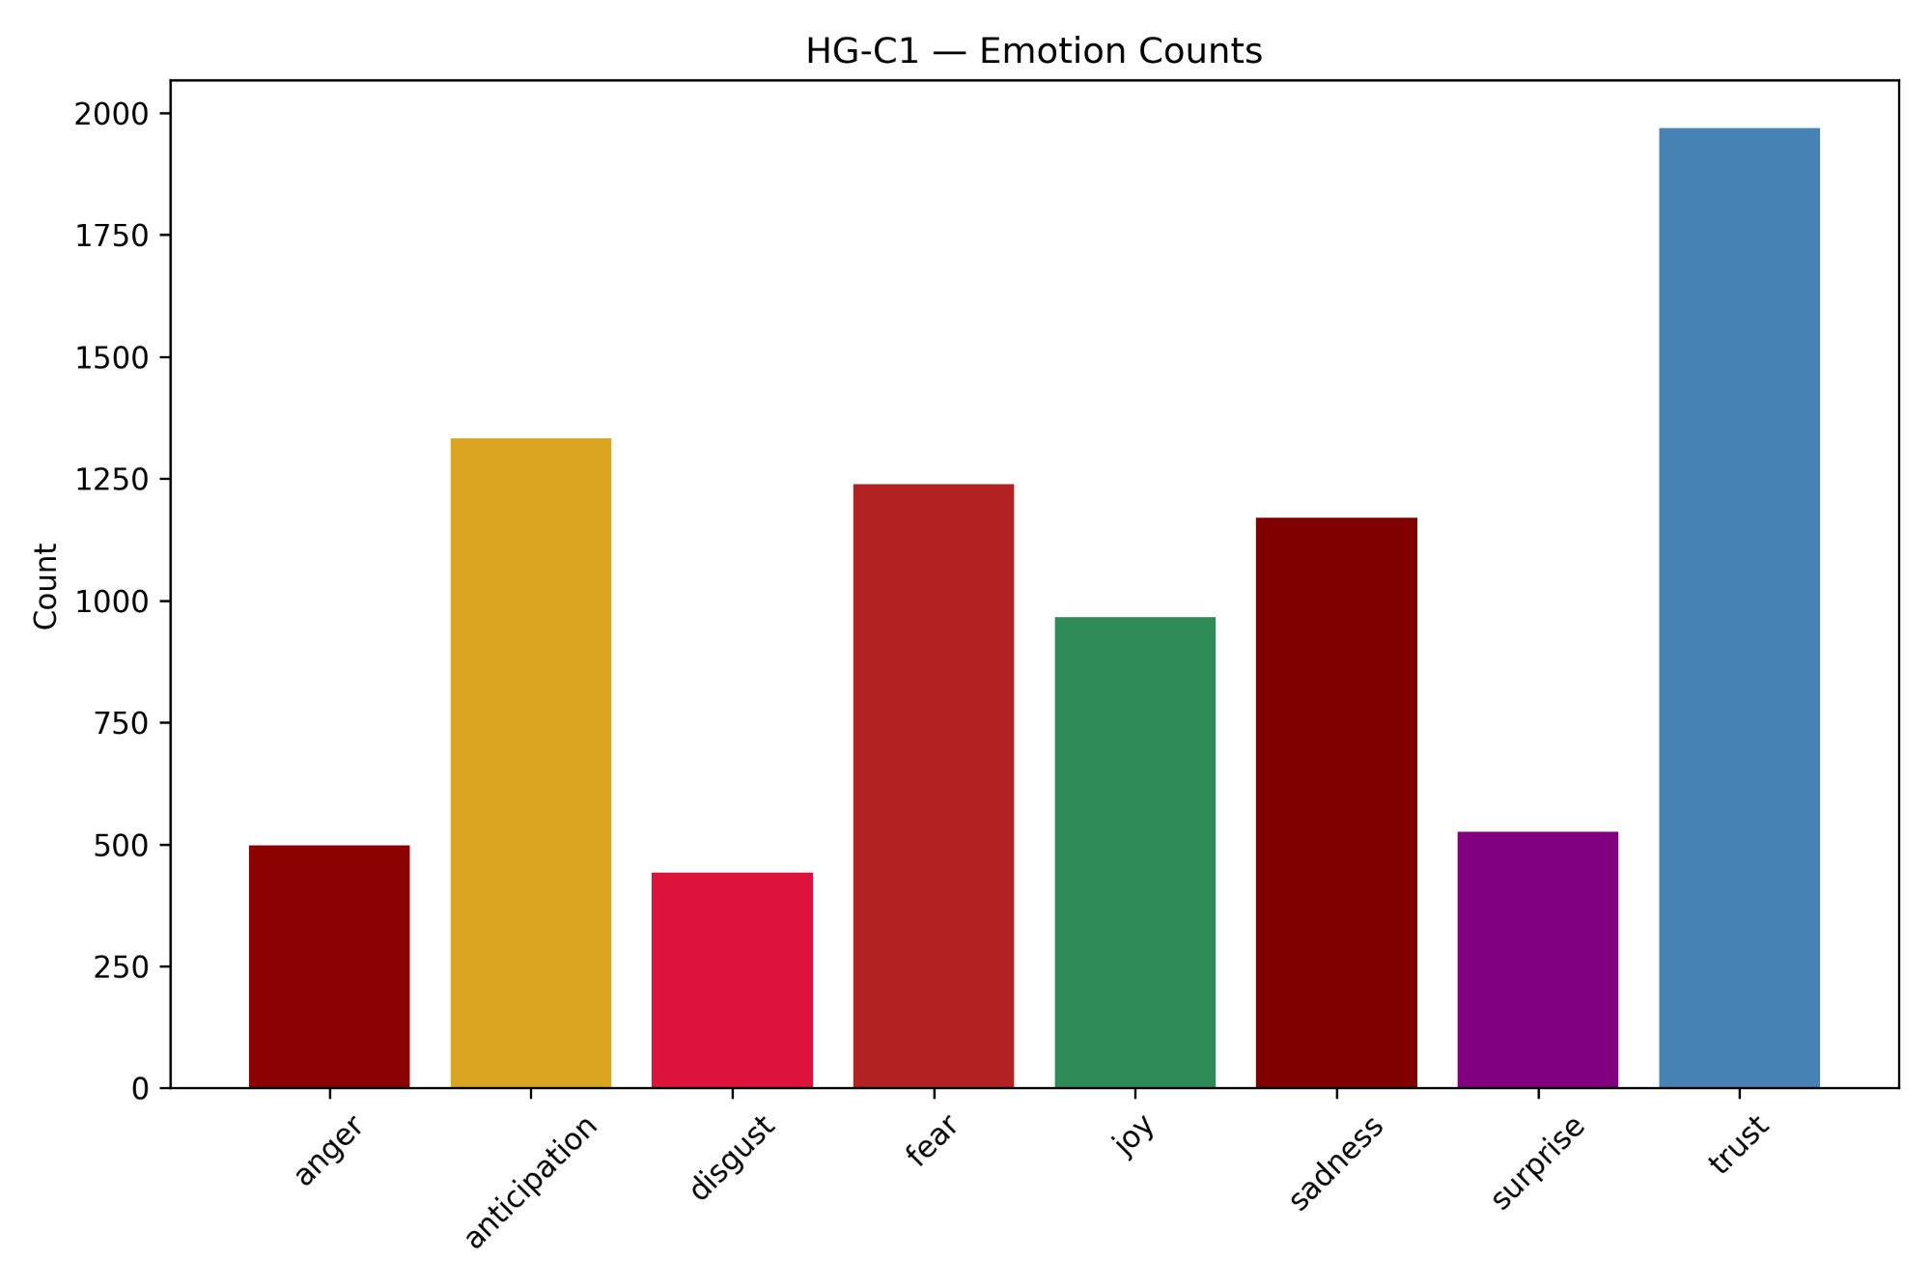
Figure 40: Emotion Counts — HG-C2 (ID, TN)
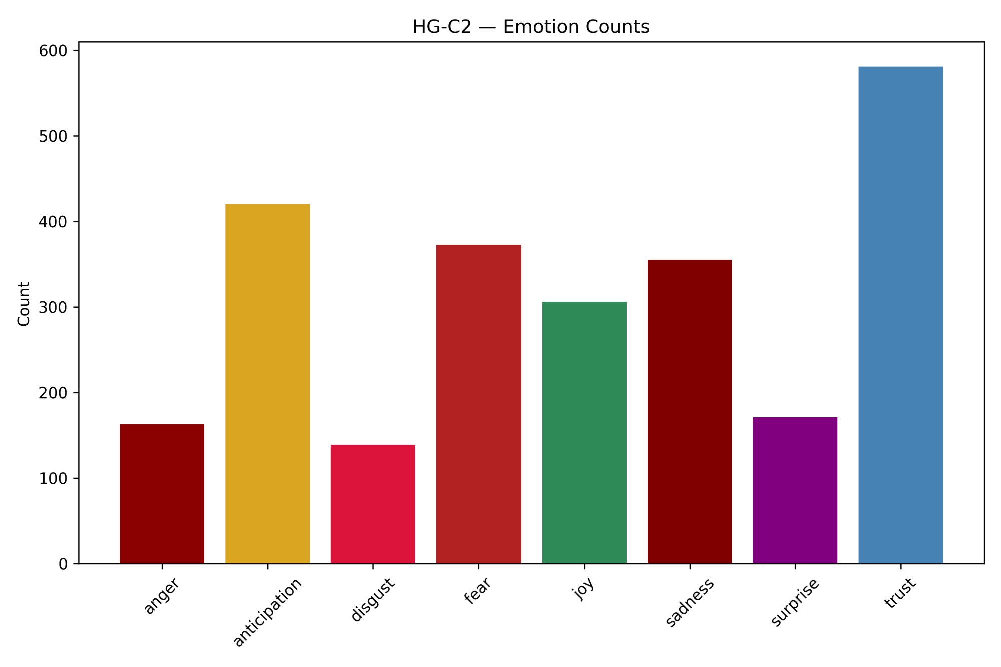
Figure 41: Emotion Counts — HG-C3 (IN, PA, MO, LA)
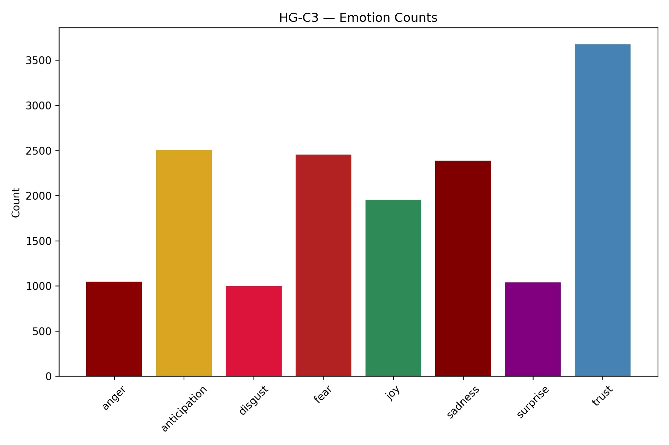
Figure 42: Emotion Counts — S-C1 (ID, IL, LA, PA, TN)
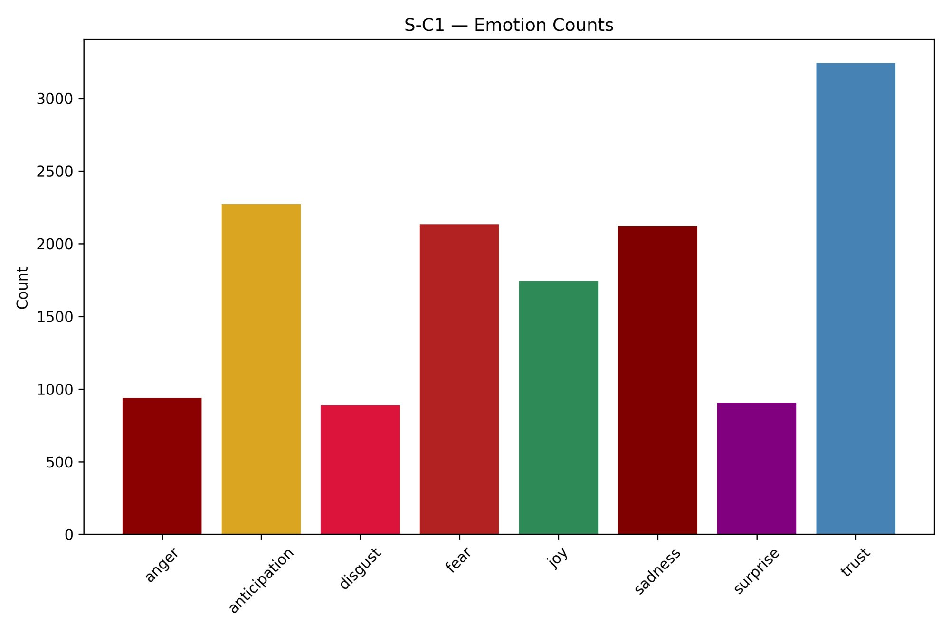
Figure 43: Emotion Counts — S-C2 (AZ, IN, NJ)
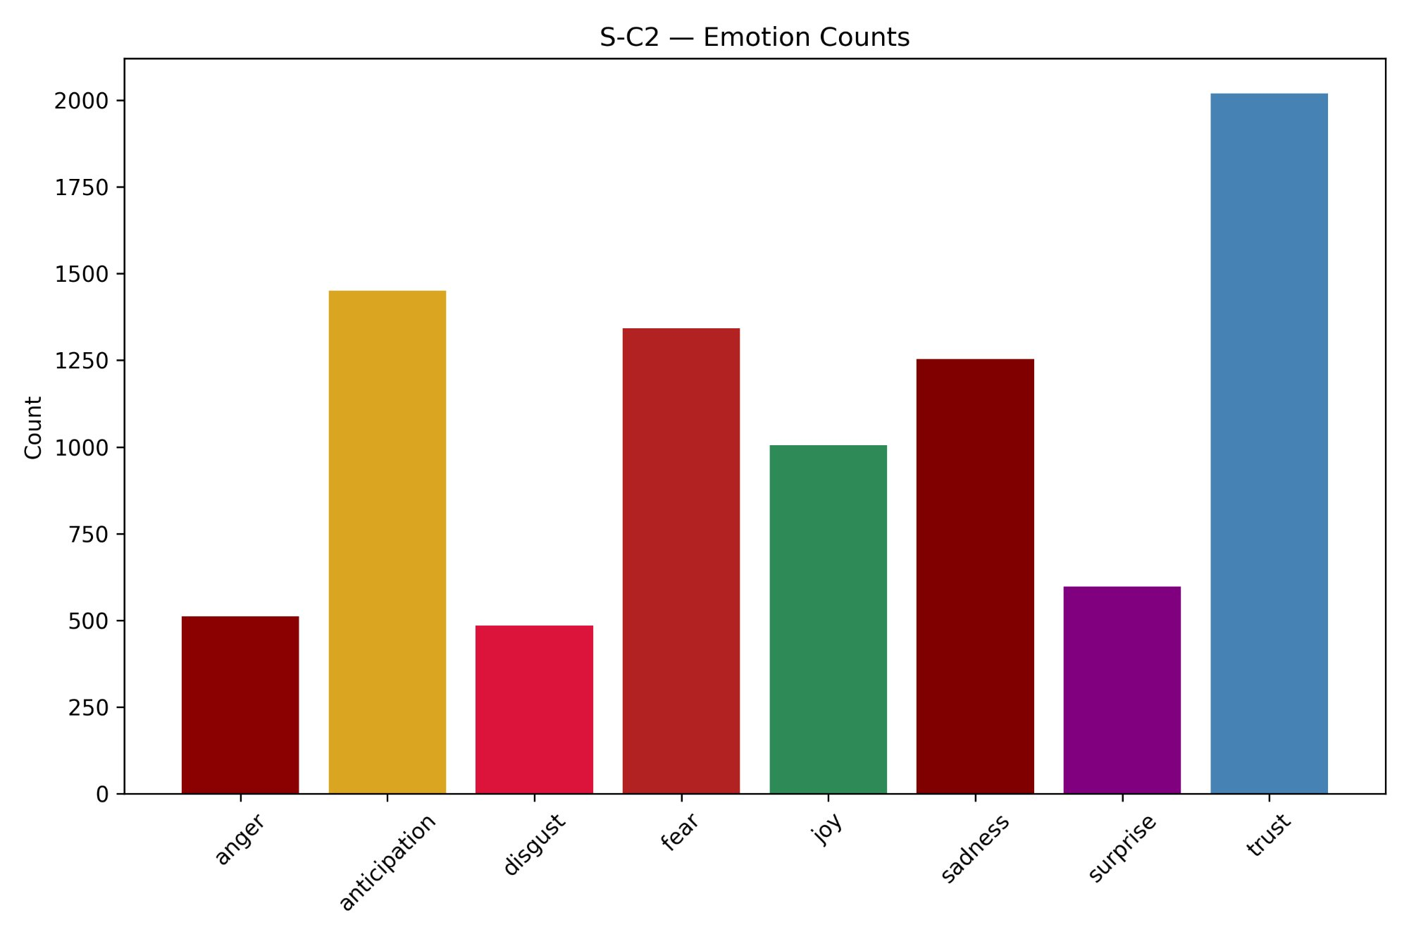
Figure 44: Emotion Counts — S-C3 (FL, MO)
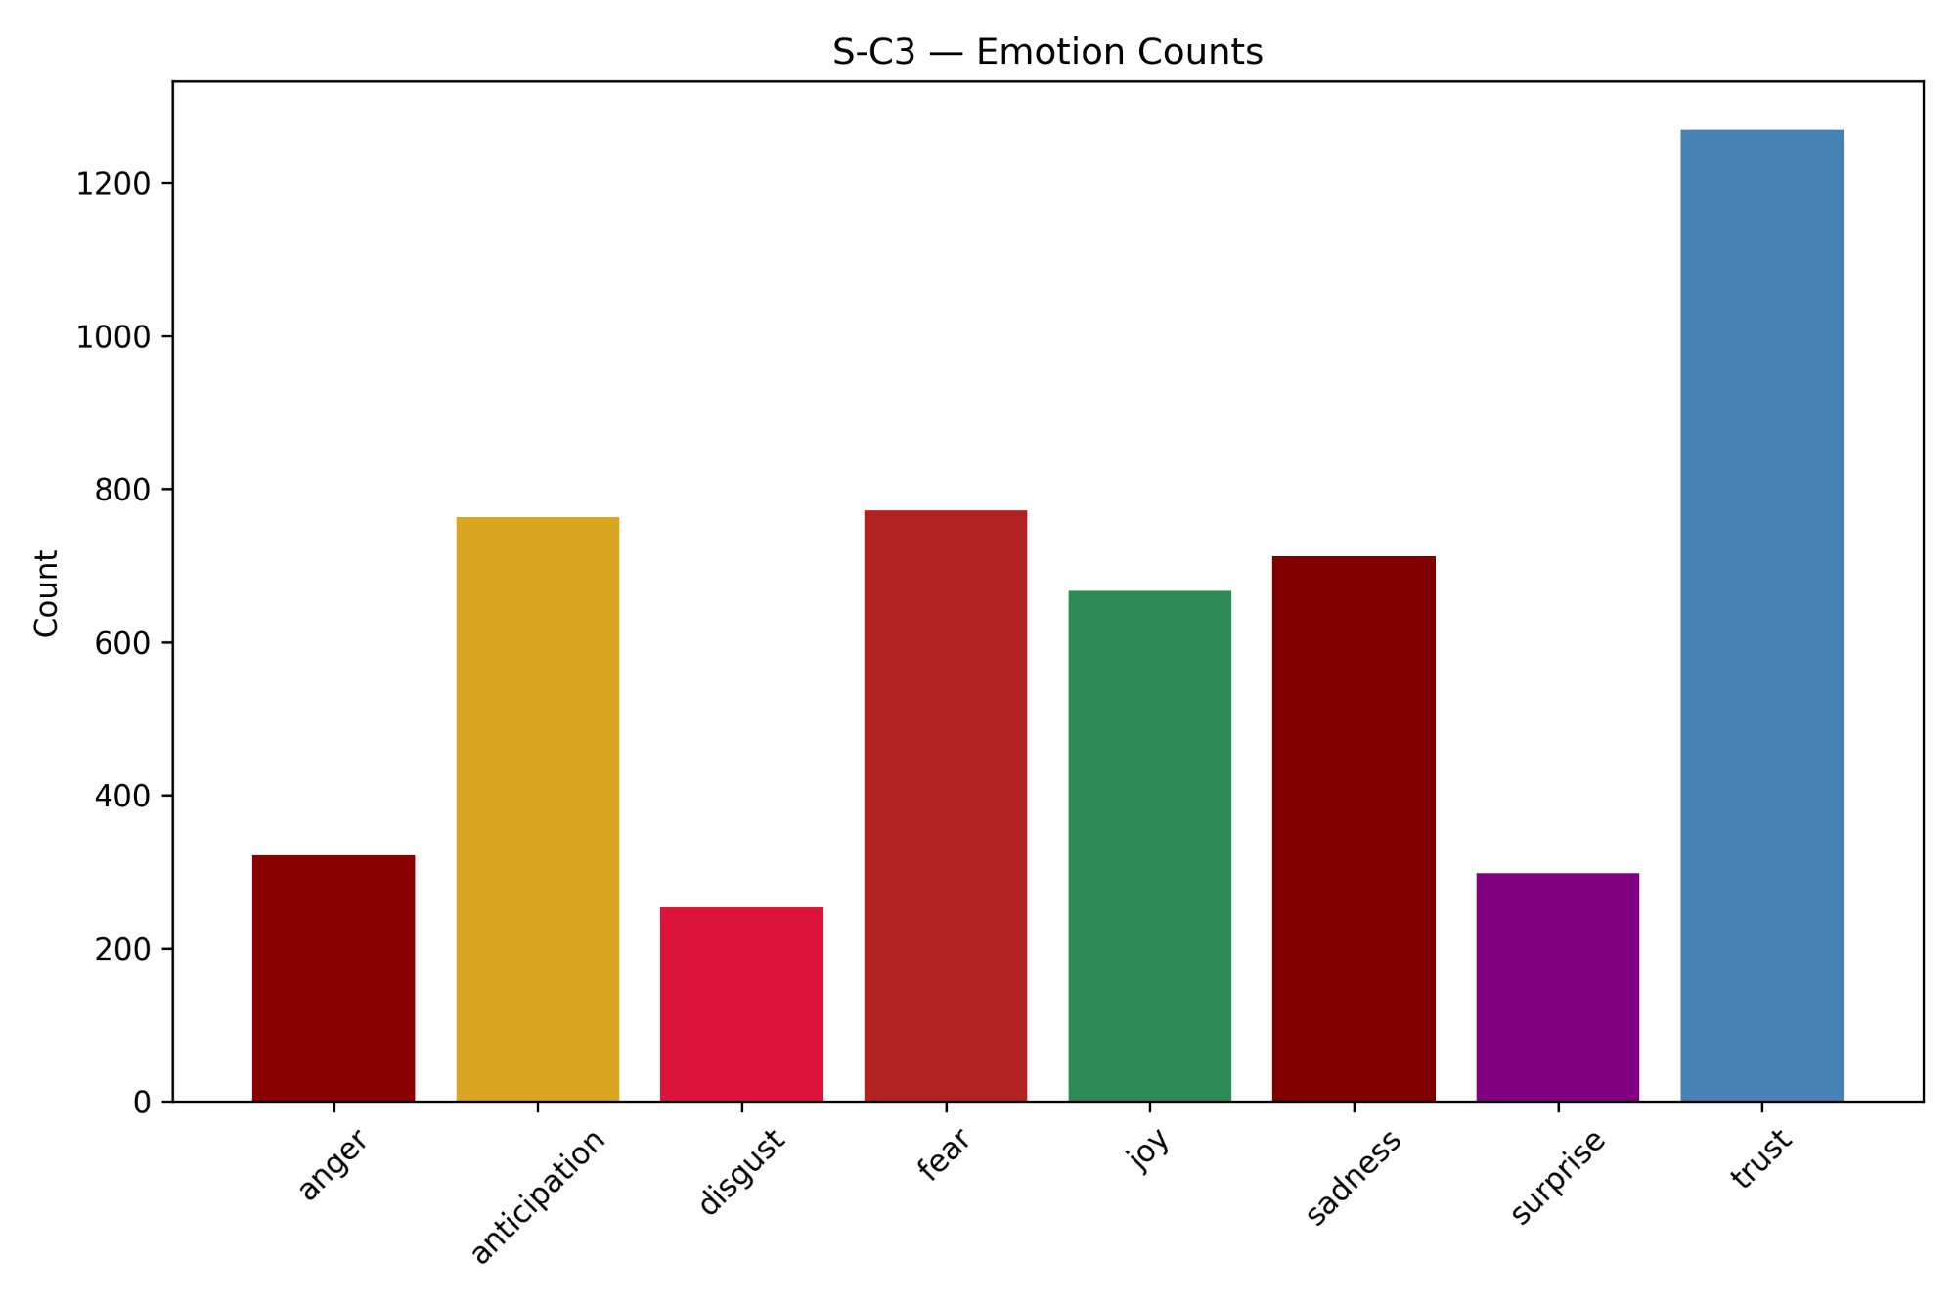
Figure 45: Emotion Distribution — HG-C1 (AZ, FL, NJ, IL)
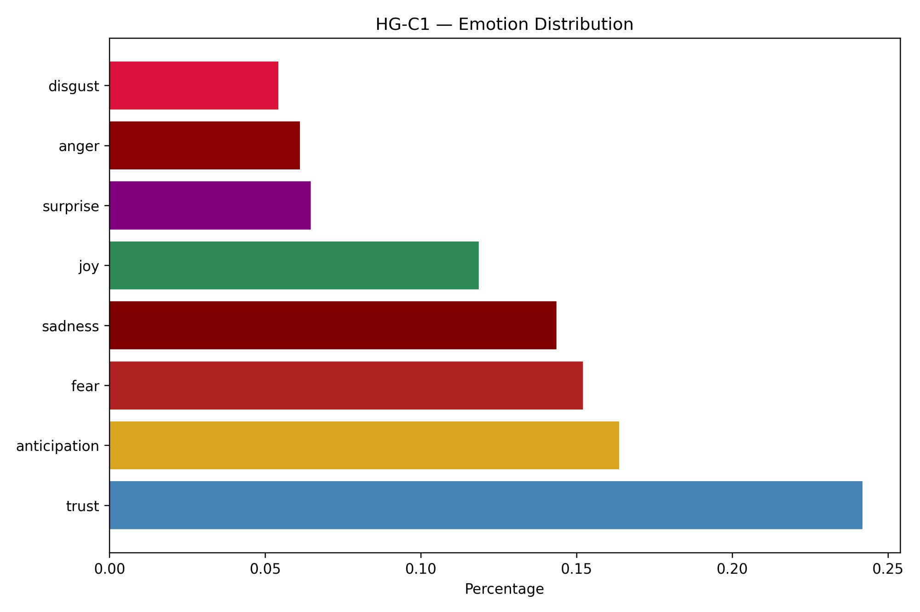
Figure 46: Emotion Distribution — HG-C2 (ID, TN)
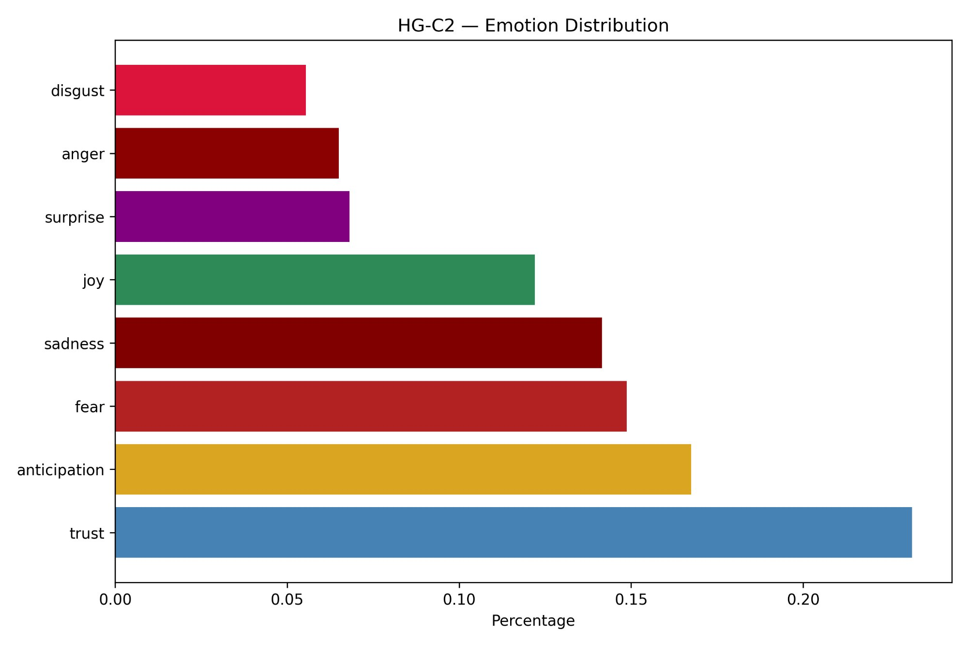
Figure 47: Emotion Distribution — HG-C3 (IN, PA, MO, LA)
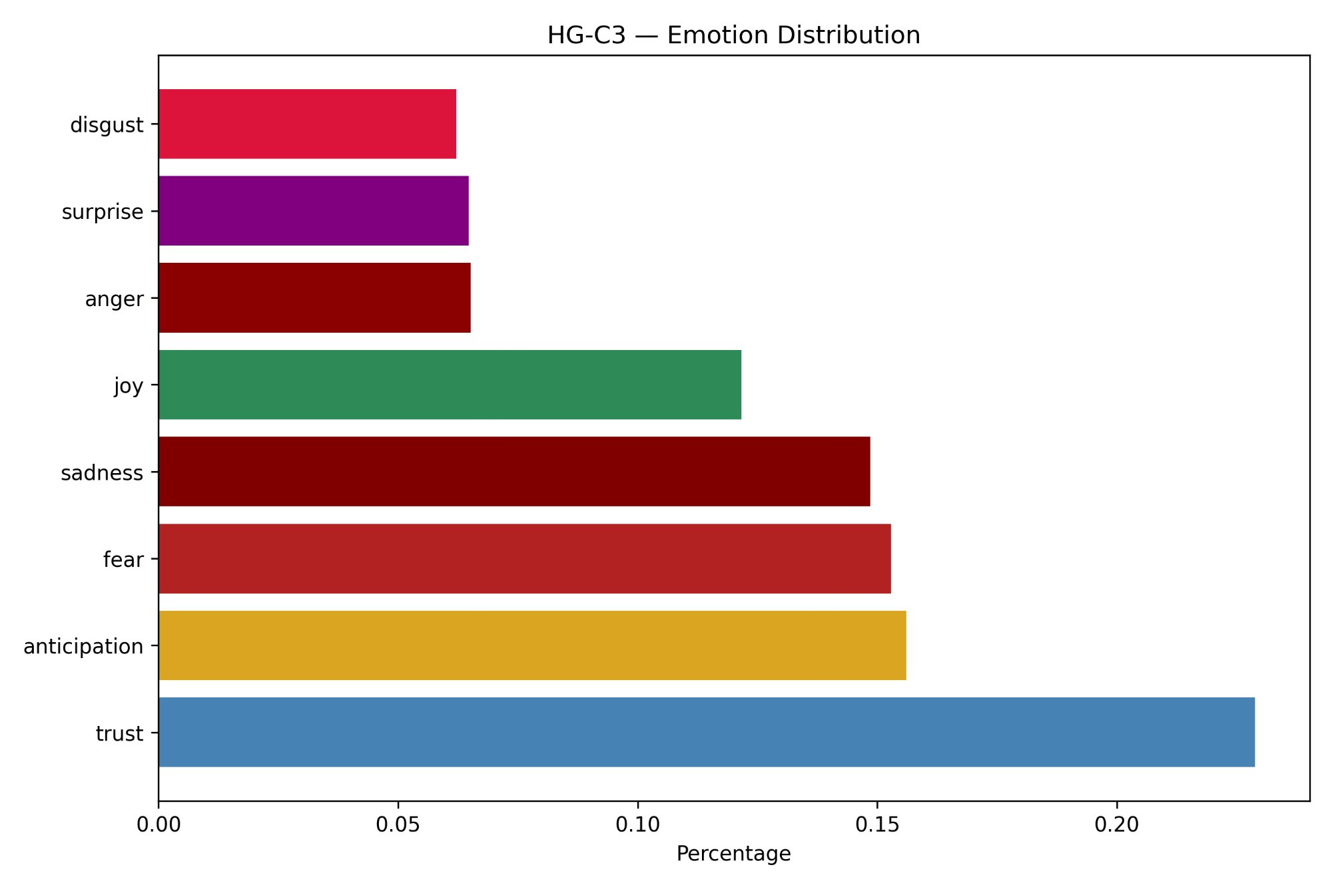
Figure 48: Emotion Distribution — S-C1 (ID, IL, LA, PA, TN)
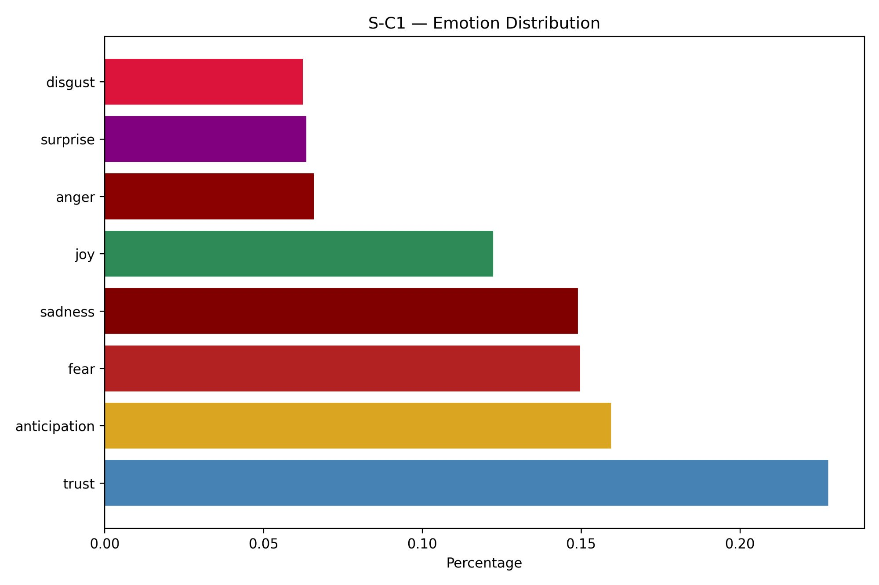
Figure 49: Emotion Distribution — S-C2 (AZ, IN, NJ)
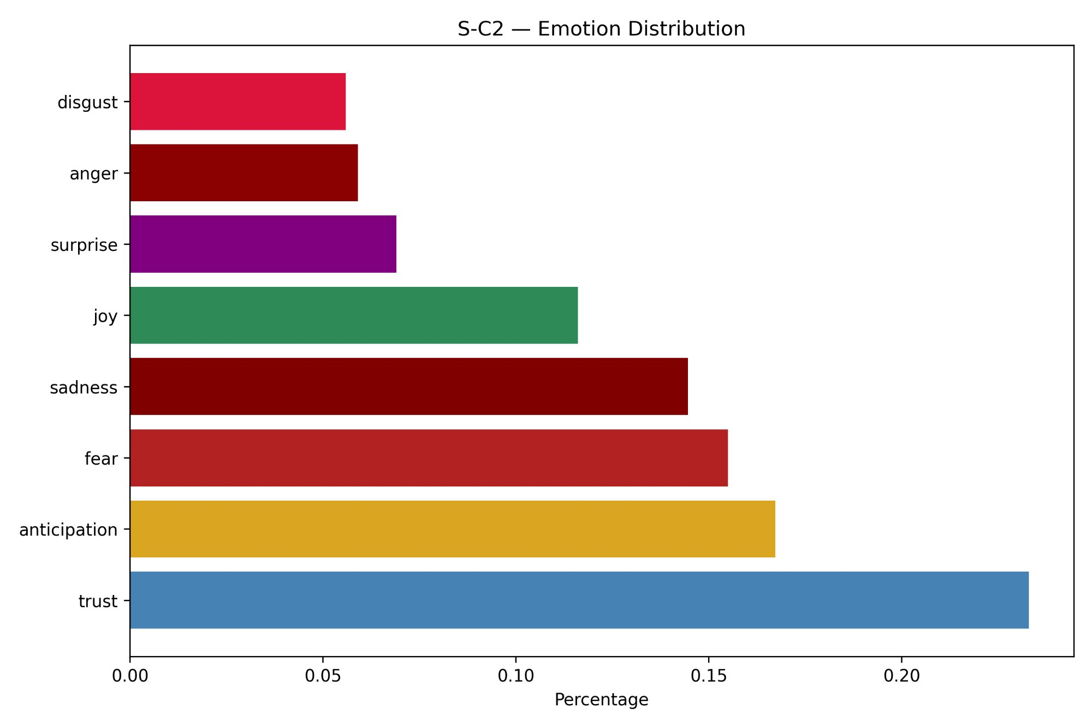
Figure 50: Emotion Distribution — S-C3 (FL, MO)
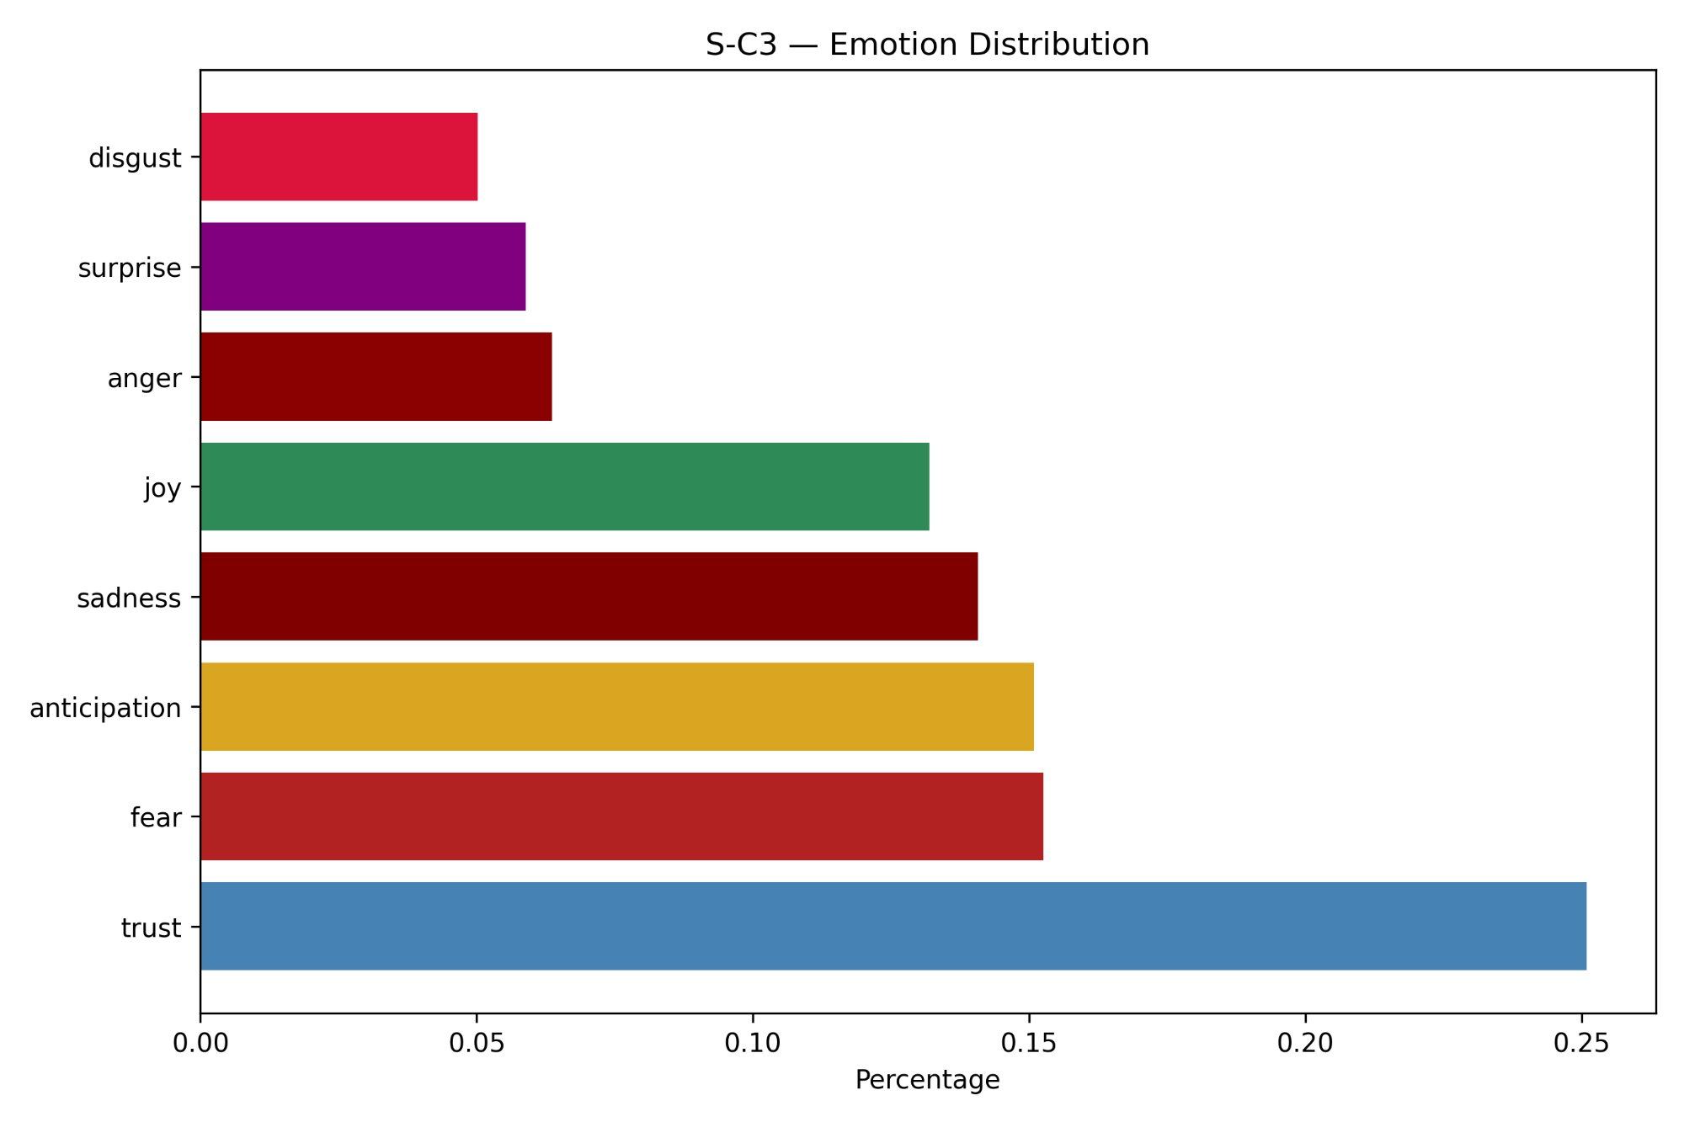
The emotional pattern is very similar across all six clusters. In every cluster, trust is the most common emotion, followed by anticipation, while fear and sadness also appear at relatively high levels. Joy remains close to 12% across all clusters, and anger, surprise, and disgust stay lower at around 5% to 7%. Overall, the order of emotions is nearly the same in all six clusters, with only small differences in their proportions.
S-C3 (Florida and Missouri) stands out with the highest trust level and the lowest disgust level, making it the most emotionally positive cluster overall. This is consistent with its strong overall sentiment results and its position in the LOVE quadrant of the Passion Index. At the same time, fear and sadness remain high in every cluster, together making up about 29% to 30% of all emotion words. This reflects the emotional weight of healthcare experiences, where patients often express anxiety, concern, and vulnerability whether their reviews are positive or negative overall. This is an important finding because it shows that even positive healthcare reviews often include fear and sadness, which reflects the uncertainty and stress associated with illness and treatment.

5.5.4 Passion Index
The Passion Index is a two-dimensional framework that shows both the direction and the strength of patient sentiment for each cluster. Each cluster is plotted on a bubble chart using two VADER-based measures: the average compound score, shown on the Y-axis, and the average absolute compound score, shown on the X-axis. The bubble size is based on the square root of the total number of reviews, so larger bubbles represent clusters with more reviews.
Two crosshair lines divide the chart into four quadrants. Following importance-performance analysis approaches used in healthcare research, the crosshair lines were placed at the mean values of the plotted metrics instead of fixed midpoint values. This approach follows Carse et al. (2021), who used mean values as the cross-point for quadrant division because that better reflects the actual data distribution than an arbitrary midpoint. The four quadrants were labeled LIKE, LOVE, DISLIKE, and HATE based on combinations of sentiment polarity and intensity.
Figure 51: Passion Index — Cluster-wise Sentiment Positioning (Mean-Based Crosshairs)
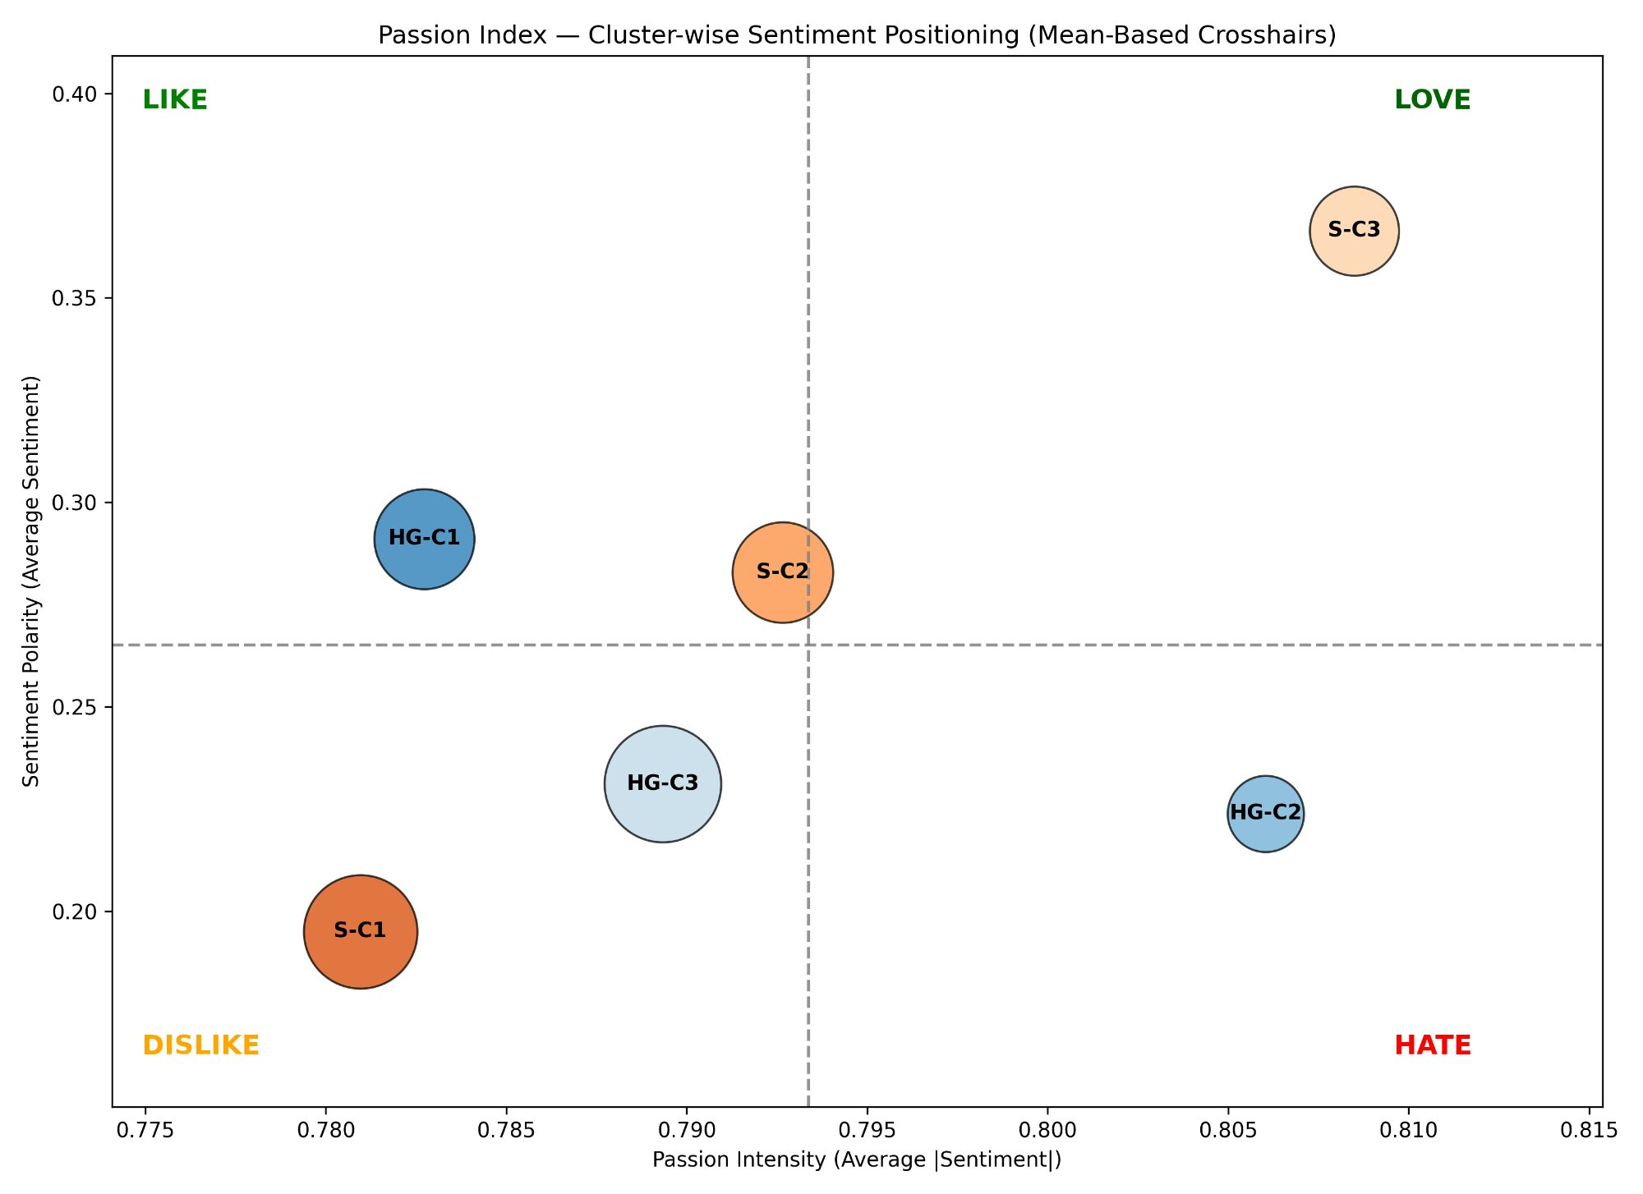
The Passion Index plot highlights clear differences among the six clusters. S-C3 (Florida and Missouri) is located in the LOVE quadrant and has both the highest polarity (approximately 0.37) and above-average intensity (approximately 0.808). This shows that patients in this cluster not only express positive sentiment, but do so with strong emotional intensity as well. This is the most desirable quadrant position and matches S-C3’s strong performance across the other text mining analyses, including the highest overall positive sentiment, the highest Cleanliness net score, and the highest trust proportion in the emotion analysis.
HG-C1 (Arizona, Florida, New Jersey, and Illinois) and S-C2 (Arizona, Indiana, and New Jersey) both fall in the LIKE quadrant or near the boundary with LOVE, showing positive sentiment that is somewhat less intense. S-C2 sits almost exactly at the center of the plot, while HG-C1 shows positive sentiment with lower intensity, suggesting that reviews in this cluster are more restrained in tone. HG-C3 (Indiana, Pennsylvania, Missouri, and Louisiana) falls in the DISLIKE quadrant, indicating below-average polarity and intensity and a more mixed sentiment profile. S-C1 (Idaho, Illinois, Louisiana, Pennsylvania, and Tennessee) is also located in the DISLIKE quadrant and has the lowest polarity of all clusters, which matches its lowest overall positive sentiment percentage. HG-C2 (Idaho and Tennessee) falls in the HATE quadrant, meaning that its reviews are more negative in direction but also more emotionally intense. This fits with its strongly negative Cost net score of -29.4% in the attribute analysis.

5.5.5 Word Association Networks
The word association network analysis looked at which words appeared together in the same reviews across each cluster, helping to visualize the thematic connections patients made when describing their hospital experiences. Three Python libraries were used for this analysis: spaCy, NetworkX, and Matplotlib.
spaCy is a widely used natural language processing library that includes pre-trained language models for English. In this analysis, its en_core_web_sm model was used to process each review through tokenization, part-of-speech tagging, lemmatization, and named entity recognition. Only nouns, adjectives, and verbs were kept because they carry most of the meaningful content of the reviews. Stop words, punctuation, and named entities were removed so that the final vocabulary reflected the main themes rather than incidental details. Each word was also reduced to its base form, so that variants such as waited and waiting were treated as the same token.
NetworkX is a Python library for building and analyzing graphs and networks. Here, it was used to create an undirected weighted graph in which each node represents a word that appears frequently enough in the cluster’s reviews, with a minimum threshold of ten occurrences. Edges show when two words appear together in the same reviews. Their weights reflect how strongly the words are associated, based on how often they co-occur relative to the total number of reviews in the cluster. To keep the network readable, only the top thirty strongest edges were retained. The spring layout algorithm was used to position the nodes, with more strongly connected words appearing closer to the center.
Figures 52 through 57 show the word association networks for all six clusters.
Figure 52: Word Association Network — HG-C1 (AZ, FL, NJ, IL)
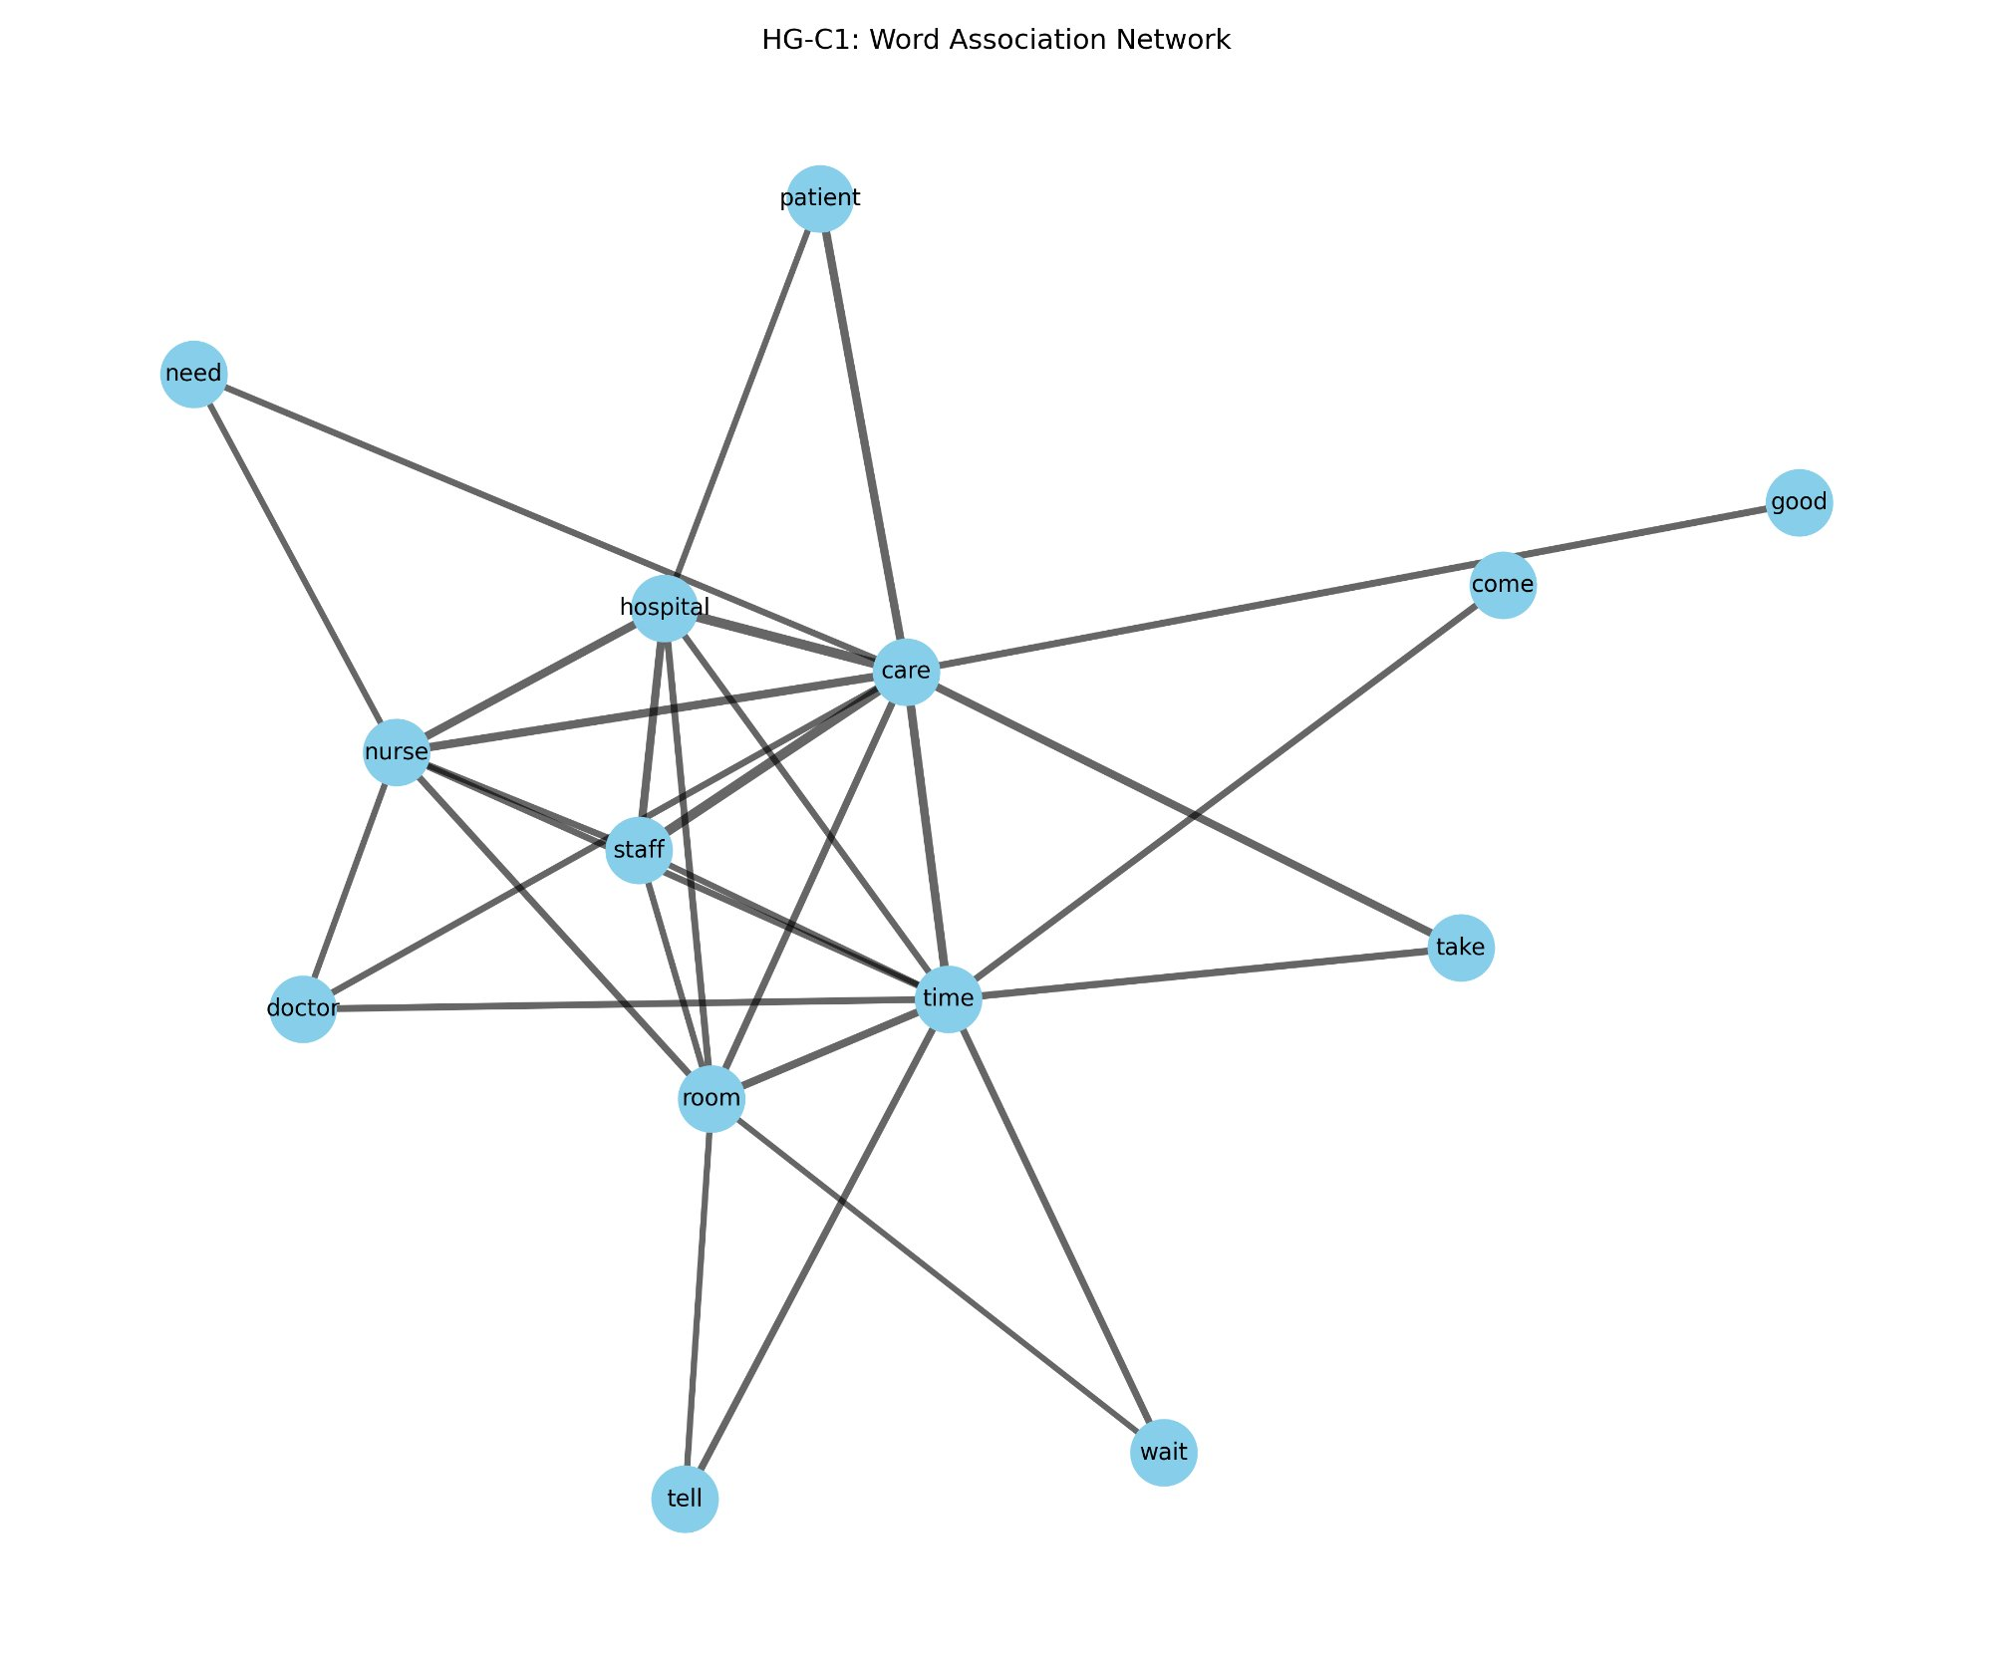

Figure 53: Word Association Network — HG-C2 (ID, TN)

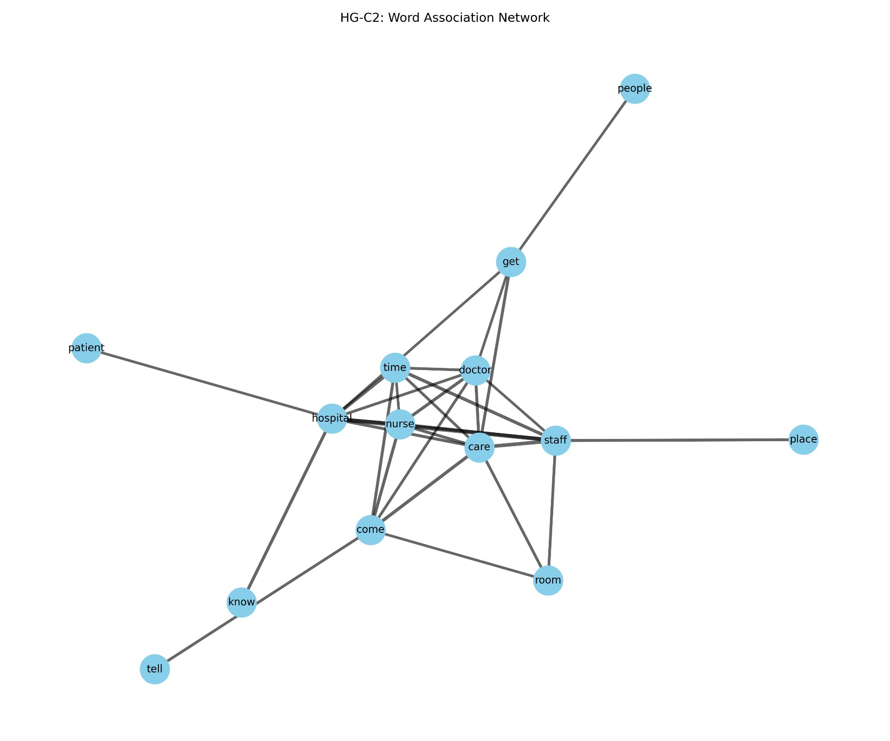

Figure 54: Word Association Network — HG-C3 (IN, PA, MO, LA)

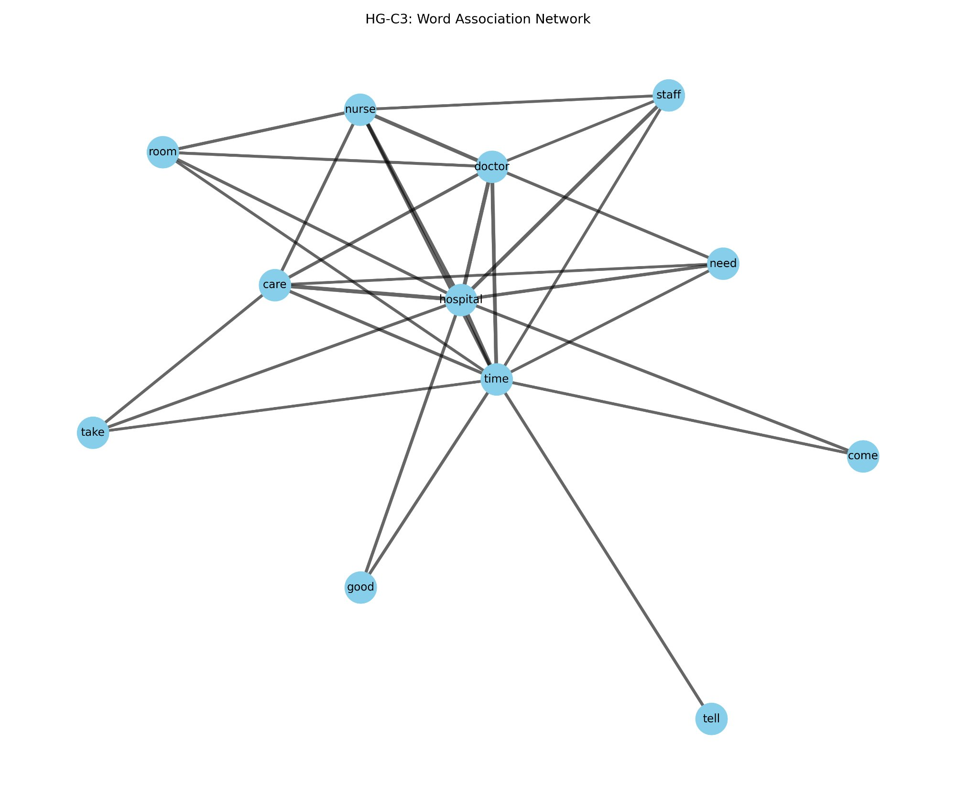

Figure 55: Word Association Network — S-C1 (ID, IL, LA, PA, TN)

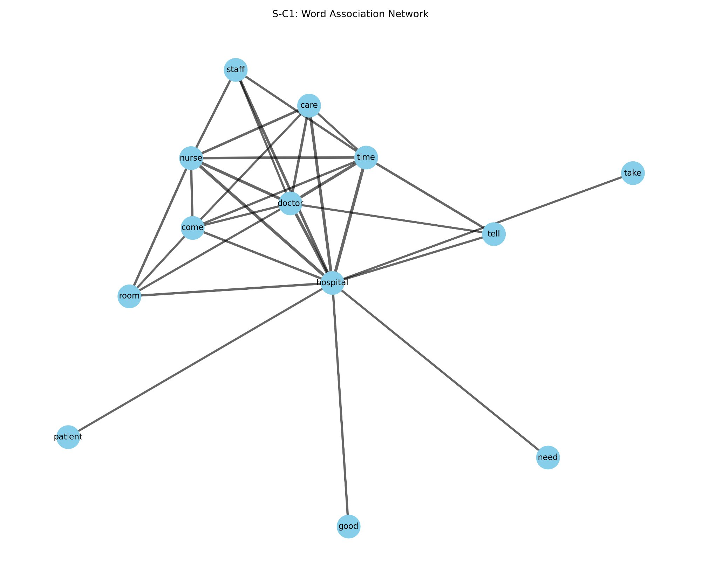

Figure 56: Word Association Network — S-C2 (AZ, IN, NJ)

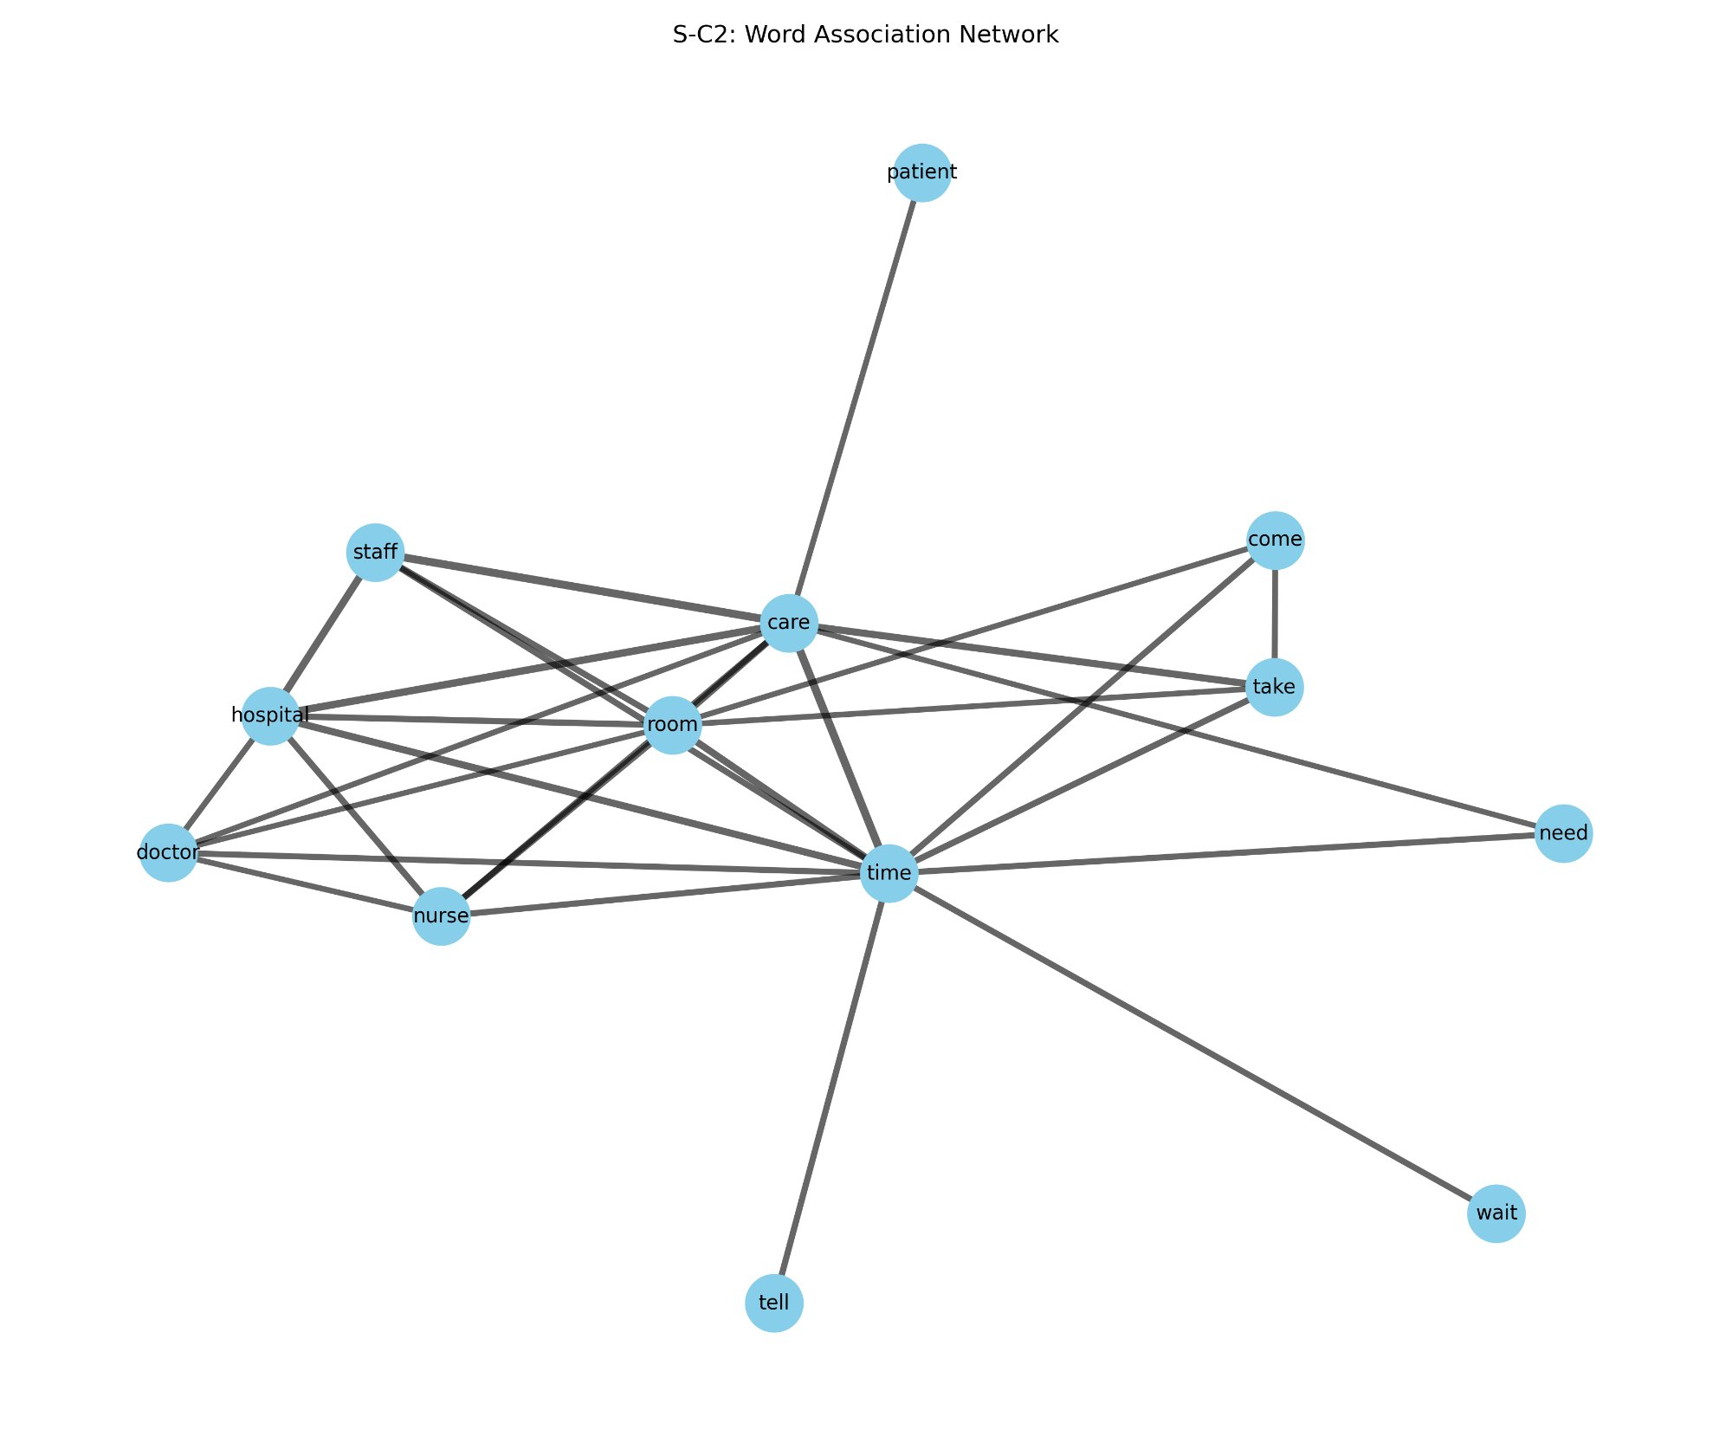

Figure 57: Word Association Network — S-C3 (FL, MO)

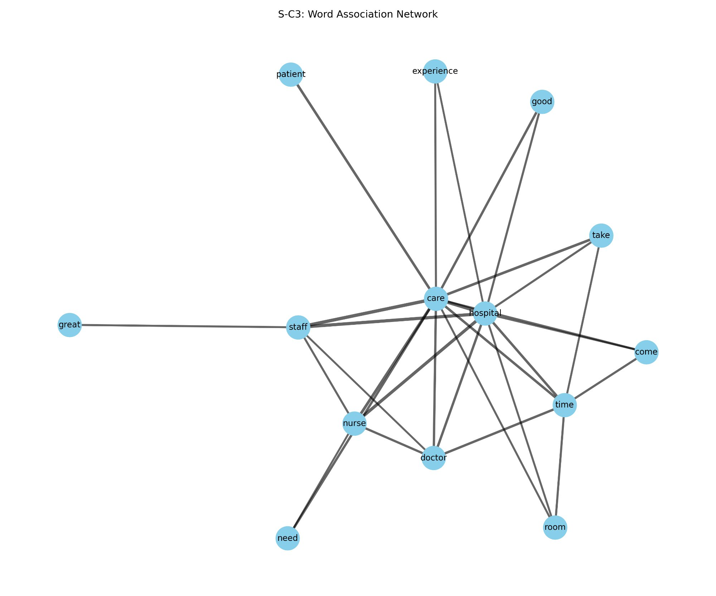
The word association networks show that all six clusters share a common core vocabulary. Words such as hospital, care, staff, nurse, doctor, time, and room appear at the center of every cluster, showing that patients consistently focus on the hospital itself, the staff, the care they received, the time involved, and the physical environment. This consistency is expected, since all of the reviews relate to hospital experiences.
The main differences between clusters can be seen in the less central words and in how strongly certain words are connected. S-C3 (Florida and Missouri) is the only cluster where words like great, experience, and good appear as connected nodes alongside the main clinical terms, highlighting the more clearly positive language used in its reviews. HG-C2 (Idaho and Tennessee) stands out because the word place appears as a connected node, which may mean that patients in this cluster talk more directly about the hospital’s physical setting. The word wait appears in the networks of HG-C1 and S-C2, showing that waiting time is an important concern in those clusters.
5.5.6 Word Clouds
Word clouds were created for each cluster to provide a visual overview of the most frequently used words in the review corpus, with larger words representing higher frequency. They were generated using the WordCloud Python library, together with NLTK’s stopword list and WordNetLemmatizer for preprocessing. Each review was cleaned by converting it to lowercase, removing non-alphabetic characters, filtering out stopwords, and lemmatizing all tokens before combining the text for each cluster. The WordCloud library then counted the word frequencies in the combined text and displayed up to 150 unique words using the tab10 color palette on a white background. Figures 58 through 63 show the word clouds for all six clusters.
Figure 58: Word Cloud — HG-C1 (AZ, FL, NJ, IL)
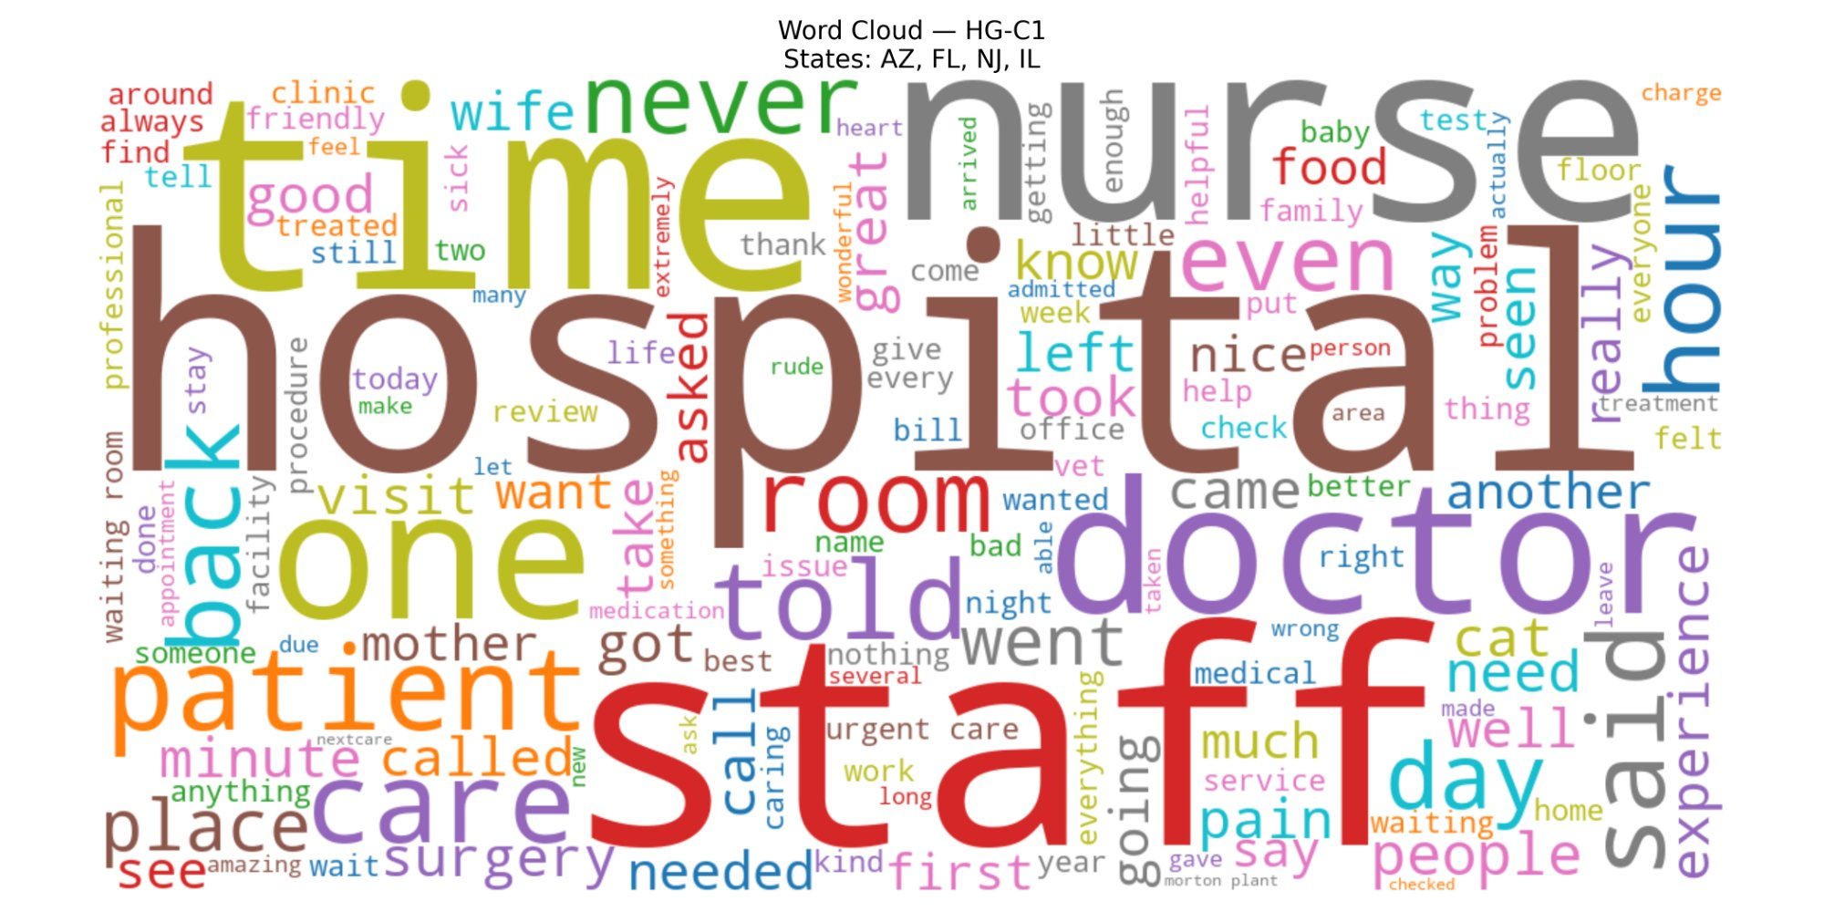
Figure 59: Word Cloud — HG-C2 (ID, TN)
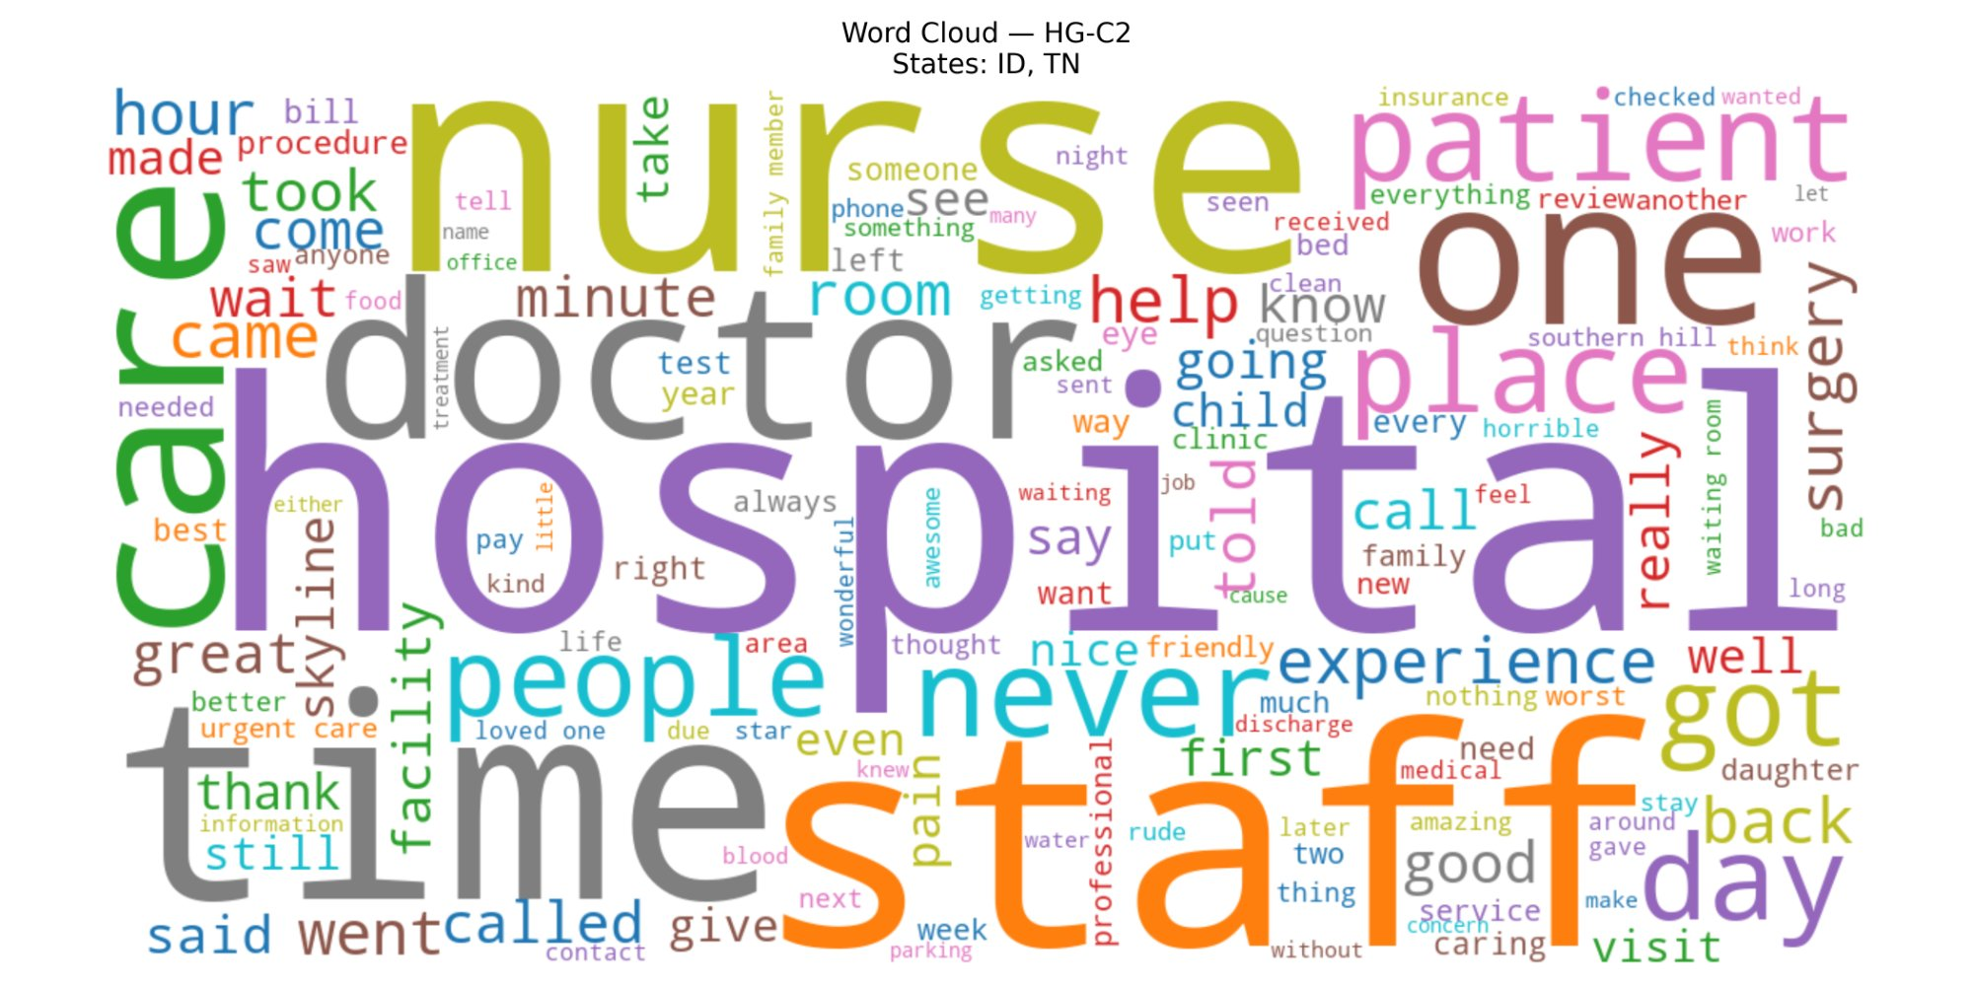
Figure 60: Word Cloud — HG-C3 (IN, PA, MO, LA)
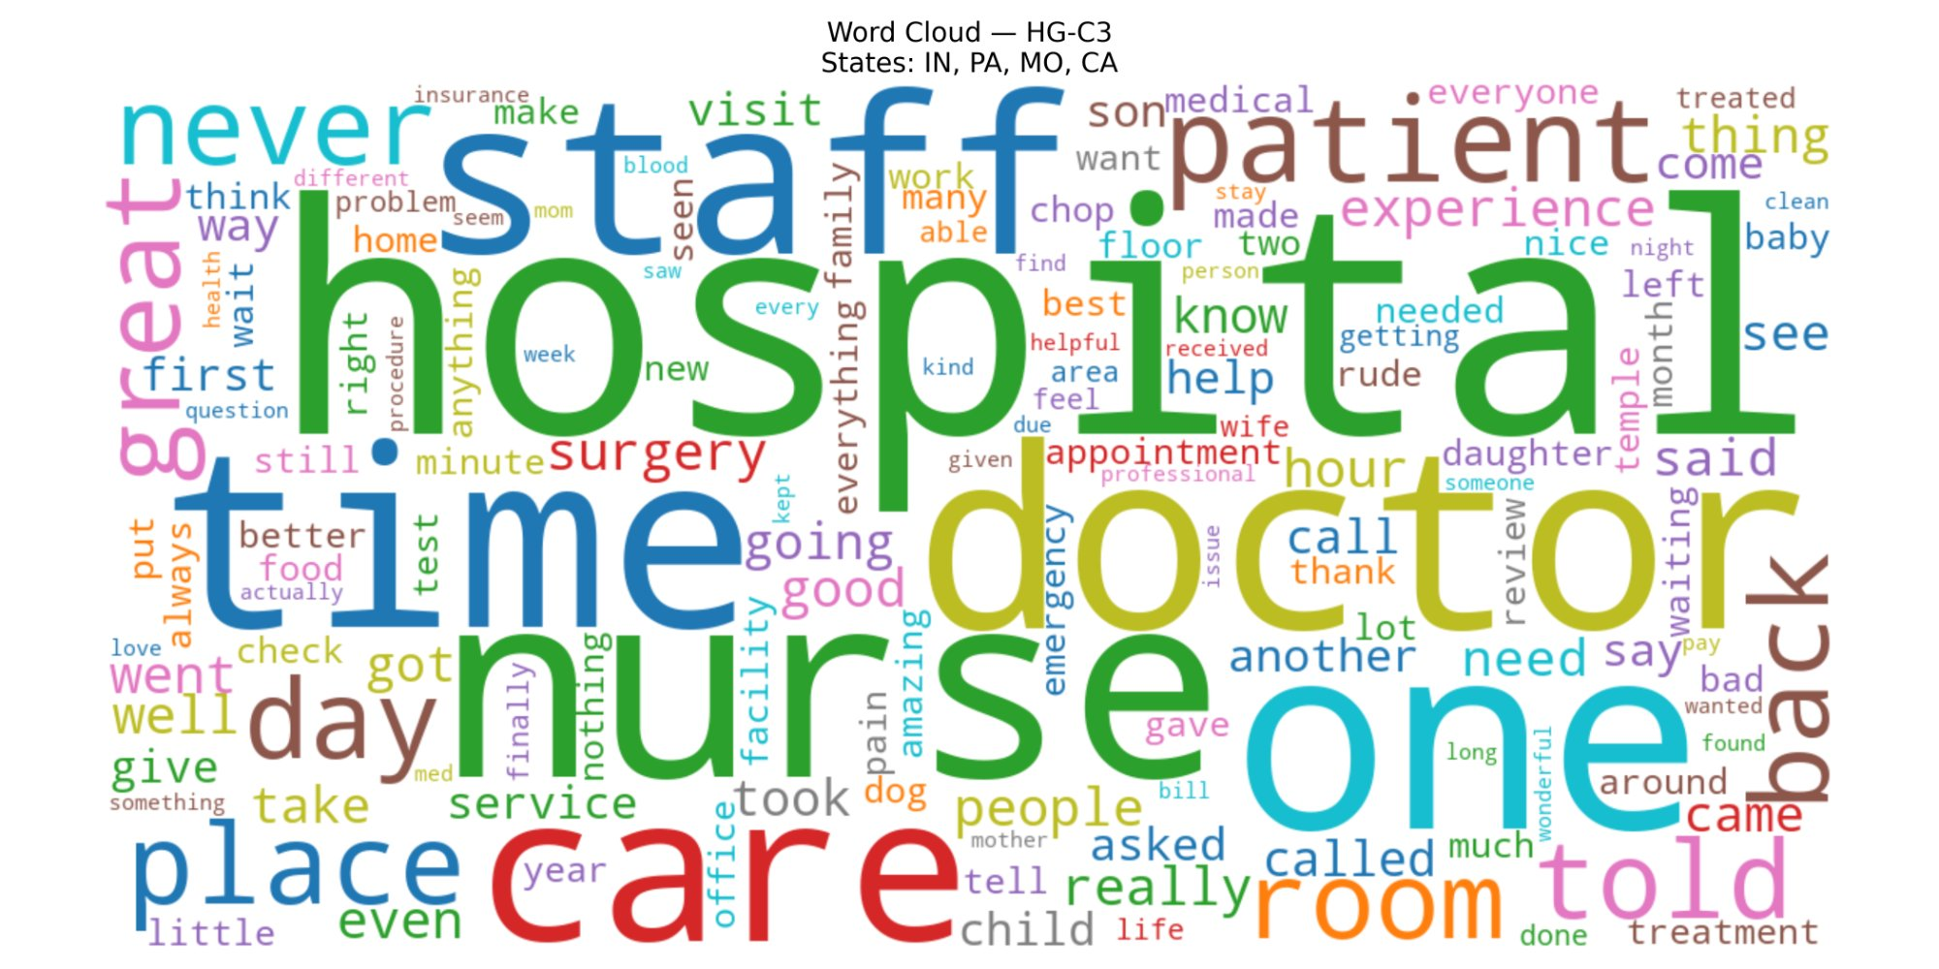
Figure 61: Word Cloud — S-C1 (ID, IL, LA, PA, TN)
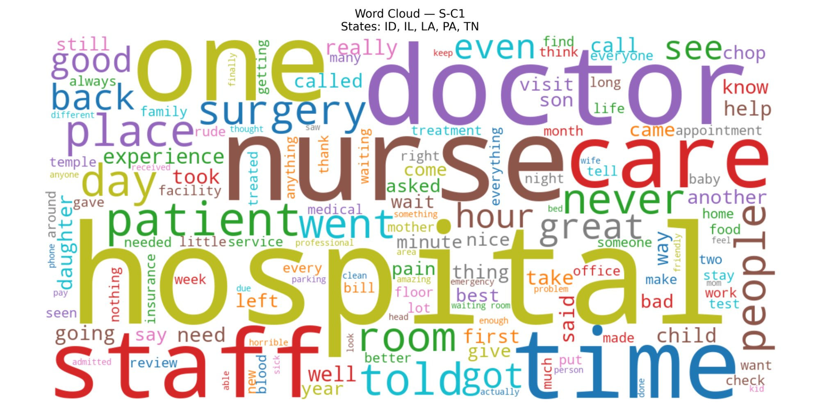
Figure 62: Word Cloud — S-C2 (AZ, IN, NJ)
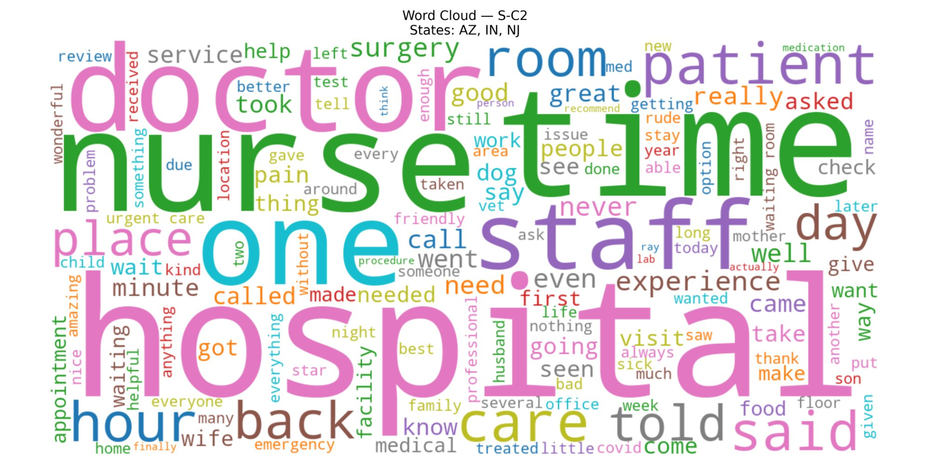
Figure 63: Word Cloud — S-C3 (FL, MO)
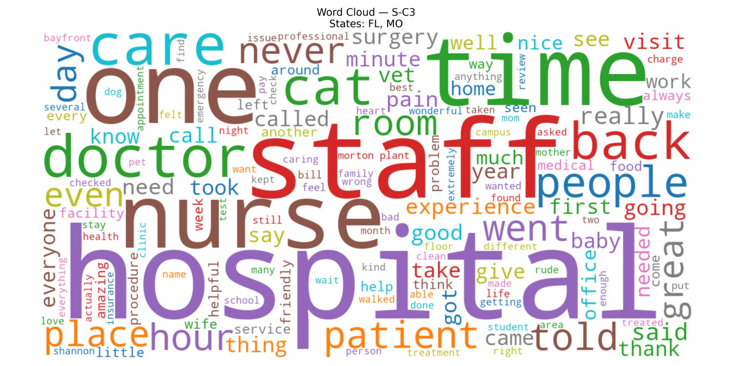
The word clouds reinforce and build on the thematic patterns seen in the word association networks. In all six clusters, words such as hospital, staff, nurse, doctor, time, care, room, and patient appear prominently, showing that these are common themes in patient hospital reviews. The word never also appears frequently across multiple clusters, which suggests that patients often use negation both to describe unsatisfactory experiences and to strongly praise positive ones.
S-C3 (Florida and Missouri) stands out for the visible presence of words like great, amazing, and helpful, which matches its role as the most positively expressive cluster in the text mining analysis. HG-C1 (Arizona, Florida, New Jersey, and Illinois) includes noticeable terms such as surgery and urgent care, suggesting that more reviews in this cluster relate to procedures or emergency care. HG-C2 (Idaho and Tennessee) is distinctive because the word place is more visible than in the other clusters, and it also includes words like horrible and worst, which aligns with its HATE quadrant placement and high negative sentiment proportion. S-C1 (Idaho, Illinois, Louisiana, Pennsylvania, and Tennessee) has a broad and fairly even vocabulary without clearly dominant evaluative words, which fits its more moderate and mixed sentiment profile

